ACCESS PACK

Break of Day
By Steve Rodgers

7 – 29 August 2026
Malthouse Theatre

CONTENTS

- General information
- Season details
- Time to Talk (Post show Q&A)
- Content warnings
- Access ratings
- Captioned performance
- Cast and Creatives
- How to get to Malthouse
- Venue images
- How to book / contact us

GENERAL INFORMATION

Sometimes you get stuck with the cards you’ve been dealt, but Pam is determined to shuffle the deck for her daughter.
Out on the edge of a satellite city, is Burra Creek, home to the world’s largest online retail warehouse, and tonight Pam (Kat Stewart) is working the nightshift, while her daughter Rae, back home, is also pulling an all-nighter, for very different reasons.
City folks drive the highway to Burra Creek for the op-shops, Biryani and famous kebab, but for the kids, there’s not so much to do, except hang with someone who makes you laugh, dances with shopping trolleys, and who you wouldn’t mind kissing.
No one sees Pam, as she catches three buses to the warehouse while the rest of us sleep, but as her night unfolds, she sees a better life for her daughter, and she’ll stop at nothing to secure it. Sometimes you’ve got to break the rules to break the cycle. And while Rae is at the top of her class, it’s hard to climb the rungs of opportunity when you live in a place the NBN forgot.
Break of Day is a story where humour is armour, grit is generosity, and the universal struggle between a mum and her daughter, is everything.
Premiering at Malthouse Theatre after winning the Rodney Seaborn Playwrights Award and The Australian Writers Guild Prize for Playwriting, Steve Rodgers’ Break of Day also sees Sarah Goodes and Kat Stewart collaborate again after the success of Who’s Afraid of Virginia Woolf (Red Stitch, Comedy Theatre and Sydney Theatre Company). This is a story that asks how far determination can go to change the course.

SEASON DETAILS

Break of Day
By Steve Rodgers
Directed by Sarah Goodes

Dates: 7 – 29 August 2026
Time to Talk: Tuesday 18 August, post-show
Venue: Merlyn Theatre, Malthouse, 113 Sturt Street, Southbank VIC 3006
Company Website: https://www.malthousetheatre.com.au/
Malthouse Theatre Access Webpage: https://www.malthousetheatre.com.au/visit-us/access
Event Page: https://www.malthousetheatre.com.au/whats-on/season-2026/break-of-day

TIME TO TALK
Tuesday 18 August, 7.30pm

Time to Talk is a post-show Q&A, where audience are welcome to stay after the show for a hosted discussion with the show’s cast and creatives. This is an optional offering, with a short break after the show before the event starts to allow audience to depart if desired.

The Break of Day Time to Talk will be hosted by Dean Bryant, Malthouse Theatre's Artistic Director & Co-CEO.

CONTENT WARNINGS

This production contains:
- Strong coarse language
- Mature themes
- Sexual references
- Partial nudity
- Loud and dynamic sounds
- Use of herbal cigarettes
- Use of haze

For detailed content information, please visit: https://www.malthousetheatre.com.au/visit-us/content-warnings

If you would like to speak with us about specific content, please contact box office on (03) 9685 5111 or email boxoffice@malthousetheatre.com.au.

ACCESS RATINGS

Aural Rating below 50% – predominantly visual event.

Visual Rating 50% – includes dialogue and background music or sounds, so Deaf and hard of hearing audiences can have some engagement with the event.

CAPTIONED PERFORMANCE
Sat 15 August, 2pm

The performance of Break of Day on Saturday 15 August at 2pm will be captioned (open and closed).

WHAT IS CAPTIONING?
Theatre captioning is a way of providing synchronised text captions alongside live performances. It aims to enhance the accessibility of theatrical shows for a range of individuals.

Malthouse works with Captioning Studio to provide specialised theatre captioning for specified performances.

OPEN CAPTIONS (ON SCREENS)
- Captions appear on two screens, one either side of the stage
- Anyone in the audience can see them
- You don’t need to use a device

CLOSED CAPTIONS (ON PERSONAL DEVICE)
- You use your own smartphone or tablet
- You scan the QR code at the theatre
- View captions during the performance

WILL USING MY DEVICE DISTURB OTHERS?
- The GoTheatrical app is designed specifically for theatre use.
- The display uses a black background suitable for low-light environments (not like social media or other apps with white backgrounds).
- When you use the

CAST AND CREATIVES


CAST AND CREATIVES cont.
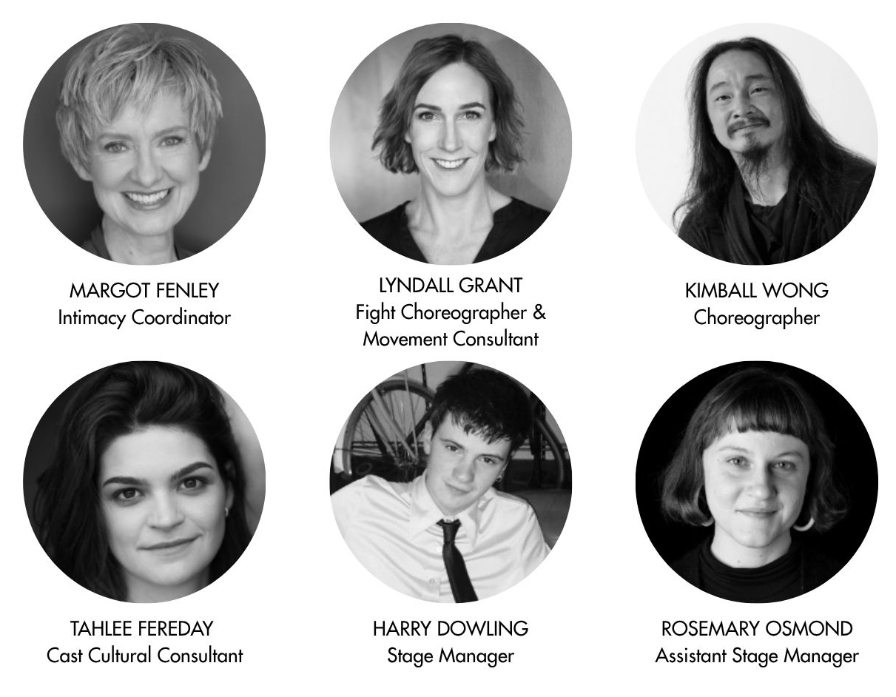

HOW TO GET TO MALTHOUSE
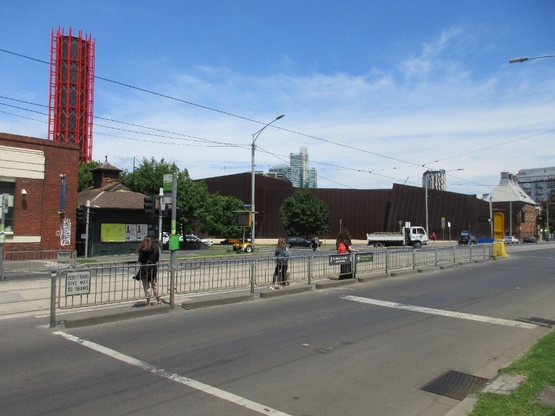
Pictured: The view of Stop 18 with Malthouse and ACCA in the distance
The Malthouse is located at 113 Sturt Street in Southbank. You can get here by tram, train, bike or car.

Tram: The closest tram stop is Stop 18 – Grant Street/Sturt Street (Route 1), however this is not wheelchair accessible. You can also get to the venue from St Kilda Road. Get off at Stop 17 – Grant Street, Police Memorial/St Kilda Road – a wheelchair accessible stop. From this stop, it is a 6-minute walk to the venue via Grant Street.

Train: Flinders Street station is approximately 15-minute walk away.

Bike: There are bike racks and a Melbourne Bike Share station outside The Malthouse.

Car: There is limited on-street parking on Grant Street, Sturt Street and Dodds Street. There are 2 disabled spaces outside The Malthouse entrance on Sturt Street.

The closest secure carparks are:
- Arts Centre Melbourne Car Park (enter from Sturt Street)
- The Australian Ballet Centre Car Park (2 Kavanagh Street)

VENUE IMAGES
ENTRANCE – FROM STURT STREET

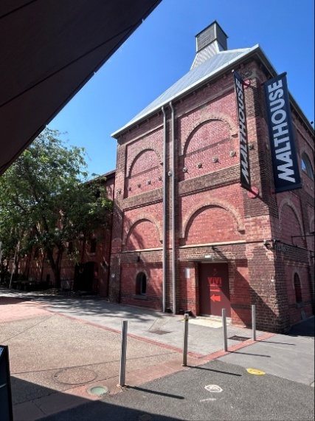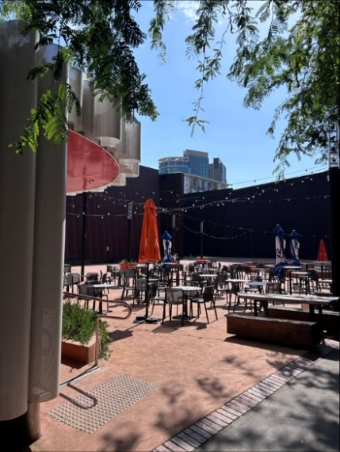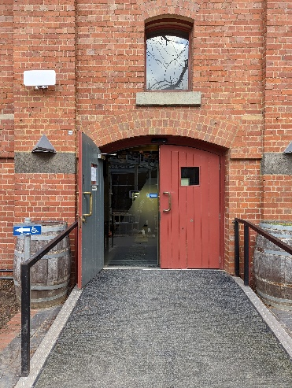
This entrance has a ramp that leads to automatic double doors.
This is the closest entrance to Vivi Southbank (café / restaurant).

ENTRANCE – FROM DODDS STREET

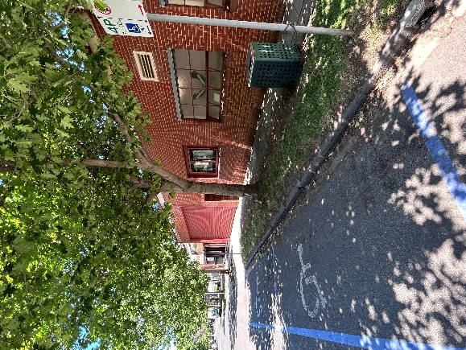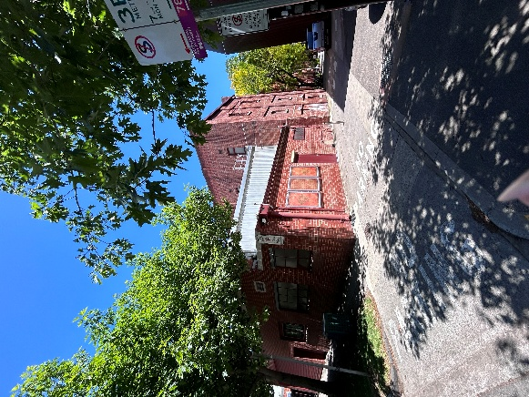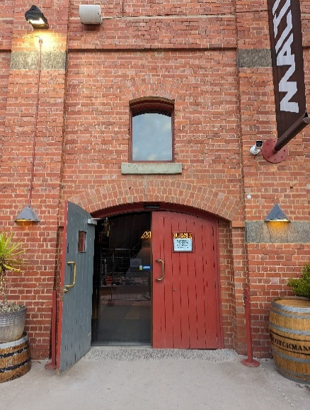
This entrance has a DDA compliant ramp that leads to automatic double doors.
It is the closest entrance to the Box Office.
It is the closest entrance from the designated on-street disability parking spaces on Dodds Street.

FOYER & BAR
Ground Floor

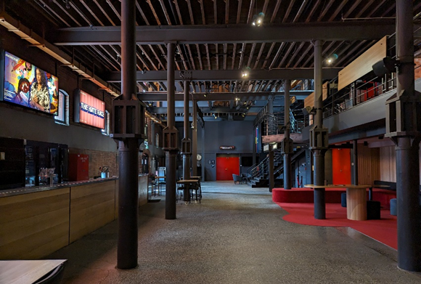

FOYER LOUNGE SEATING
Ground Floor

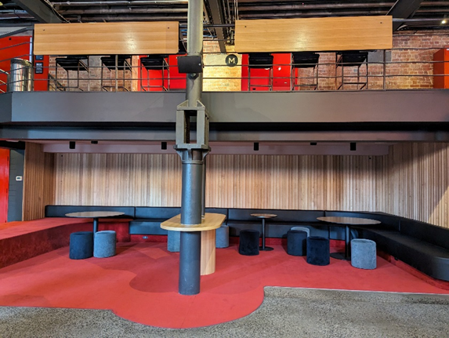

BOX OFFICE IN THE FOYER
Ground Floor, located next to the Beckett Theatre

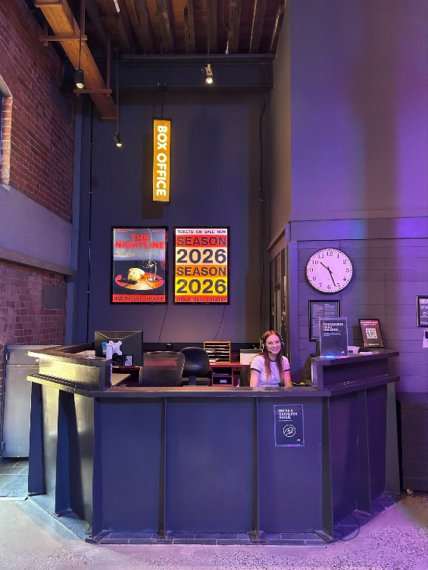

BATHROOMS IN THE FOYER
Ground Floor, located next to the middle stairs

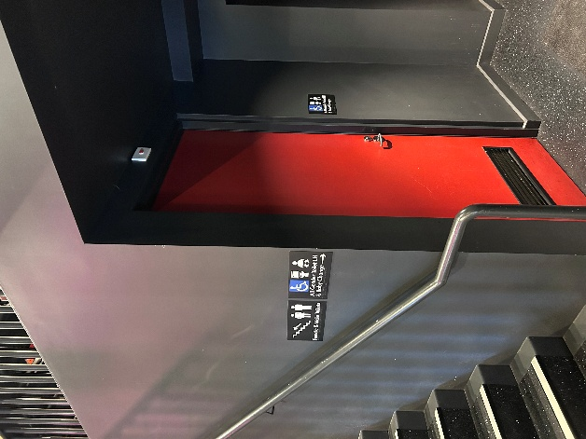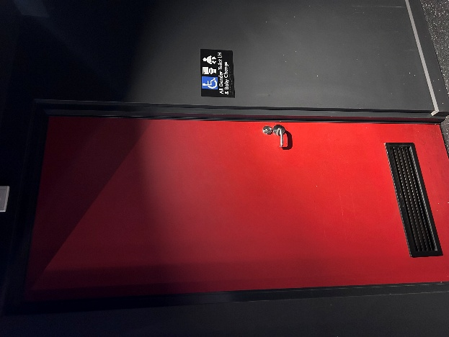
- Wheelchair accessible
- 1 toilet
- All gender
- Baby change facility

BATHROOMS IN THE FOYER
Located next to the foyer lounge seating area

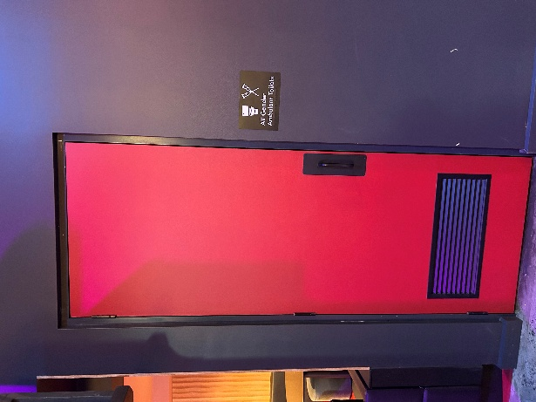
- 2 cubicles with toilets
- All gender
- Ambulant access

BATHROOMS ON MEZZANINE
Located on level 1 (up one flight of stairs)

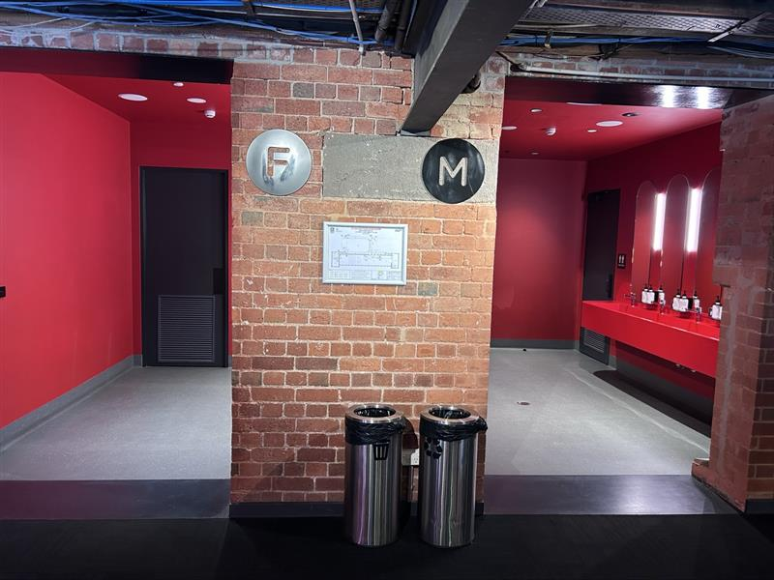
Bathroom labelled ‘F’ has:
- Toilet stalls
- 1 ambulant stall
- Sanitary bins in all stalls

Bathroom labelled ‘M’ has:
- 2 stalls with toilets
- 1 ambulant stall
- Open urinals
- Sanitary bins in all stalls

MERLYN THEATRE

Break of Day is performed in the Merlyn Theatre at The Malthouse.

The theatre seats are organised in rows. Each row is assigned a letter and each seat has a number on it.

Stalls – Ground Floor (wheelchair accessible)
Rows AA to K

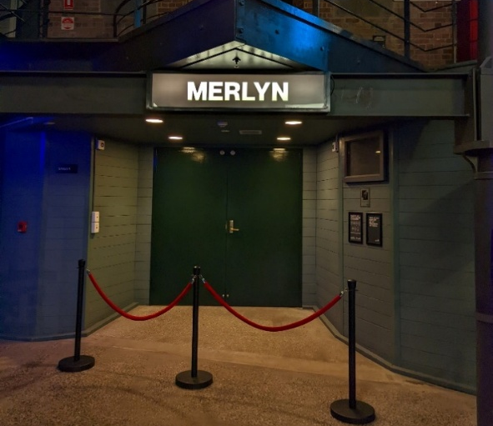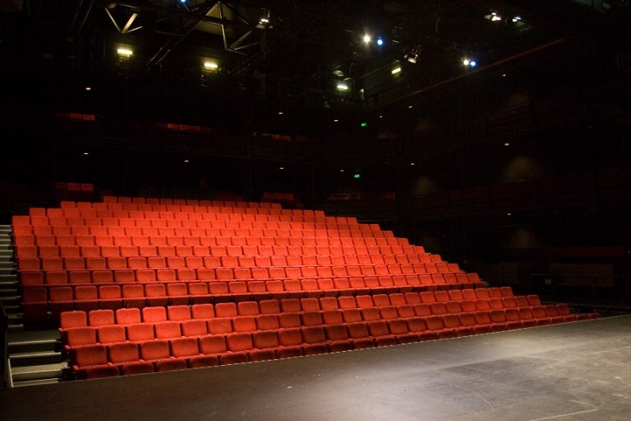

Circle – Level 1
Rows L & M

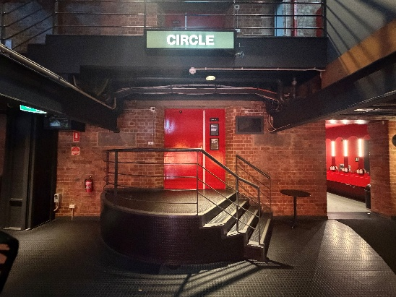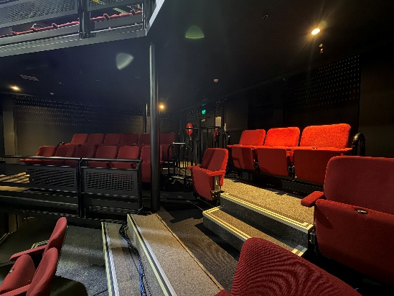

Balcony – Level 3
Rows Balcony A & B

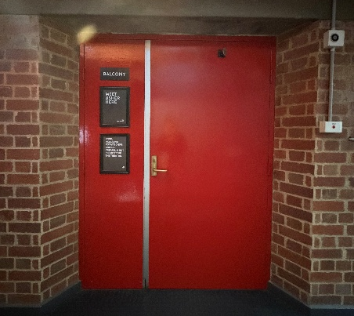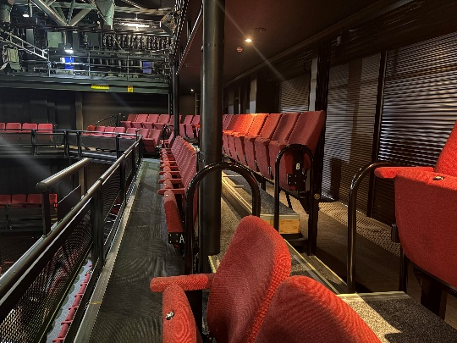

WE’RE HERE TO HELP
If you need help finding your seat, or with anything else, you can ask a member of our Front of House team when you’re at the venue.

HOW TO BOOK TICKETS AND CONTACT US

Information about The Malthouse venue and this production can be found on Malthouse Theatre’s website www.malthousetheatre.com.au

You can book tickets on the website or by calling the Box Office on (03) 9685 5111.

For more detailed access information, please feel free to contact our box office team on: boxoffice@malthousetheatre.com.au

We are committed to continual improvement and learning and welcome your feedback.

