ACCESS PACK & VISUAL GUIDE

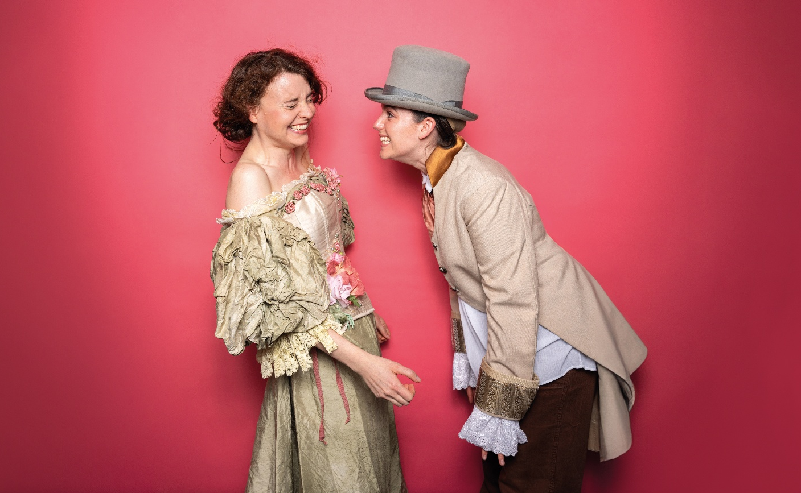

Pride and Prejudice
14 – 23 May 2026
Malthouse Theatre

CONTENTS

- General information
- Season details
- Community Night
- Time to Talk
- Content warnings
- Access ratings
- How to book / contact us
- Cast and Creatives
- How to get to Malthouse
- Venue images

GENERAL INFORMATION

‘What does it matter which one he chooses? We have a horde of them! Any one of them will do!’ – Mrs Bennet
In the plush ballrooms of high society, Mrs Bennet sees too well the value of a strategic union. But her five daughters all have ambitions of their own. Jane and Elizabeth want to marry for love (whatever that means). Mary’s stuck in a goth phase, Lydia’s hot for the local militia, and Kitty is... well, we don't need to talk about Kitty. With the cost of living rising, and Mr Bennet played by a potted monstera, how will the Bennet family hold onto their precarious position on the property ladder?
Addressing the concerns of a generation staring down the barrel of intense economic and environmental hardship, Pride and Prejudice questions the function of ‘Love’ in the twenty-first century. As the popularity of period drama soars and dreams of homeownership plummet, does love (and marriage) become a means to an end? Or, in a world where individuals are defined by their asset portfolio, is love our collective salvation? In this searing satire on polite society, Bloomshed attempts to deliver the rom com’s most prized outcome: the happy ever after.

SEASON DETAILS

Pride and Prejudice
Created by Bloomshed
After Jane Austen

Dates: 14 – 23 May 2026
Time to Talk: Tuesday 19 May, 7:30pm
Venue: Merlyn Theatre, Malthouse, 113 Sturt Street, Southbank VIC 3006
Company Website: https://www.malthousetheatre.com.au/
Malthouse Theatre Access Webpage: https://www.malthousetheatre.com.au/visit-us/access
Event Page: https://www.malthousetheatre.com.au/whats-on/season-2026/pride-and-prejudice

TIME TO TALK
Tuesday 19 May, 7:30pm

Time to Talk is a post-show Q&A, where audience are welcome to stay after the show for a hosted discussion with the show’s cast and creatives. This is an optional offering, with a short break after the show before the event starts to allow audience to depart if desired.

The Time to Talk discussion for this production will be hosted by Malthouse Theatre's New Work Associate, Jessica Arthur.

CONTENT WARNINGS

This production contains:

- Strong coarse language
- Sexual references
- Smoke and haze effects
- Flashing lights
- Loud noises
- Use of a prop gun
- Mentions of colonisation and stolen land

If you would like to speak with us about specific content, please contact bvox office on (03) 9685 5111 or email boxoffice@malthousetheatre.com.au

ACCESS RATINGS

Aural Rating 50% – has both sound and visual components, but sight isn’t essential to be able to engage with the event.

Visual Rating 50% – includes dialogue and background music or sounds, so Deaf and hard of hearing audiences can have some engagement with the event.

HOW TO BOOK / CONTACT US

Information about The Malthouse venue and this production can be found on Malthouse Theatre’s website www.malthousetheatre.com.au

You can book tickets on the website or by calling the Box Office on (03) 9685 5111.

For more detailed access information, please feel free to contact our box office team on: boxoffice@malthousetheatre.com.au

We are committed to continual improvement and learning and welcome your feedback.

CAST AND CREATIVES

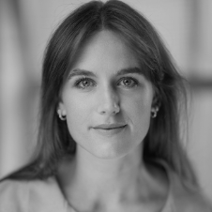 | 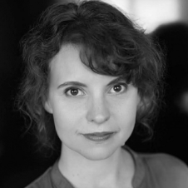 |  | 
PERFORMER  LAURA ALDOUS | PERFORMER  ELIZABETH BRENNAN | PERFORMER  SYD BRISBANE | PERFORMER  EMILY CARR
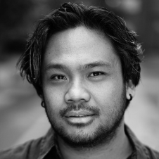 | 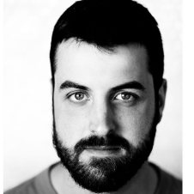 |  | 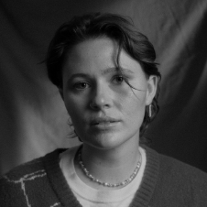
PERFORMER  JOHN MARC DESENGANO | PERFORMER  JAMES JACKSON | PERFORMER  ANNA LOUEY | PERFORMER  LAUREN SWAIN
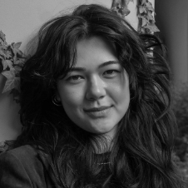 |  |  | 
SET DESIGNER  SAVANNA WEGMAN | COSTUME DESIGNER  SAMANTHA HASTINGS | LIGHTING DESIGNER  JOHN COLLOPY | SOUND DESIGNER  JUSTIN GARDAM
 | 
DRAMATURG  EMILY O’CONNOR | STAGE MANAGER  JACINTA ANDERSON

HOW TO GET TO MALTHOUSE
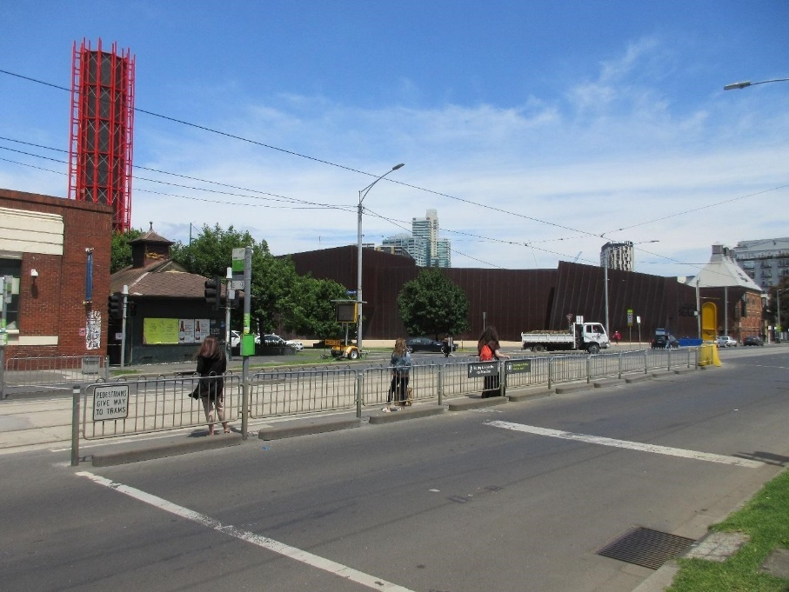
Pictured: The view of Stop 18 with Malthouse and ACCA in the distance
The Malthouse is located at 113 Sturt Street in Southbank. You can get here by tram, train, bike or car.

Tram: The closest tram stop is Stop 18 – Grant Street/Sturt Street (Route 1), however this is not wheelchair accessible. You can also get to the venue from St Kilda Road. Get off at Stop 17 – Grant Street, Police Memorial/St Kilda Road – a wheelchair accessible stop. From this stop, it is a 6-minute walk to the venue via Grant Street.

Train: Flinders Street station is approximately 15-minute walk away.

Bike: There are bike racks and a Melbourne Bike Share station outside The Malthouse.

Car: There is limited on-street parking on Grant Street, Sturt Street and Dodds Street. There are 2 disabled spaces outside The Malthouse entrance on Sturt Street.

The closest secure carparks are:
- Arts Centre Melbourne Car Park (enter from Sturt Street)
- The Australian Ballet Centre Car Park (2 Kavanagh Street)

VENUE IMAGES
Entrance from Sturt Street side
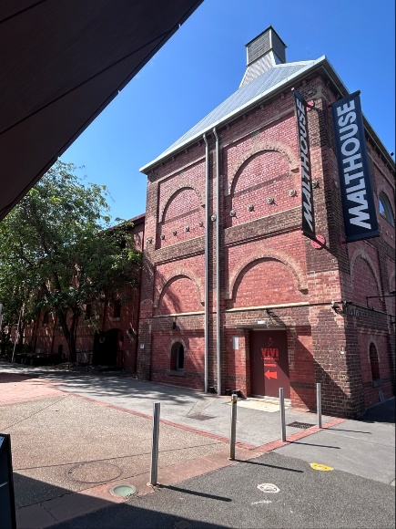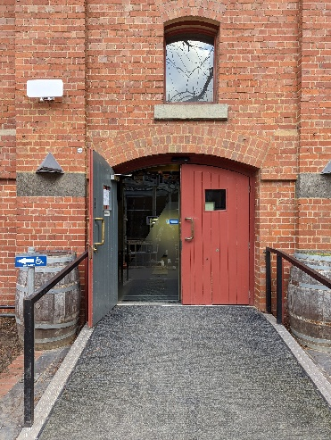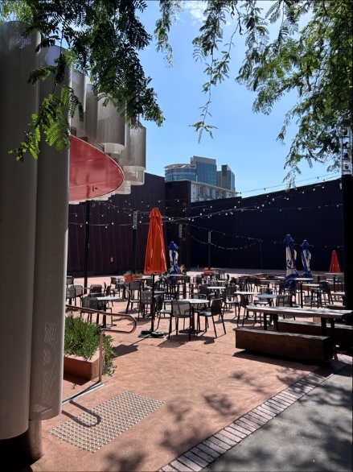

Entrance from Dodds Street side (wheelchair access)
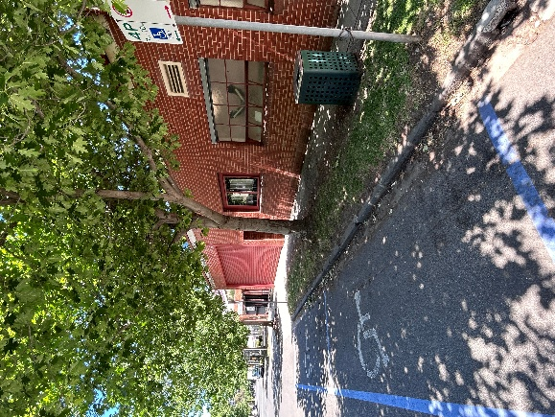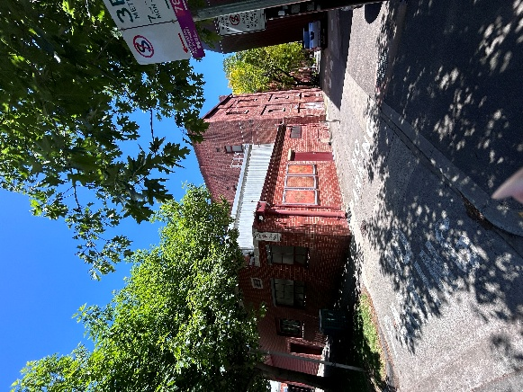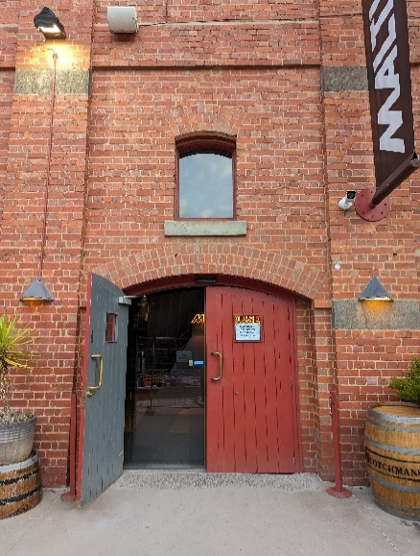

Bar and seating in the Foyer
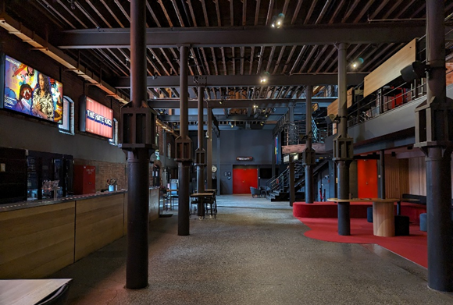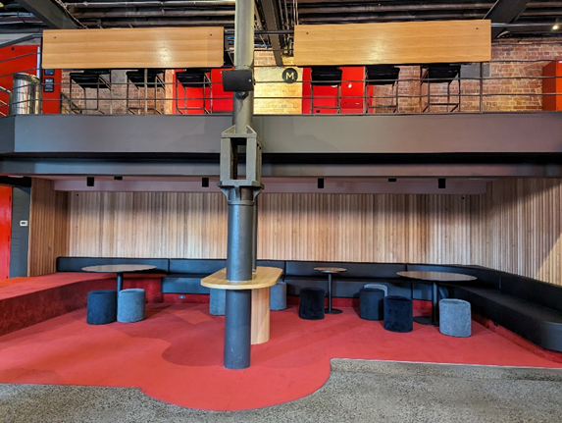

Box Office in the Foyer
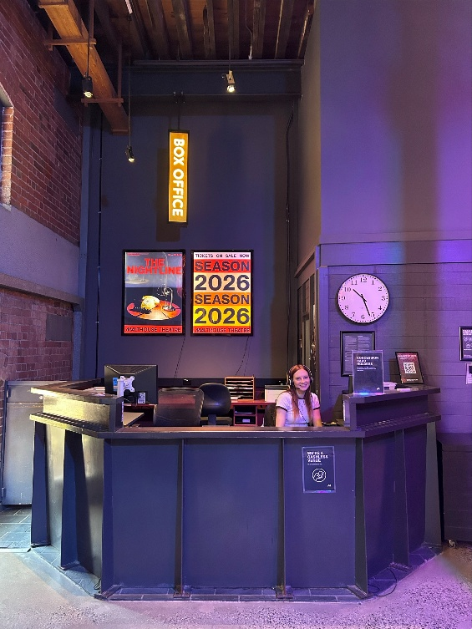

Bathrooms in Foyer (Ground Level)
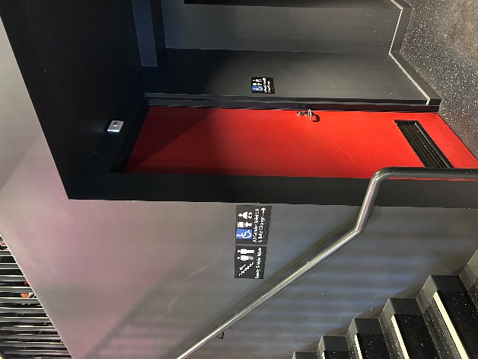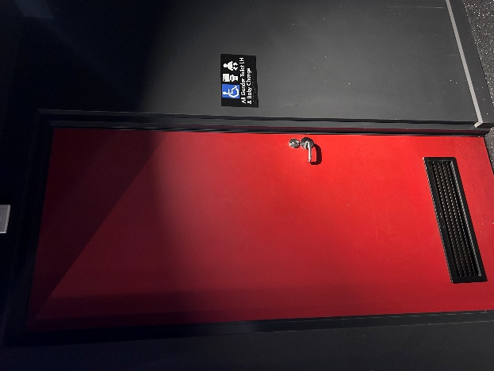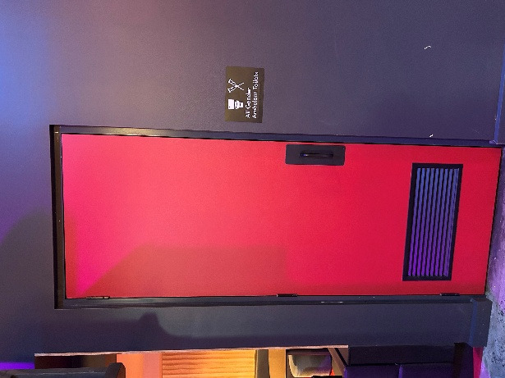

Bathrooms on Mezzanine (up a flight of stairs)
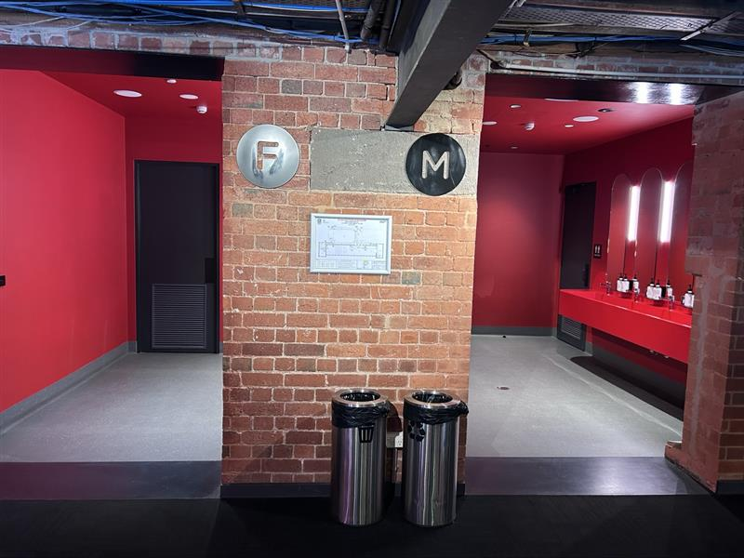

The bathrooms to the left have seated toilet stalls, an ambulant stall, and sanitary bins. The bathrooms to the right have seated stalls, urinals, an ambulant stall, and sanitary bins.
THEATRES
All theatres and spaces at the Malthouse are clearly marked. There are many staff members who will be able to assist you if you have any questions.

Merlyn Theatre
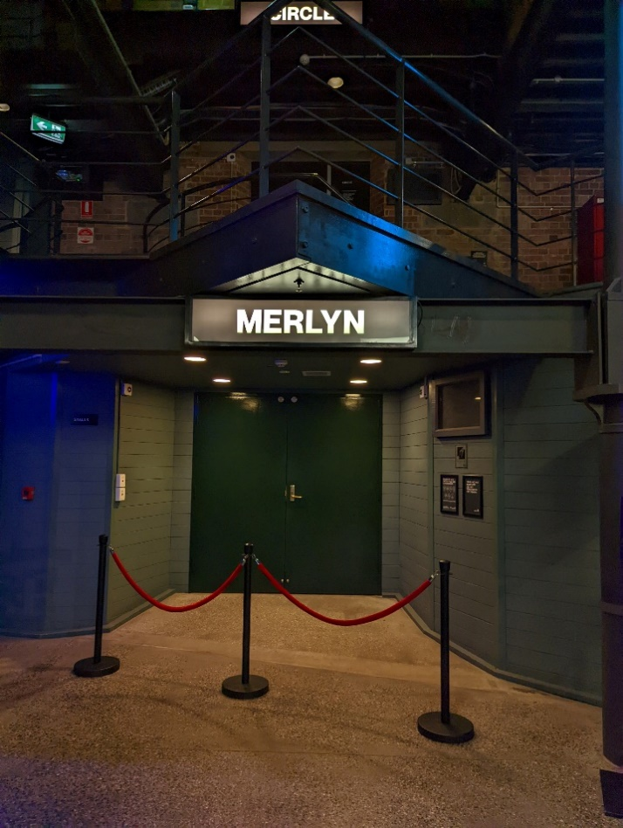
This entrance is wheelchair accessible.

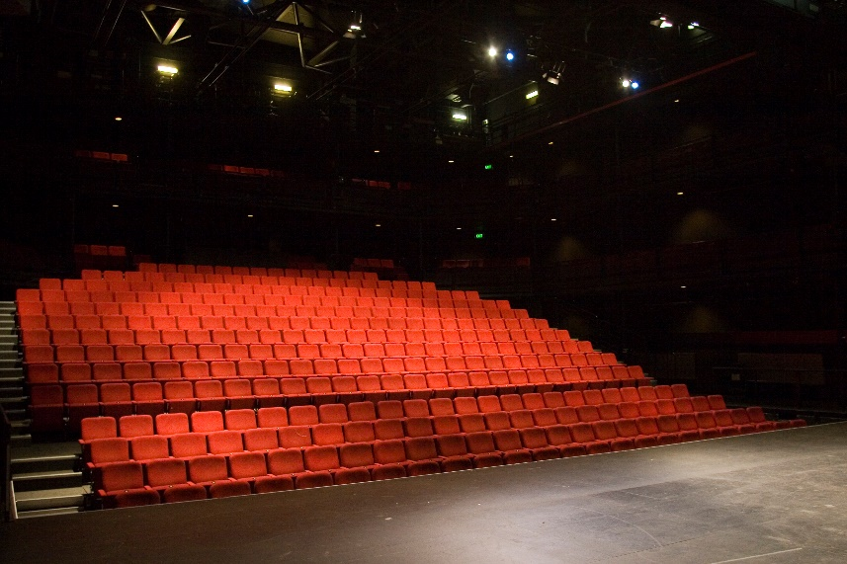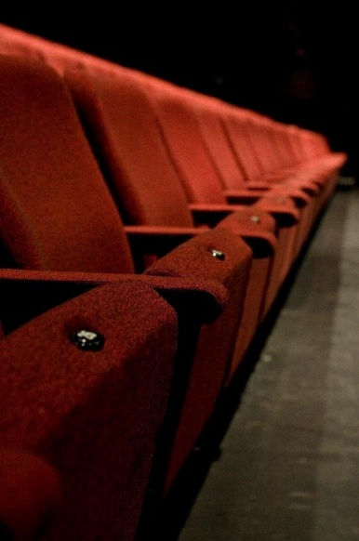

The theatre seats are organised in rows, labelled with letters from AA to M. Each seat also has a number on it. Your ticket will show which row and seat number you can sit in. The seating bank is not always in this configuration.

Beckett Theatre

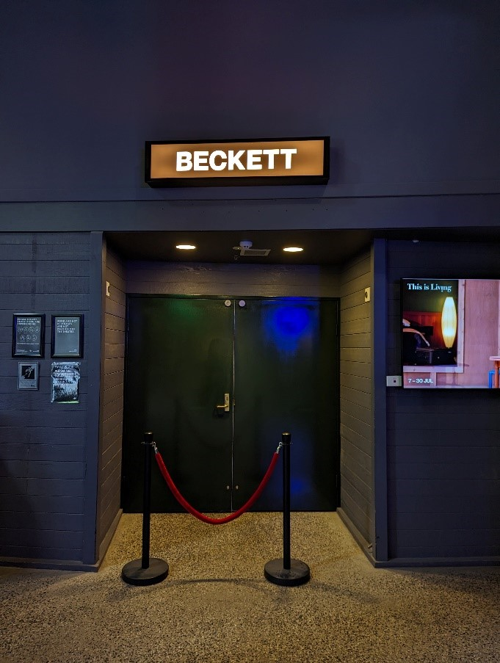

This entrance is wheelchair accessible.

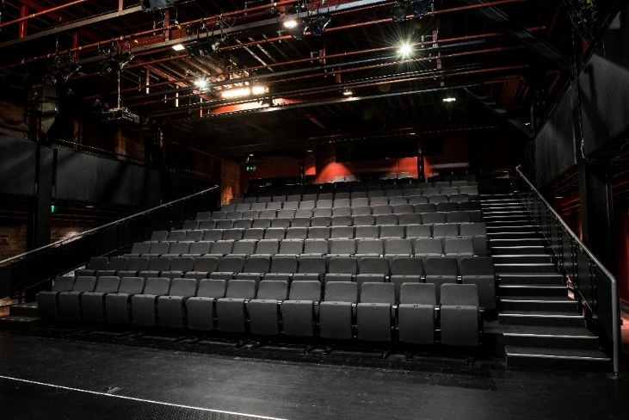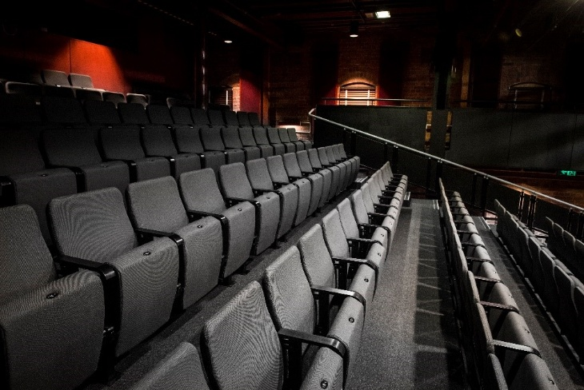

The theatre seats are organized in rows, labelled with letters from A to M. Each seat also has a number on it. Your ticket will show which row and seat number you can sit in.

WE’RE HERE TO ASSIST
If you need help finding your seat, or with anything else, you can ask a Malthouse Theatre Usher. Ushers wear a uniform of a black shirt with a lanyard.
