ACCESS PACK & VISUAL GUIDE

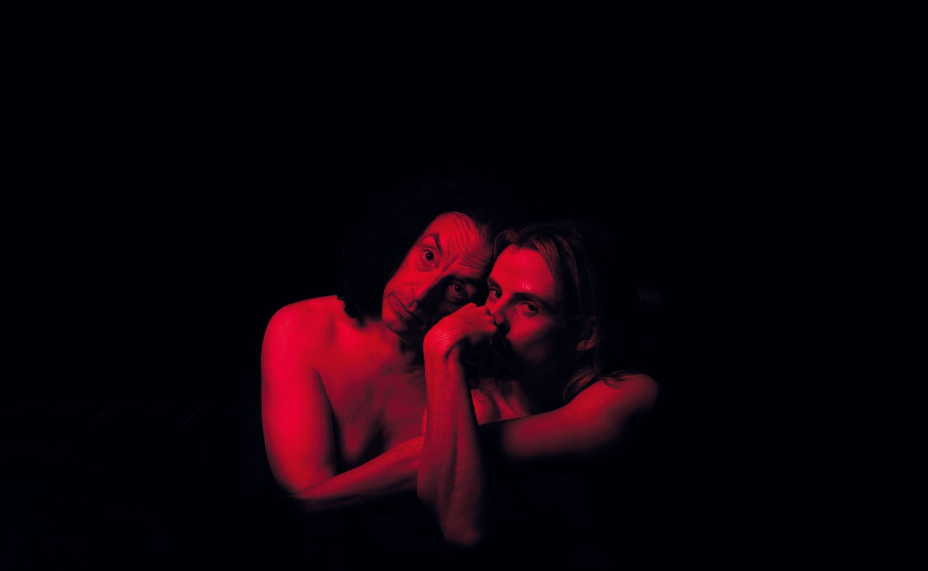

House of Rot
18 – 20 June 2026
Malthouse Theatre

CONTENTS

- General information
- Season details
- Community Night
- Time to Talk
- Content warnings
- Access ratings
- How to book / contact us
- Cast and Creatives
- How to get to Malthouse
- Venue images

GENERAL INFORMATION

How do we fend off the rot when everything is caving in?
Starring Paul Capsis and Adam Noviello, HOUSE OF ROT is a cabaret invocation: part unholy communion, part elegy in heels. Created by director Dino Dimitriadis and musical director Victoria Falconer this premiere work weaves original compositions with new interpretations of known songs both contemporary and classic to reckon with legacy, survival, and the spaces we inherit when no one’s looking.
HOUSE OF ROT is inspired (loosely, dangerously) by Grey Gardens, the documentary that introduced the world to Big and Little Edie; two eccentric recluses who lived in a house slowly falling in on itself.
Because maybe there’s a way to live inside collapse. Because grief and fury, if left untouched, will eat through the floor.
SEASON DETAILS

House of Rot
Created by Dino Dimitridadis & Victoria Falconer

Dates: 18 – 20 June 2026
Time to Talk: n/a
Venue: Merlyn Theatre, Malthouse, 113 Sturt Street, Southbank VIC 3006
Company Website: https://www.malthousetheatre.com.au/
Malthouse Theatre Access Webpage: https://www.malthousetheatre.com.au/visit-us/access
Event Page: https://www.malthousetheatre.com.au/whats-on/season-2026/house-of-rot

TIME TO TALK

There is no Time to Talk event for this production.

CONTENT WARNINGS

This production contains:

- Haze and fog effects
- Partial nudity

If you would like to speak with us about specific content, please contact box office on (03) 9685 5111 or email boxoffice@malthousetheatre.com.au

ACCESS RATINGS

Aural Rating 50% – has both sound and visual components, but sight isn’t essential to be able to engage with the event.

Visual Rating below 50% – predominantly sound-based event.

HOW TO BOOK / CONTACT US

Information about The Malthouse venue and this production can be found on Malthouse Theatre’s website www.malthousetheatre.com.au

You can book tickets on the website or by calling the Box Office on (03) 9685 5111.

For more detailed access information, please feel free to contact our box office team on: boxoffice@malthousetheatre.com.au

We are committed to continual improvement and learning and welcome your feedback.

CAST AND CREATIVES

 | 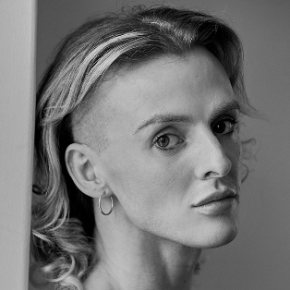 |  | 
PERFORMER  PAUL CAPSIS | PERFORMER  ADAM NOVIELLO | CO-CREATOR &  DIRECTOR  DINO DIMITRIADIS | CO-CREATOR &  MUSICAL DIRECTOR  VICTORIA FALCONER

LIGHTING DESIGNER / BROCKMAN
COSTUME DSIEGNER / NICOL & FORD
DRAMATURG / LEILA ENWRIGHT
PRODUCTION & STAGE MANAGER / THOMAS BENSLEY

HOW TO GET TO MALTHOUSE
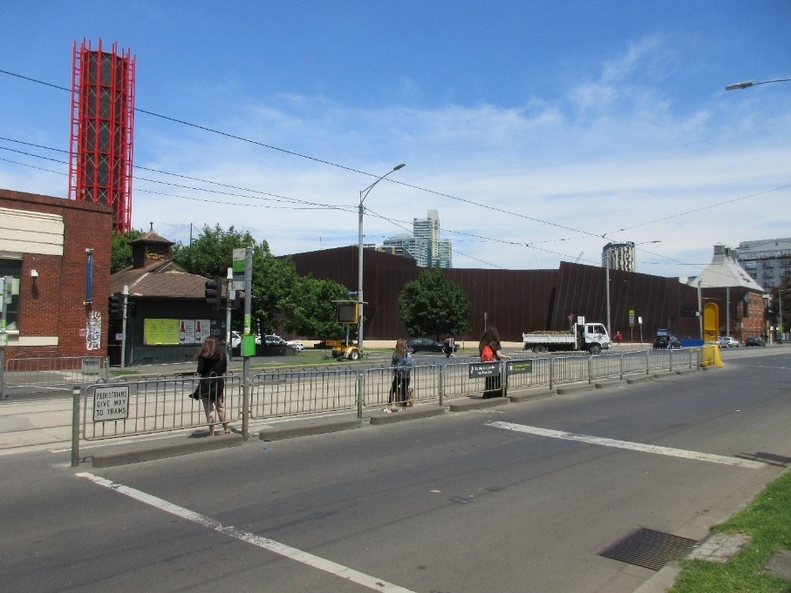
Pictured: The view of Stop 18 with Malthouse and ACCA in the distance
The Malthouse is located at 113 Sturt Street in Southbank. You can get here by tram, train, bike or car.

Tram: The closest tram stop is Stop 18 – Grant Street/Sturt Street (Route 1), however this is not wheelchair accessible. You can also get to the venue from St Kilda Road. Get off at Stop 17 – Grant Street, Police Memorial/St Kilda Road – a wheelchair accessible stop. From this stop, it is a 6-minute walk to the venue via Grant Street.

Train: Flinders Street station is approximately 15-minute walk away.

Bike: There are bike racks and a Melbourne Bike Share station outside The Malthouse.

Car: There is limited on-street parking on Grant Street, Sturt Street and Dodds Street. There are 2 disabled spaces outside The Malthouse entrance on Sturt Street.

The closest secure carparks are:
- Arts Centre Melbourne Car Park (enter from Sturt Street)
- The Australian Ballet Centre Car Park (2 Kavanagh Street)

VENUE IMAGES
Entrance from Sturt Street side
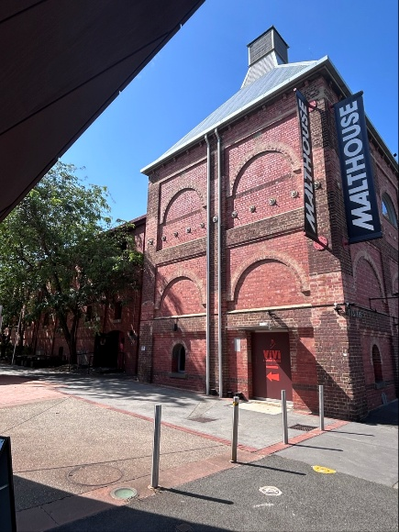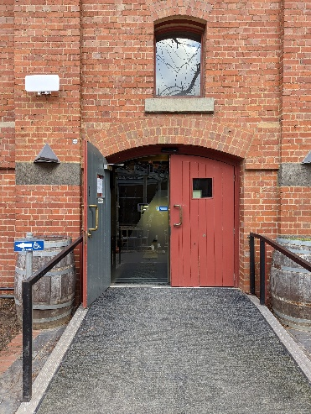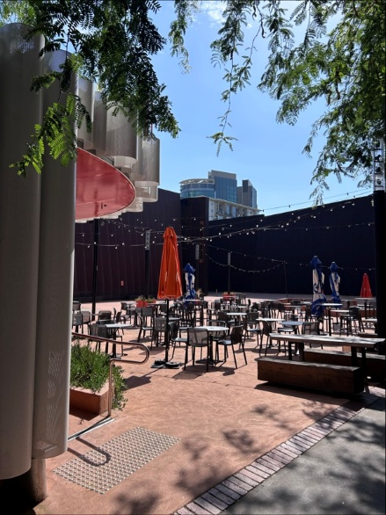

Entrance from Dodds Street side (wheelchair access)
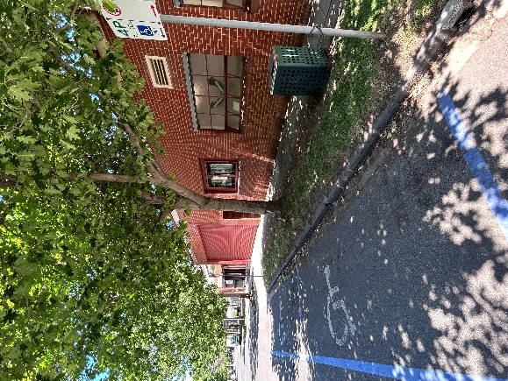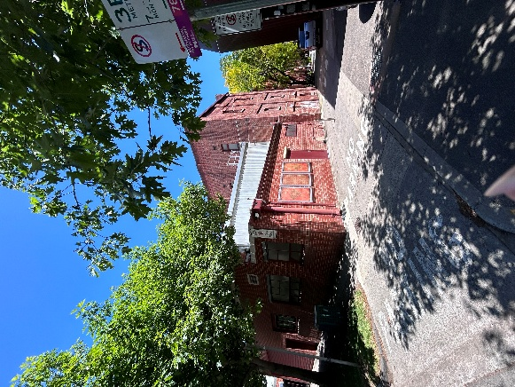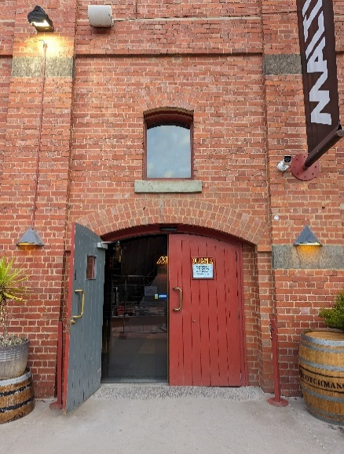

Bar and seating in the Foyer
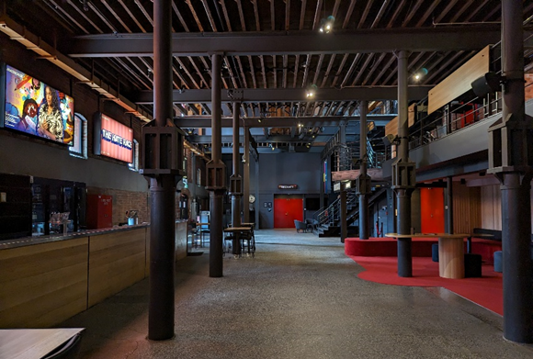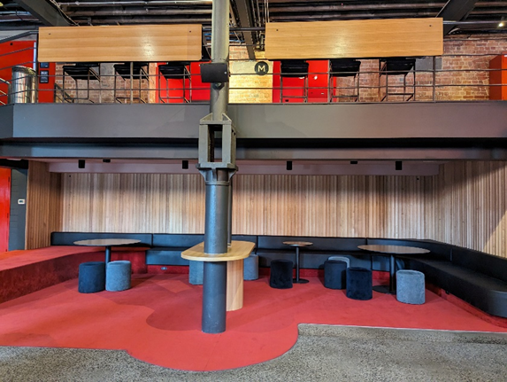

Box Office in the Foyer
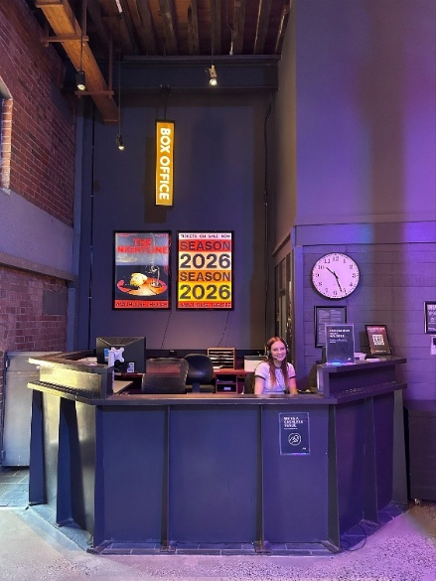

Bathrooms in Foyer (Ground Level)
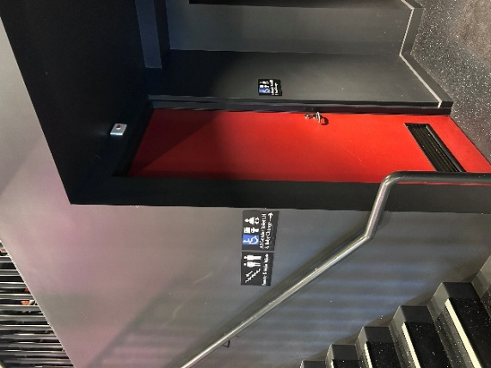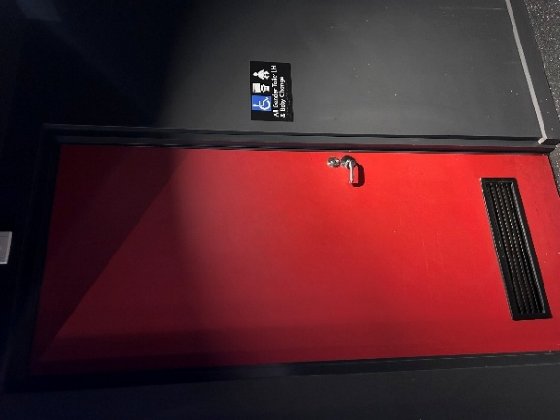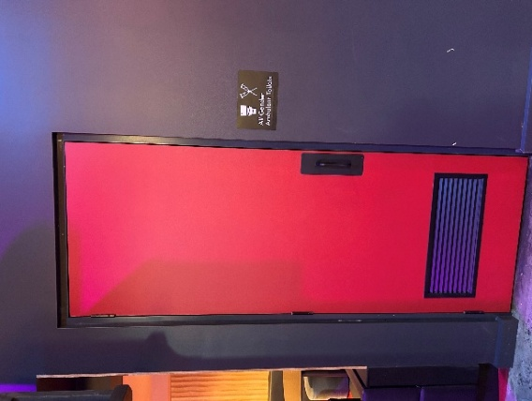

Bathrooms on Mezzanine (up a flight of stairs)
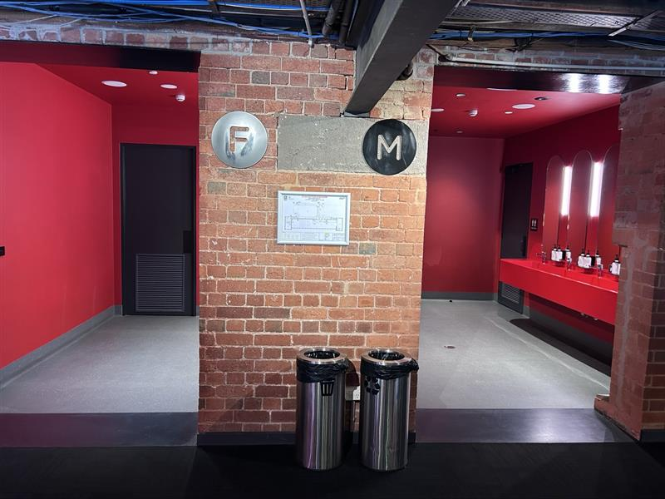
The bathrooms to the left have seated toilet stalls, an ambulant stall, and sanitary bins. The bathrooms to the right have seated stalls, urinals, an ambulant stall, and sanitary bins.
THEATRES
All theatres and spaces at the Malthouse are clearly marked. There are many staff members who will be able to assist you if you have any questions.

Merlyn Theatre
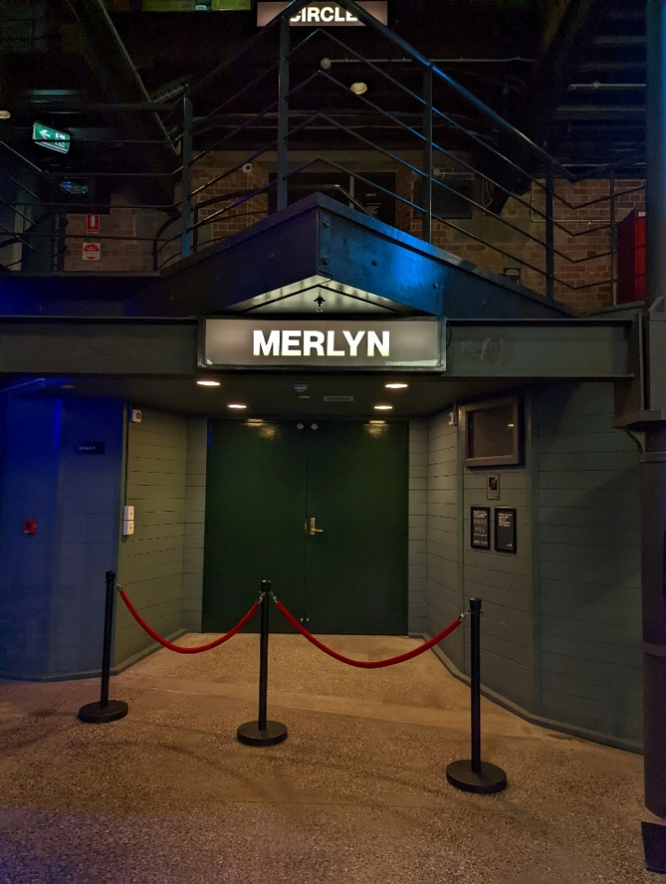
This entrance is wheelchair accessible.

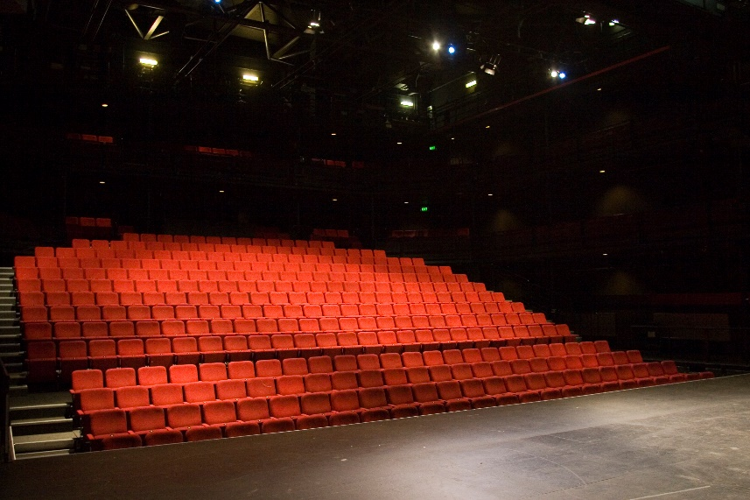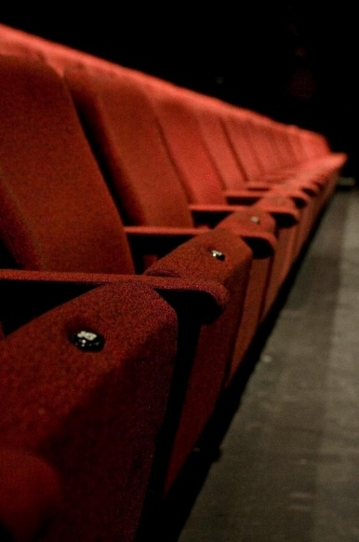

The theatre seats are organised in rows, labelled with letters from AA to M. Each seat also has a number on it. Your ticket will show which row and seat number you can sit in. The seating bank is not always in this configuration.

Beckett Theatre

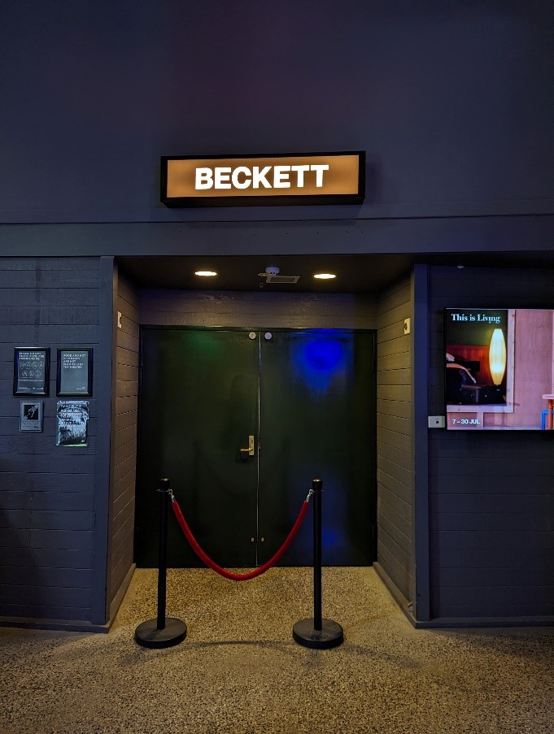

This entrance is wheelchair accessible.

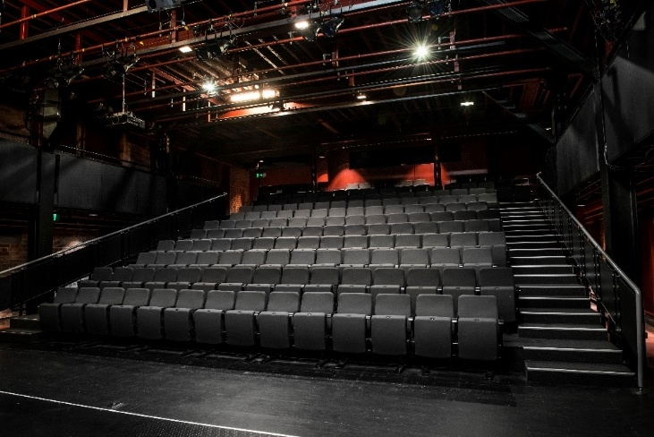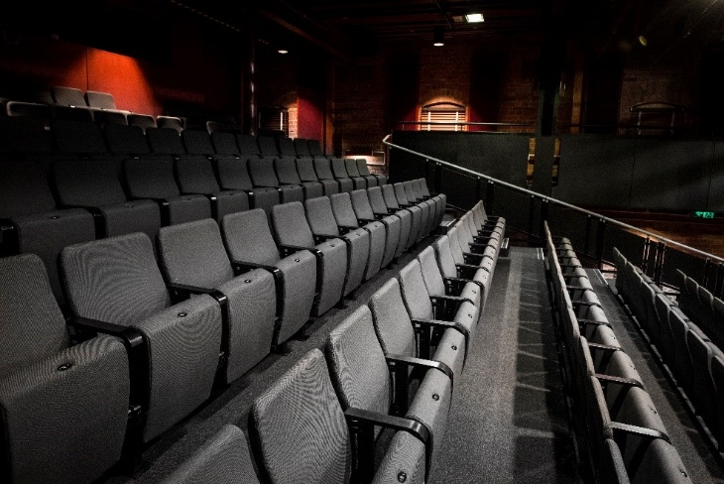

The theatre seats are organized in rows, labelled with letters from A to M. Each seat also has a number on it. Your ticket will show which row and seat number you can sit in.

WE’RE HERE TO ASSIST
If you need help finding your seat, or with anything else, you can ask a Malthouse Theatre Usher. Ushers wear a uniform of a black shirt with a lanyard.
