ACCESS PACK

KOREABOO
By Michelle Lim Davison

24 September – 10 October 2026
Beckett Theatre, Malthouse

CONTENTS
- General information
- Season details
- Time to Talk
- Content warnings
- Access ratings
- Community night
- How to book / contact us
- Cast and Creatives
- How to get to Malthouse
- Venue images

GENERAL INFORMATION

Koreaboo
By Michelle Lim Davison
Directed by Jessica Arthur
The road to reunion is paved with awkward moments. Hannah had her trip all planned out. Travel to Korea. Visit her birth mother. Spend a golden summer creating precious memories.
But when she arrives in Seoul reality hits hard. Her Umma works in a convenience store day and night, barely taking a break. She seems more interested in stacking shelves and re-arranging the garden gnome display than connecting with her long-lost Australian daughter.
Hannah is Korean, raised in Australia, yet in Umma’s mind, Hannah is a “Koreaboo” – a foreigner captivated by K-Pop, kimchi and hanboks. Armed with only Google Translate and unrelenting optimism, Hannah must try to find a place within Umma’s world before the end of a sweltering summer.
Taking inspiration from real events of Michelle Lim Davidson‘s life (The Feather in the Web, The Newsreader), this profound and heartfelt play marks the writing debut of one of Australia’s most beloved performers. Michelle herself takes to the stage under the direction of Jessica Arthur (The Dictionary of Lost Words, The Shiralee), in a reunion story that reaches across continents, cultures and Spotify playlists.
SEASON DETAILS

Dates: 24 September – 10 October 2026
Time to Talk: Tuesday 6 October, post-show
Venue: Beckett Theatre, Malthouse, 113 Sturt Street, Southbank VIC 3006
Company Website: https://www.malthousetheatre.com.au/
Malthouse Theatre Access Webpage: https://www.malthousetheatre.com.au/visit-us/access
Event Page: https://www.malthousetheatre.com.au/whats-on/season-2026/koreaboo

TIME TO TALK
Tuesday 6 October, 7.30pm

Time to Talk is a post-show Q&A, where audience are welcome to stay after the show for a hosted discussion with the show’s cast and creatives. This is an optional offering, with a short break after the show before the event starts to allow audience to depart if desired.

The Koreaboo Time to Talk will be hosted by Keziah Warner, Malthouse Theatre's New Work Associate – Script Development.

CONTENT WARNINGS

Koreaboo contains detailed discussions of inter-country adoption and culturally contextual references to diet and body image. This production also contains theatrical haze and smoke and flashing lights.
For detailed content information, please visit: https://www.malthousetheatre.com.au/visit-us/content-warnings

If you would like to speak with us about specific content, please contact box office on (03) 9685 5111 or email boxoffice@malthousetheatre.com.au.

ACCESS RATINGS

Aural Rating 50% – this production has both sound and visual components, but sight isn’t essential to be able to engage with the event.

Visual Rating 50% – includes dialogue and background music or sounds, so Deaf and hard of hearing audiences can have some engagement with the event.

COMMUNITY NIGHT
Friday 9 October, 7.30pm

Koreaboo Community Night is a chance to come together with fellow adoptees, experience the show and connect with others in the community.

Community members can purchase $25 tickets to the performance on Fri 9 October via the Malthouse website here.

Korean adoptees are encouraged to contact KAIAN first, as they have a limited number of free tickets to distribute: email info@kaian.org.au or contact @kaian_inc on Instagram.

RESOURCES

Griffin Theatre Company and Korean Adoptees in Australia Network (KAIAN) have assembled a collection of resources to shape your experience seeing Koreaboo by Michelle Lim Davidson. Find them here.

HOW TO BOOK / CONTACT US

Information about The Malthouse venue and this production can be found on Malthouse Theatre’s website www.malthousetheatre.com.au

You can book tickets on the website or by calling the Box Office on (03) 9685 5111.

For more detailed access information, please feel free to contact our box office team on: boxoffice@malthousetheatre.com.au

We are committed to continual improvement and learning and welcome your feedback.

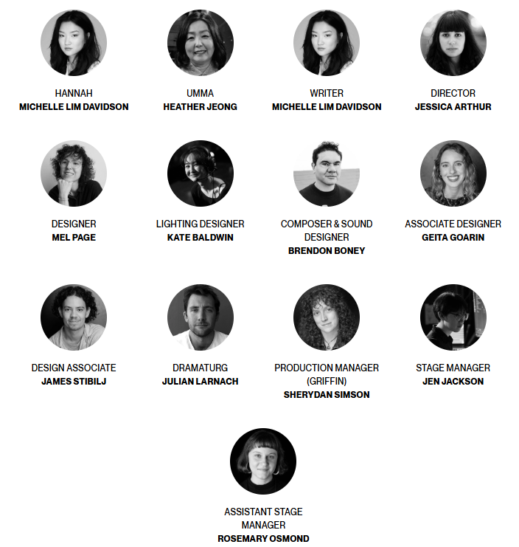
CAST AND CREATIVES

CAST
Hannah / Michelle Lim Davidson
Umma / Heather Jeong

CREATIVES
Director / Jessica Arthur
Designer / Mel Page
Lighting Designer / Kate Baldwin
Composer & Sound Designer / Brendon Boney
Associate Designer / Geita Goarin
Design Associate (Premiere Production) / James Stibilj
Dramaturg / Julian Larnach
Sound Realiser / Amy Norton
Production Manager (Griffin) / Sherydan Simson
Stage Manager / Jen Jackson
Assistant Stage Manager / Rosemary Osmond

HOW TO GET TO MALTHOUSE
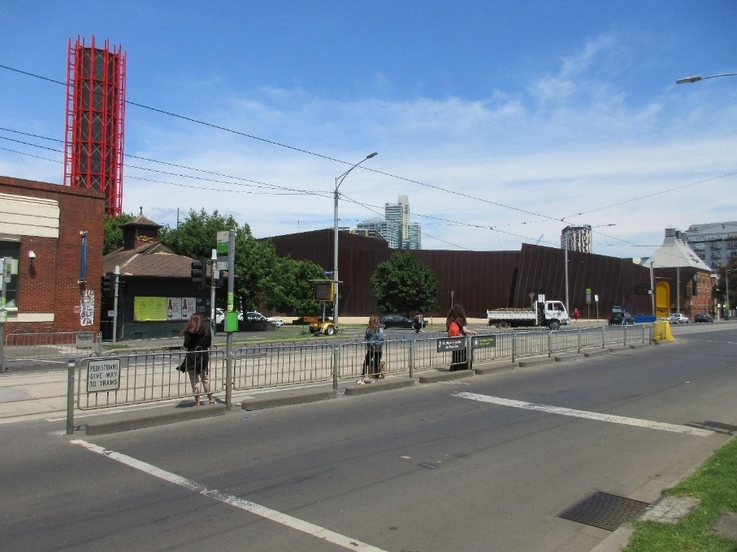
Pictured: The view of Stop 18 with Malthouse and ACCA in the distance
The Malthouse is located at 113 Sturt Street in Southbank. You can get here by tram, train, bike or car.

Tram: The closest tram stop is Stop 18 – Grant Street/Sturt Street (Route 1), however this is not wheelchair accessible. You can also get to the venue from St Kilda Road. Get off at Stop 17 – Grant Street, Police Memorial/St Kilda Road – a wheelchair accessible stop. From this stop, it is a 6-minute walk to the venue via Grant Street.

Train: Flinders Street station is approximately 15-minute walk away.

Bike: There are bike racks and a Melbourne Bike Share station outside The Malthouse.

Car: There is limited on-street parking on Grant Street, Sturt Street and Dodds Street. There are 2 disabled spaces outside The Malthouse entrance on Sturt Street.

The closest secure carparks are:
- Arts Centre Melbourne Car Park (enter from Sturt Street)
- The Australian Ballet Centre Car Park (2 Kavanagh Street)

VENUE IMAGES
Entrance from Sturt Street side
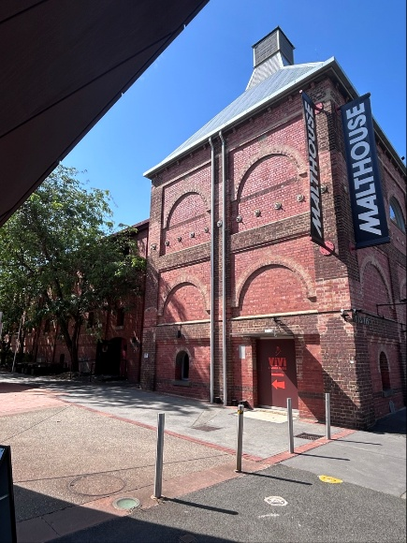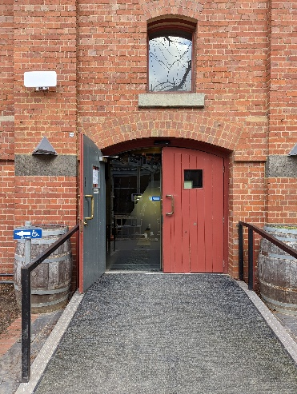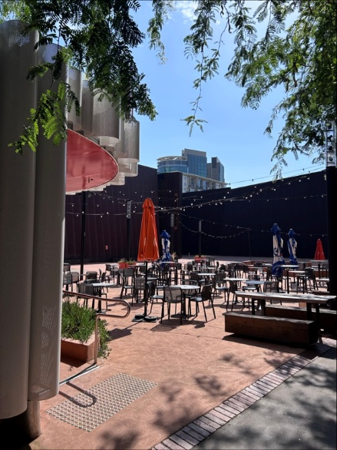

Entrance from Dodds Street side (wheelchair access)
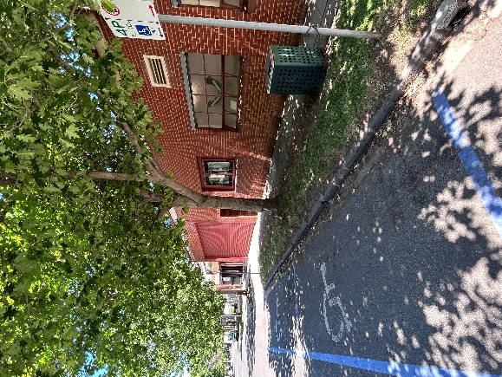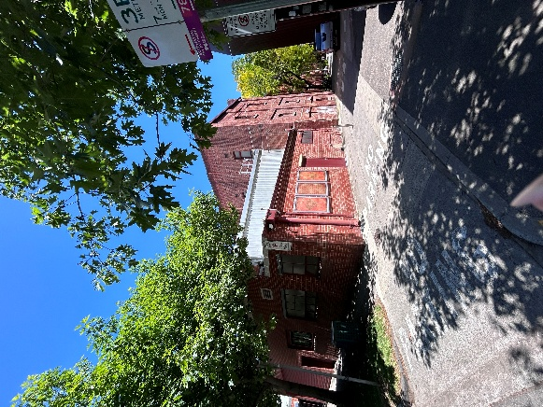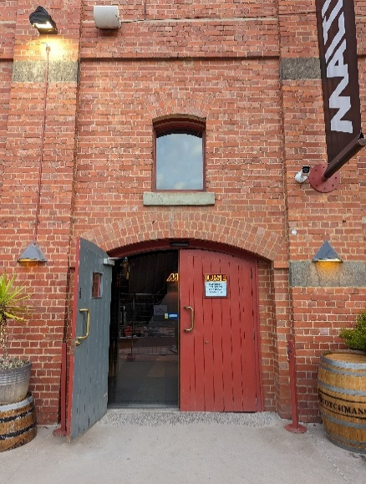

Bar and seating in the Foyer
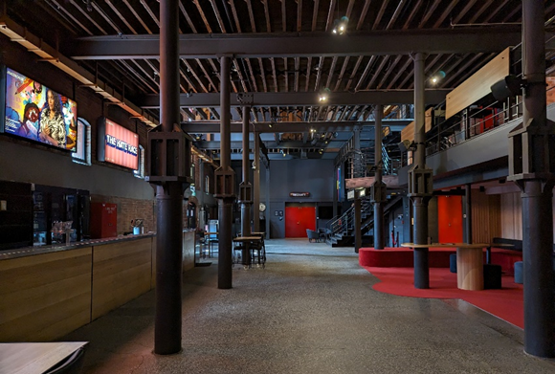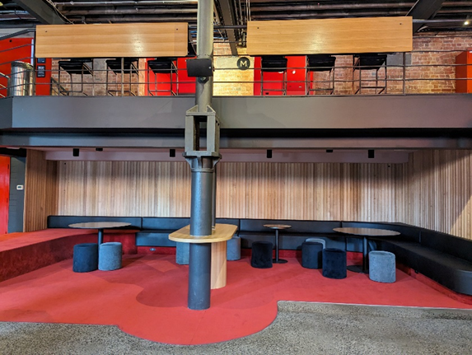

Box Office in the Foyer
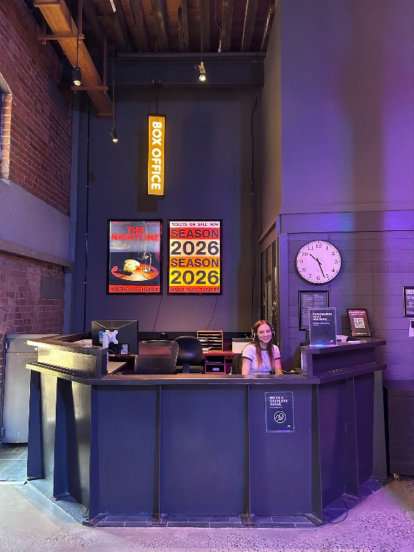

Bathrooms in Foyer (Ground Level)
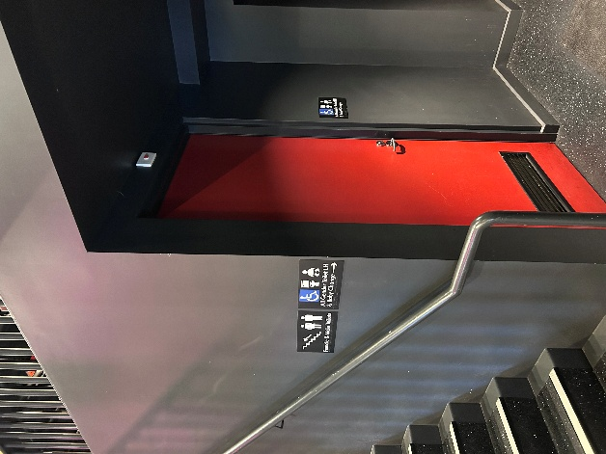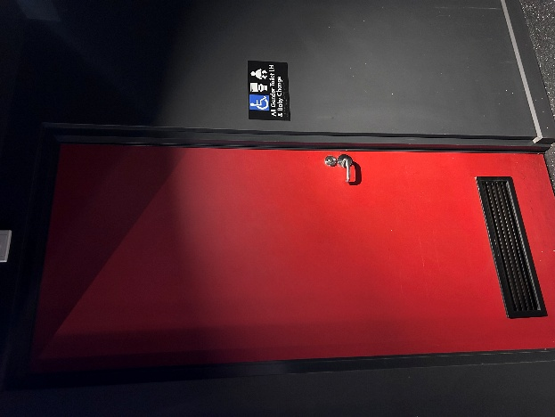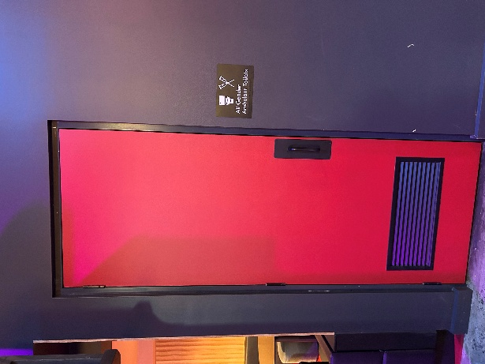

Bathrooms on Mezzanine (up a flight of stairs)
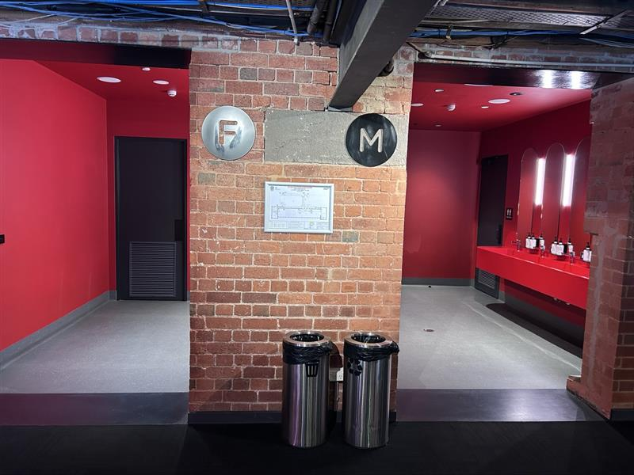

The bathrooms to the left have seated toilet stalls, an ambulant stall, and sanitary bins. The bathrooms to the right have seated stalls, urinals, an ambulant stall, and sanitary bins.
THEATRES
All theatres and spaces at the Malthouse are clearly marked. There are many staff members who will be able to assist you if you have any questions.

Merlyn Theatre
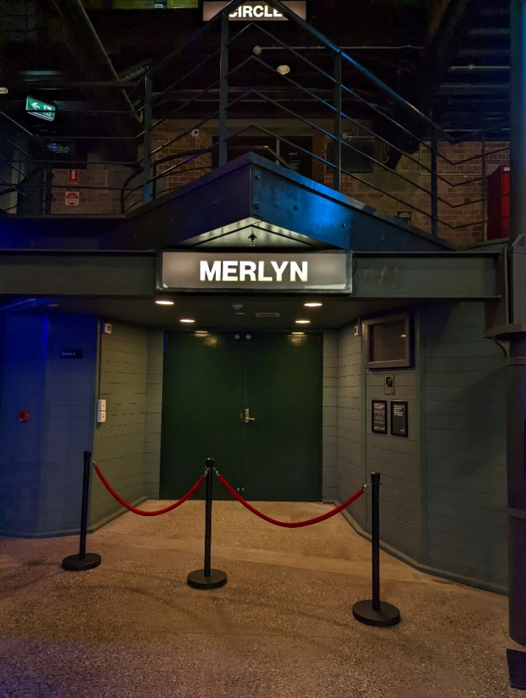
This entrance is wheelchair accessible.

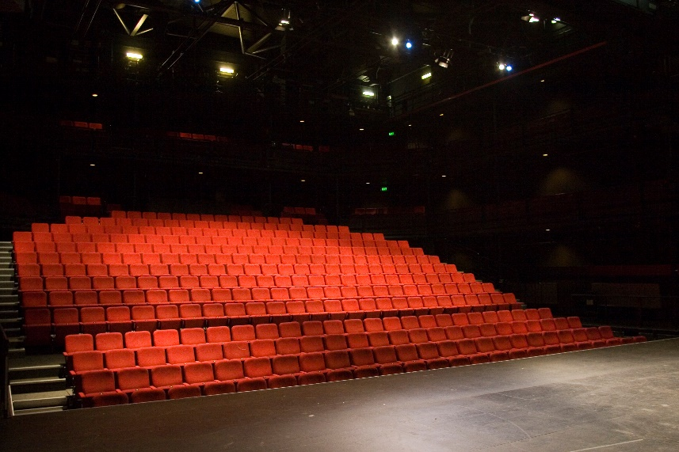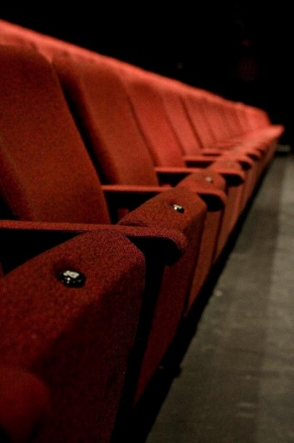

The theatre seats are organised in rows, labelled with letters from AA to M. Each seat also has a number on it. Your ticket will show which row and seat number you can sit in. The seating bank is not always in this configuration.

Beckett Theatre

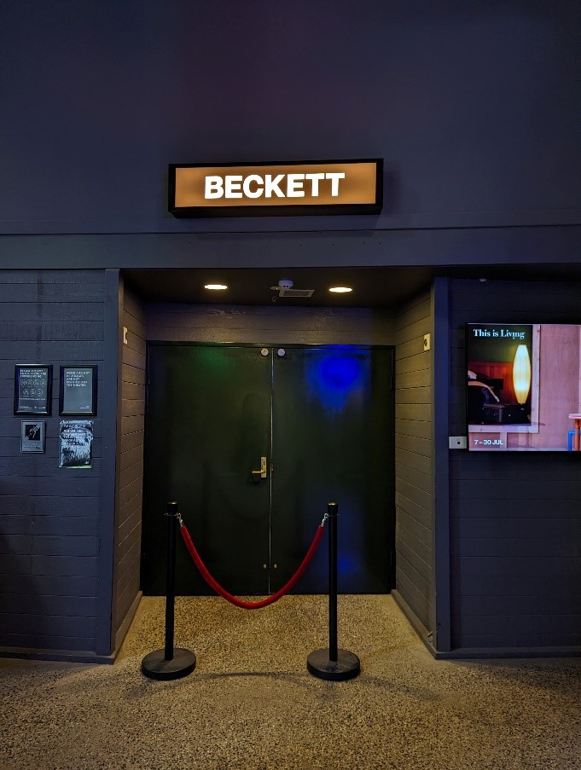

This entrance is wheelchair accessible.

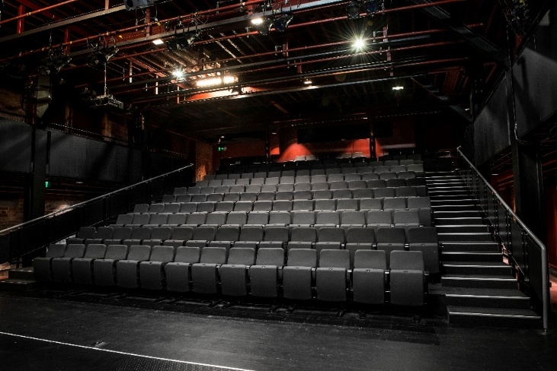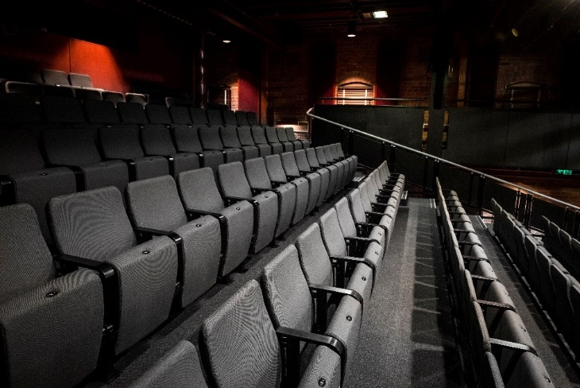

The theatre seats are organized in rows, labelled with letters from A to M. Each seat also has a number on it. Your ticket will show which row and seat number you can sit in.

WE’RE HERE TO ASSIST
If you need help finding your seat, or with anything else, you can ask a Malthouse Theatre Usher. Ushers wear a uniform of a black shirt with a lanyard.
