

**ACCESS PACK**

***The Orchard***

**By Pony Cam**

*Updated 4 August 2025*

**GENERAL INFORMATION**

Congratulations!

You’ve inherited a redundant cherry orchard, a crumbling climate, a failing economy and the final play written by Anton Chekhov. What will you salvage? How much are you willing to let go? How much will be taken from you?

Welcome to *The Orchard*, where doomed inheritances and impossible expectations collide. Choices must be made. Classics must be questioned. Wood must be chopped.

From the "frenetically uproarious" (Time Out) collective renowned for their ‘meticulously practiced feat[s] of coordinated effort’ (The Skinny) such as *Burnout Paradise* and *Grand Theft Theatre*, witness Pony Cam as they attempt to adapt Chekhov’s classic for an increasingly demanding world – and transform everything we hold dear along with it.

There will be real indecision, real stories, a person in a tree costume, a lot of cling wrap and a chainsaw borrowed from a friend.

Will you survive the adaptation?

**SEASON DETAILS**

The Orchard

By Pony Cam

**Dates:** 5 – 16 August 2016

**Duration:** Approximately 75 minutes, no interval

**Relaxed Performance:** There is no dedicated relaxed performance for this show, please talk to our Front of House or Box Office Team if you require assistance.

**Venue:** Beckett Theatre, The Malthouse, 113 Sturt Street, Southbank VIC 3006

**Company Website:** <https://www.malthousetheatre.com.au/>

**Malthouse Theatre Access Webpage**: <https://www.malthousetheatre.com.au/visit-us/access>

**Production Page**: <https://www.malthousetheatre.com.au/whats-on/season-2025/the-orchard>

**PERFORMANCE STYLE**

Pony Cam is a theatre collective known for its highly participatory and immersive performance style. Their work often blurs the line between performer and audience, creative communal, unpredictable experiences that are both playful and provocative.

*The Orchard* will embrace improvisation and invite audiences to witness – and perhaps influence – the unfolding drama.

While consensual participation is embedded into the performance, making each night a unique, communal experience, you are not required to participate if you do not wish to.

**CAST AND CREATIVES**

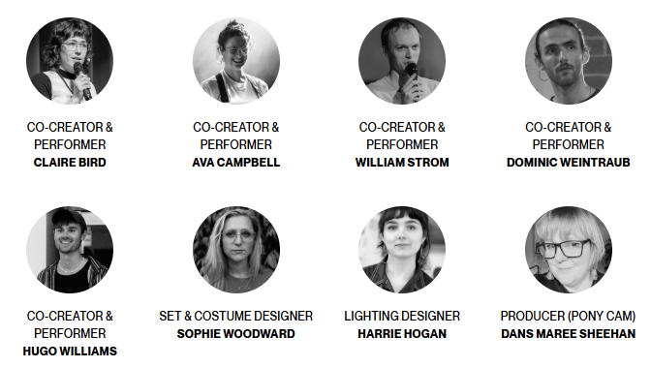

**ADDITIONAL BILLING NOTES**

*The Orchard* was commissioned and developed by Malthouse Theatre.

Pony Cam thanks La Mama Umbria International for generously supporting an artistic residency and development period in Italy, where valuable insights into *The Orchard* were gained and future collaborators were discovered.

**CONTENT INFORMATION**

This production contains:

* loud and dynamic sound
* smoke effects
* strobe and flashing lights
* adult themes
* coarse language
* partial nudity
* simulated alcohol consumption

While we do our best to inform audiences in advance about what to expect, the improvisational nature of *The Orchard* means we cannot guarantee the exact content of each performance.

Detailed content information is available here: <https://www.malthousetheatre.com.au/visit-us/content-warnings>

If you have specific questions or concerns about potential content, please contact our Box Office.

**ACCESS RATINGS**

**Aural Rating 50%** – has both sound and visual components, but sight isn’t essential to be able to engage with the event.

**Visual Rating 50%** – includes dialogue and background music or sounds, so Deaf and hard of hearing audiences can have some engagement with the event.

**HOW TO BOOK / CONTACT US**

Information about The Malthouse venue and *The Orchard* can be found on Malthouse Theatre’s **website** [www.malthousetheatre.com.au](http://www.malthousetheatre.com.au)

You can book tickets on the website or by calling the **Box Office** on (03) 9685 5111.

For more detailed access information, please feel free to contact our box office team on: [boxoffice@malthousetheatre.com.au](mailto:boxoffice@malthousetheatre.com.au)

We are committed to continual improvement and learning and welcome your feedback.

**VISUAL GUIDE**

**HOW TO GET TO MALTHOUSE**

The Malthouse is located at 113 Sturt Street in Southbank. You can get here by tram, train, bike or car.

|  |
| --- |
| **TRAM**  The closest tram stop is Stop 18 – Grant Street/Sturt Street (Route 1). You can also get to the venue from St Kilda Road. Get off at Stop 17 – Grant Street, Police Memorial/St Kilda Road. From this stop, it is a 6-minute walk to the venue via Grant Street.  A street with a fence and people walking  Description automatically generated  *Tram Stop 18, with ACCA and Malthouse distance* |

|  |
| --- |
| **TRAIN**  The closest train station is Flinders Street.  The walk from the station is approximately 12 minutes and covers about 1.2 km through Melbourne’s Arts Precinct.  The route is generally flat and pedestrian-friendly, with crosswalks. |

|  |
| --- |
| **BIKE**  There are bike racks and a Melbourne Bike Share station outside The Malthouse. |

|  |
| --- |
| **CAR**  There is limited on-street parking on Grant Street, Sturt Street and Dodds Street. There are 2  disabled spaces outside The Malthouse entrance on Sturt Street.  The closest secure carparks are:   * Arts Centre Melbourne Car Park (enter from Sturt Street) * The Australian Ballet Centre Car Park (2 Kavanagh Street) |

**VENUE IMAGES**

|  |  |
| --- | --- |
| Malthouse building, viewed from Sturt Street | |
| A brick building with a red door  Description automatically generated  Entry from Sturt Street side  (ramp access) | A brick building with a door open  Description automatically generated  Entry from Dodds Street side  (wheelchair access) |
| Foyer bar and seating | Foyer bar and seating |
| Foyer lounge seating | Box Office in Foyer |
| All gender bathroom in Foyer – wheelchair accessible with baby change station | A room with red walls and red doors  Description automatically generated  Bathrooms on Mezzanine (accessible via one flight of stairs). Bathrooms marked ‘F’ are cubicles, bathrooms marked ‘M’ have both cubicles and urinals. |

**THEATRES**

The Malthouse has three theatres, The Merlyn, The Beckett and the Tower Theatre.

All theatres and spaces at the Malthouse are clearly marked. There are many staff members who will be able to assist you if you have any questions.

The theatre seats are organized in rows, labelled with letters from AAA to M. Each seat also has a number on it. Your ticket will show which row and seat number you can sit in.

|  |  |
| --- | --- |
| Merlyn Theatre entrance on Ground Floor.  This entrance is wheelchair accessible. |   Pictures of inside the Merlyn Theatre. Please note, the seating may not always be set up in this configuration. |
| Theatre seats with number labels. |   Wheelchair position in the Merlyn Theatre. |
| A roped barrier in front of a building  Description automatically generated  Beckett Theatre entrance on Ground Floor.  This entrance is wheelchair accessible. | Inside the Beckett Theatre |

**WE ARE HERE TO ASSIST**

If you need help finding your seat, or with anything else, you can ask a Malthouse Theatre Usher. Ushers wear a uniform of a black shirt with a lanyard.

*****Pictured: Usher wearing their uniform.*