**ACCESS PACK**

***Troy***

**4 – 25 September 2025**

**VISUAL GUIDE: MALTHOUSE THEATRE**

**113 STURT STREET SOUTHBANK VIC 3006**

**GENERAL INFORMATION**

How far would you go to protect what you love?

Be transported to 12th century BCE, when gods walked among us, epic battles were fought on the sands of time and no one escaped the hand of violence. A great city will be invaded and the stories of its people screamed inside the great machine of war. Can you hear them?

Written by Tom Wright – renowned for his awe-inspiring adaptations *The Odyssey*, *Oedipus* and *Women of Troy* – and directed by Ian Michael (*Picnic at Hanging Rock*, *Stolen*), this is the legend of Troy like you’ve never seen it before. A powerhouse ensemble cast will take to a transformed theatre to deliver the most physically demanding and hauntingly poetic performance of their lives under the eyes of the Trojan horse.

Prepare to be struck with wonder as you experience the theatrical event of the season.

**DETAIL**

Troy

By Tom Wright   
Directed by Ian Michael

**Dates:** 2 – 25 September 2025

**Duration:** 110 minutes, no interval

**Relaxed Performance:** No dedicated relaxed performance, please talk to our Front of House or Box Office Team if you require assistance.

**Venue:** Merlyn Theatre, The Malthouse, 113 Sturt Street, Southbank VIC 3006

**Company Website:** <https://www.malthousetheatre.com.au/>

**Malthouse Theatre Access Webpage**: <https://www.malthousetheatre.com.au/visit-us/access>

**Event Page**:<https://www.malthousetheatre.com.au/whats-on/season-2025/troy>

**CAST AND CREATIVES**  
 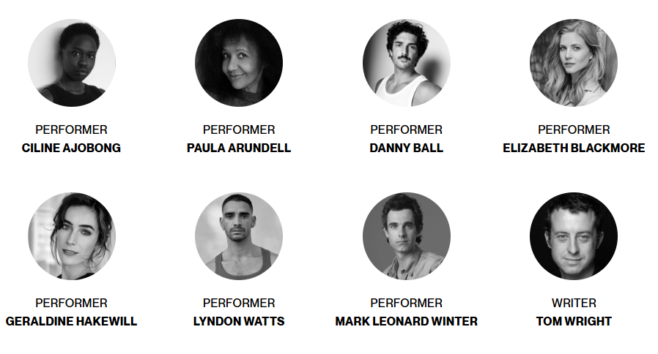

**CAST**

Iphigenia & Others / Ciline Ajobong

Hecuba & Others / Paula Arundell

Achilles & Others / Danny Ball

Cassandra & Others / Elizabeth Blackmore

Clytemnestra & Others / Geraldine Hakewill

Patroclus & Others / Lyndon Watts

Agamemnon & Others / Mark Leonard Winter

**CREATIVES**

Director / Ian Michael

Set & Costume Designer / Dann Barber

Lighting Designer / Paul Jackson

Composer / Rosalind Hall

Sound Designer / Marco Cher

Assistant Set & Costume Designer / Jodi Hope

Fight & Movement Director / Lyndall Grant

Intimacy Coordinator / Amy Cater

Voice & Text Coach / Mark Wong

Stage Manager / Jess Keepence

Assistant Stage Manager / Claudia Howarth

Assistant Stage Manager (cover) / Lyndie Li Wan Po

Lighting Operator / Rob Ballingall

Lighting Programmer / Rhys Pottinger

Sound Operator / Andrew Boswell

Costume Maker / Jo Foley

Miliner / Phillip Rhodes

Harp & Additional Vocals (Recorded) / Lucy Roleff

Directing Intern (VCA) / Simon Porro

Stage Management Intern (VCA) / Georgette Tétaz

Wardrobe Intern (VCA) / Asha Robinson

Key Campaign Image / Peter Tarasiuk

Original Campaign Image / Kristian Gehradte

Production Photography / Pia Johnson

Rehearsal Photography / Tavis Pinnington

**CONTENT & ACCESS RATINGS**

This production contains adult themes, coarse language, distressing depictions and descriptions of war, death, physical violence, drowning, reference to sexual assault, loud sounds including lengthy war-like soundscapes, smoke effects including herbal cigarettes, haze, and flashing lights. Some design elements of this show use small particles, including sand, powder and breadcrumbs.

Particles

The set for Troy is covered in a layer of sand and some special effects use bursts of Holi powder and gluten-free breadcrumbs; we don’t anticipate this reaching the audience, but the first few rows may be affected. Masks will be available on request.

War Depiction

The sound design for Troy uses source material from contemporary wars, including Gaza and Ukraine. Fake blood and fake weapons are used realistically during the production.

If this production raises concerns for you or someone you know, there is support available. Contact Beyond Blue (1300 224 636). Aboriginal and Torres Strait Islander people can contact 13 Yarn (13 92 76) or Yarning Safe’n’Strong (1800 959 563).

Aural Rating 50% – has both sound and visual components, but sight isn’t essential to be able to engage with the event.

Visual Rating 50% – includes dialogue and background music or sounds, so Deaf and hard of hearing audiences can have some engagement with the event.

**HOW TO BOOK / CONTACT US**

Information about The Malthouse venue and *Troy* can be found on Malthouse Theatre’s **website** [www.malthousetheatre.com.au](http://www.malthousetheatre.com.au)

You can book tickets on the website or by calling the **Box Office** on (03) 9685 5111.

For more detailed access information, please feel free to contact our box office team on: [boxoffice@malthousetheatre.com.au](mailto:boxoffice@malthousetheatre.com.au)

We are committed to continual improvement and learning and welcome your feedback.

**HOW TO GET TO THE MALTHOUSE**

*Pictured: The view of Stop 18 with Malthouse and ACCA in the distance* 

The Malthouse is located at 113 Sturt Street in Southbank. You can get here by tram, train, bike or car.

**Tram:** The closest tram stop is Stop 18 – Grant Street/Sturt Street (Route 1). You can also get to the venue from St Kilda Road. Get off at Stop 17 – Grant Street, Police Memorial/St Kilda Road. From this stop, it is a 6-minute walk to the venue via Grant Street.

**Train:** Flinders Street station is approximately 15-minute walk away.

**Bike:** There are bike racks and a Melbourne Bike Share station outside The Malthouse.

**Car:** There is limited on-street parking on Grant Street, Sturt Street and Dodds Street. There are 2 disabled spaces outside The Malthouse entrance on Sturt Street.

The closest secure carparks are:

* Arts Centre Melbourne Car Park (enter from Sturt Street)
* The Australian Ballet Centre Car Park (2 Kavanagh Street)

**VENUE IMAGES**  
  
Entrance from Sturt Street side

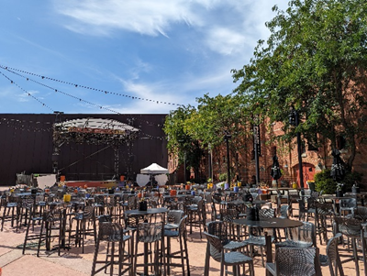 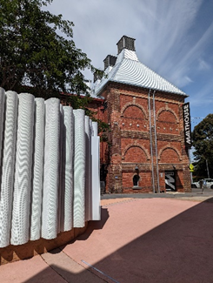

Entrance from Dodds Street side (wheelchair access)

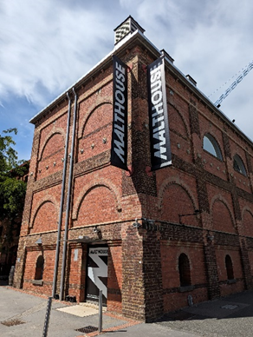

Bar and seating in the Foyer

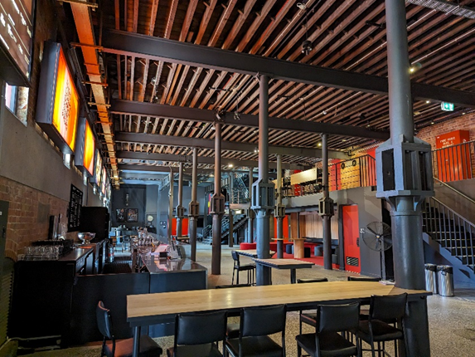

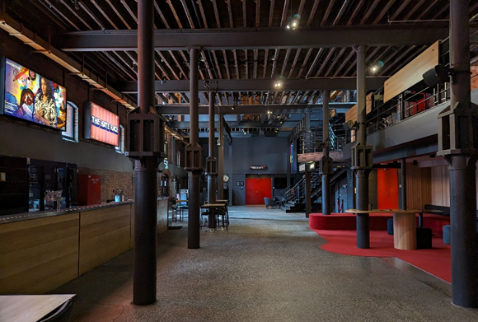

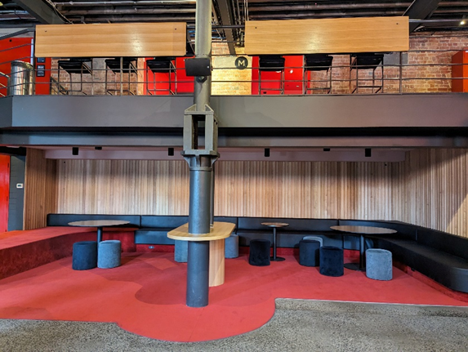

Box Office in the Foyer

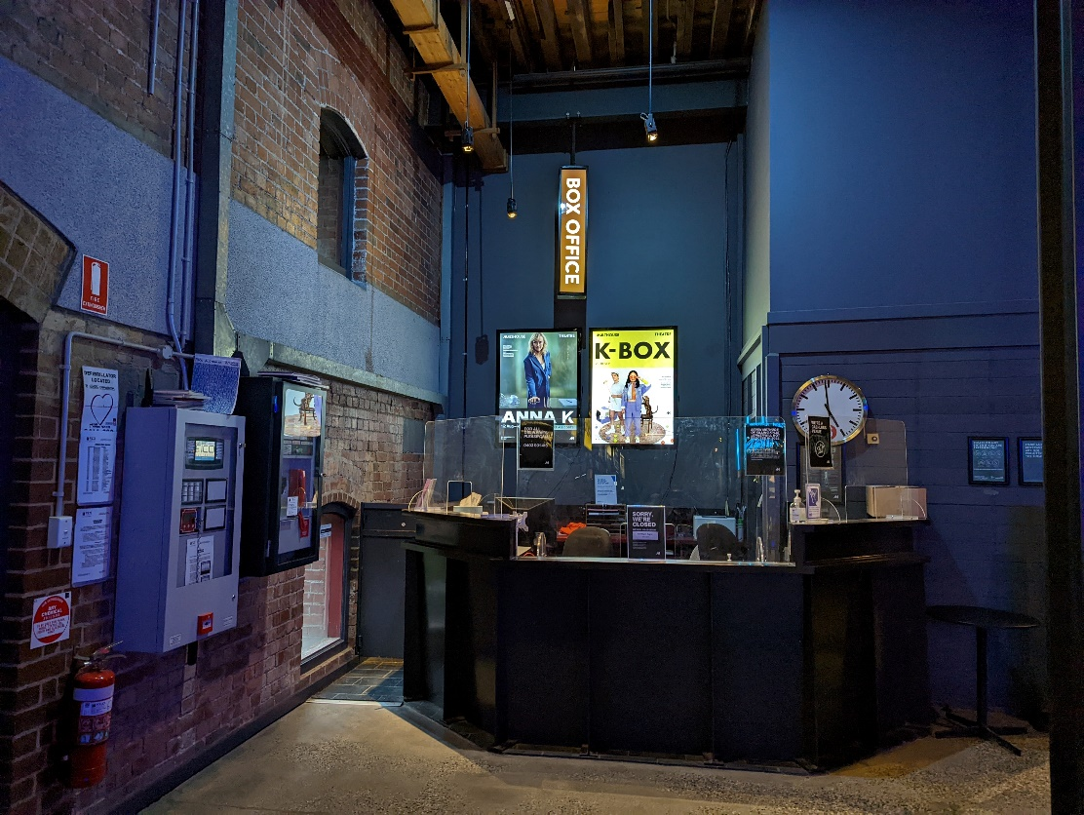

Bathroom in Foyer (Ground Level)

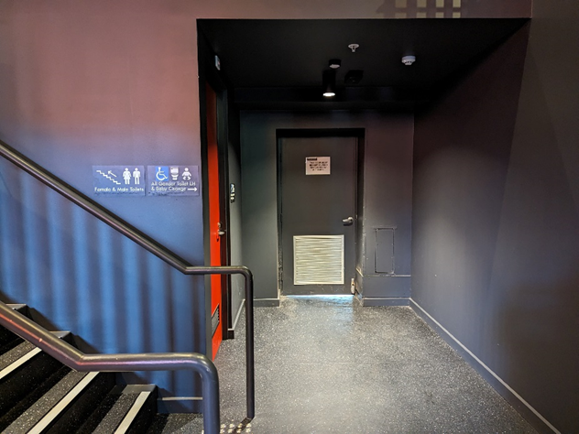

*All gender toilet, Baby Change*

Bathrooms on Mezzanine (up a flight of stairs)

**THEATRES**

The Malthouse has three theatres, The Merlyn, The Beckett and the Tower Theatre.

All theatres and spaces at the Malthouse are clearly marked. There are many staff members who will be able to assist you if you have any questions.

**Merlyn Theatre entrance**

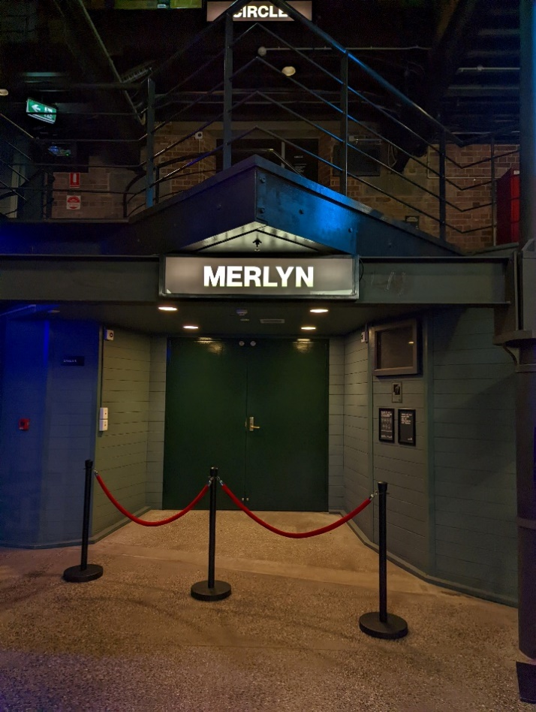

*This entrance is wheelchair accessible.*

*Below is a picture of inside the Merlyn Theatre*, the seats are not always in this configuration. 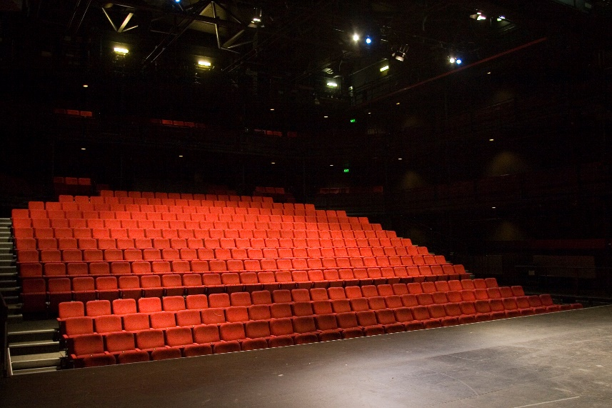

The theatre seats are organized in rows, labelled with letters from AAA to M. Each seat also has a number on it. Your ticket will show which row and seat number you can sit in.

Pictured: theatre seats with number labels

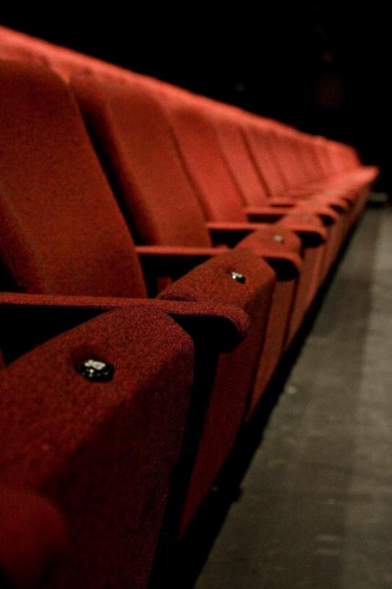

**Beckett Theatre entrance**

This entrance is wheelchair accessible.

*Below is a picture of inside the Beckett Theatre*

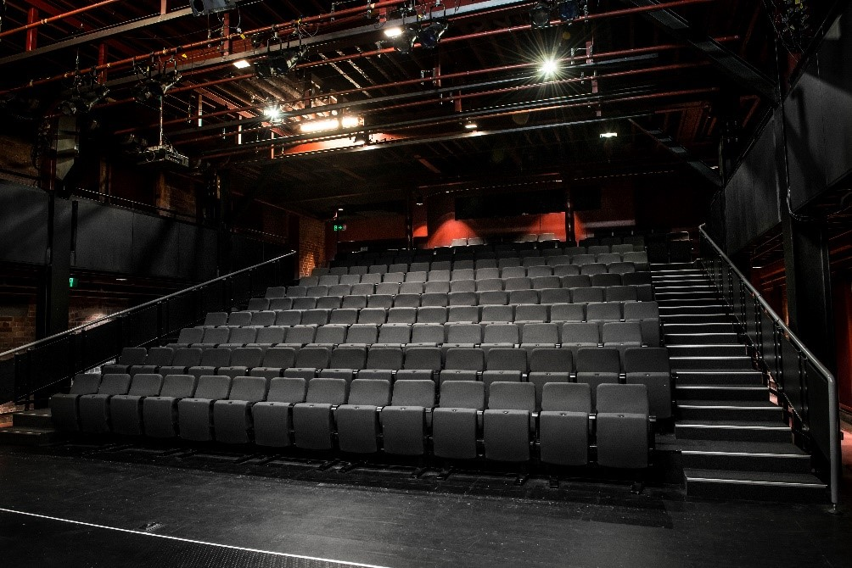

The theatre seats are organized in rows, labelled with letters from A to M. Each seat also has a number on it. Your ticket will show which row and seat number you can sit in.

Pictured: theatre seats with number labels

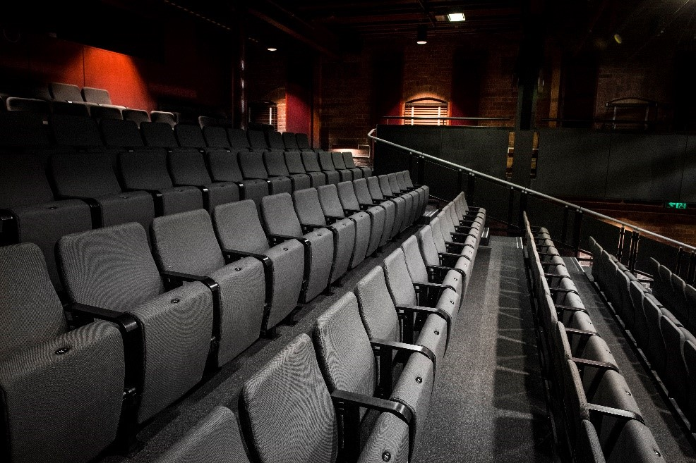

**WE’RE HERE TO ASSIST**

If you need help finding your seat, or with anything else, you can ask a Malthouse Theatre Usher. Ushers wear a uniform of a black shirt with a lanyard.

**Pictured:** Usher wearing their uniform.