ACCESS PACK
Game. Set. Match.
1 – 23 May 2026

VISUAL GUIDE: MALTHOUSE THEATRE
113 STURT STREET SOUTHBANK VIC 3006
CONTENTS

- General information
- Season details
- Community Night
- Time to Talk
- Content warnings
- Access ratings
- How to book / contact us
- Cast and Creatives
- How to get to Malthouse
- Venue images

GENERAL INFORMATION

A rom-com about tennis with a little bit of blood. And, strawberries.
Ray meets Joshua. She’s cleaning up after his mother’s funeral, he makes a mess clumsily coming in late. As they flirt over styrofoam cups, their banter builds into something more, something as exciting as the tennis game playing on the radio in the room.
Over one balmy, boozy night in January watching the Aus Open semi-final at the local, Ray leads Joshua into an explosive game of will-they-or-won’t-they. But this is a game of two halves and it’s not over until the umpire says ‘match’.
Past secrets are uncovered. Strawberry stains are scrubbed off tennis whites. True colours are revealed. Who is playing a game, and who is about to get played?
Do not miss this explosive new production from proud Gamilaroi woman and award-winning playwright Megan Wilding (Australian Offence Force, A Little Piece of Ash); a mind-blowing thriller about bodies living their past. You’ve never seen revenge served like this.

SEASON DETAILS

Game. Set. Match.
Written by Megan Wilding
Directed by Jessica Arthur

Dates: 1 – 23 May 2026
Community Night: Monday 4 May, 7pm
Time to Talk: Tuesday 12 May, 7pm
Venue: Beckett Theatre, Malthouse, 113 Sturt Street, Southbank VIC 3006
Company Website: https://www.malthousetheatre.com.au/
Malthouse Theatre Access Webpage: https://www.malthousetheatre.com.au/visit-us/access
Event Page: https://www.malthousetheatre.com.au/whats-on/season-2026/game-set-match

COMMUNITY NIGHT
Monday 4 May, from 6pm (show starts 7pm)
The Game. Set. Match. Community Night invites First Nations audiences to come along to the performance on Monday 4 May and join us for complimentary tea and coffee before and after the show. First Nations jewellery designer Haus of Dizzy will also be doing a pop-up store, selling their “Kiss My Ace” tennis range from 6pm before the show.

Aboriginal and Torres Strait Islander community members can purchase $25 tickets to the performance on Community Night when you book via our website.

There is also an allocation of free tickets available to Mob across every performance of Game. Set. Match. (including Community Night). Submit your request for free MobTix HERE.

TIME TO TALK
Tuesday 12 May, 7pm

Time to Talk is a post-show Q&A, where audience are welcome to stay after the show for a hosted discussion with the show’s cast and creatives. This is an optional offering, with a short break after the show before the event starts to allow audience to depart if desired.

CONTENT WARNINGS

This production contains:

- Explicit descriptions of sexual assault
- Graphic violence
- Discussion of racism
- Racial slurs
- Strong coarse language
- Simulated use of drugs
- A prop gun
- Fake blood

For detailed content information, please visit: https://www.malthousetheatre.com.au/visit-us/content-warnings

ACCESS RATINGS

Aural Rating 50% – has both sound and visual components, but sight isn’t essential to be able to engage with the event.

Visual Rating 50% – includes dialogue and background music or sounds, so Deaf and hard of hearing audiences can have some engagement with the event.

HOW TO BOOK / CONTACT US

Information about The Malthouse venue and this production can be found on Malthouse Theatre’s website www.malthousetheatre.com.au

You can book tickets on the website or by calling the Box Office on (03) 9685 5111.

For more detailed access information, please feel free to contact our box office team on: boxoffice@malthousetheatre.com.au

We are committed to continual improvement and learning and welcome your feedback.

CAST AND CREATIVES

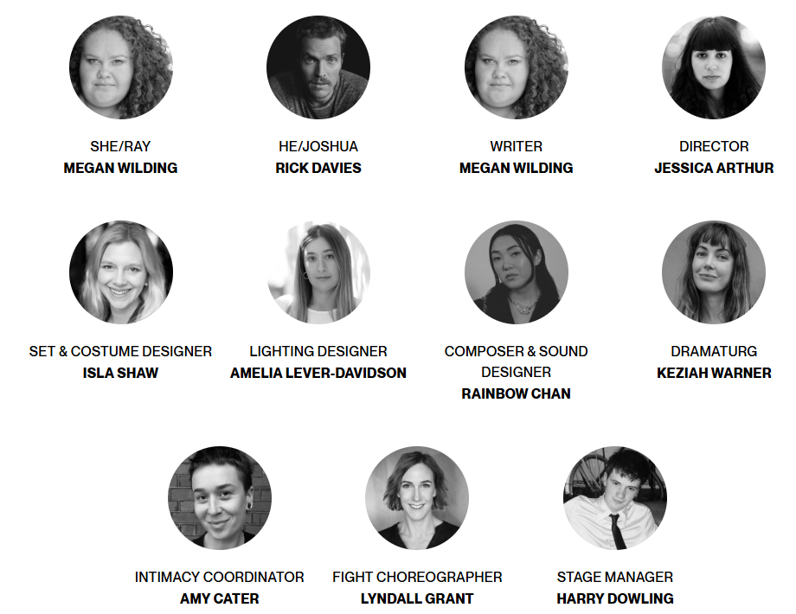

CAST

SHE/RAY Megan Wilding
HE/JOSHUA Rick Davies

CREATIVES

DIRECTOR Jessica Arthur
SET & COSTUME DESIGNER Isla Shaw
LIGHTING DESIGNER Amelia Lever-Davidson
COMPOSER & SOUND DESIGNER Rainbow Chan
DRAMATURG Keziah Warner
INTIMACY COORDINATOR Amy Cater
FIGHT CHOREOGRAPHER Lyndall Grant
STAGE MANAGER Harry Dowling

HOW TO GET TO MALTHOUSE
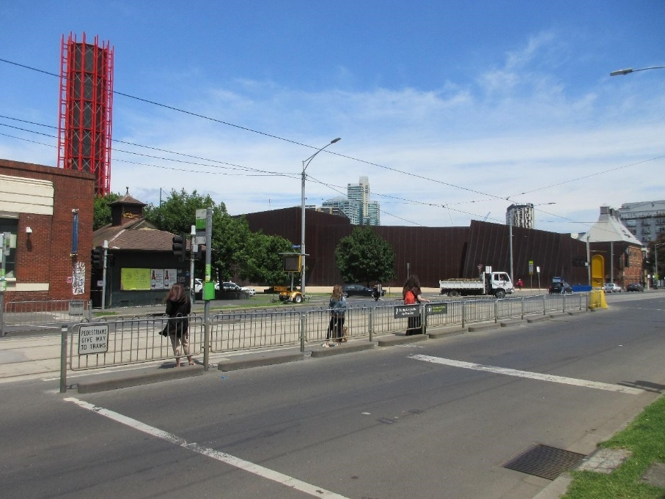
Pictured: The view of Stop 18 with Malthouse and ACCA in the distance
The Malthouse is located at 113 Sturt Street in Southbank. You can get here by tram, train, bike or car.

Tram: The closest tram stop is Stop 18 – Grant Street/Sturt Street (Route 1), however this is not wheelchair accessible. You can also get to the venue from St Kilda Road. Get off at Stop 17 – Grant Street, Police Memorial/St Kilda Road – a wheelchair accessible stop. From this stop, it is a 6-minute walk to the venue via Grant Street.

Train: Flinders Street station is approximately 15-minute walk away.

Bike: There are bike racks and a Melbourne Bike Share station outside The Malthouse.

Car: There is limited on-street parking on Grant Street, Sturt Street and Dodds Street. There are 2 disabled spaces outside The Malthouse entrance on Sturt Street.

The closest secure carparks are:
- Arts Centre Melbourne Car Park (enter from Sturt Street)
- The Australian Ballet Centre Car Park (2 Kavanagh Street)

VENUE IMAGES
Entrance from Sturt Street side
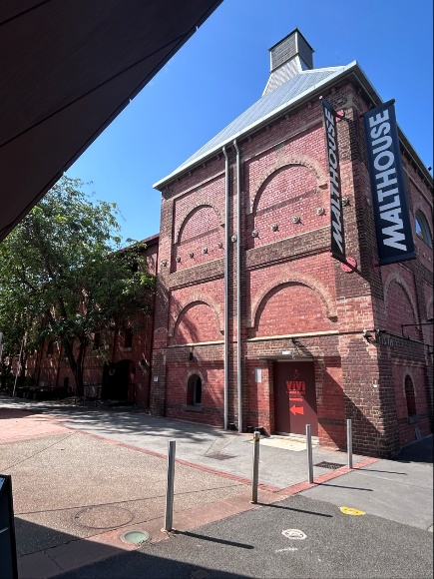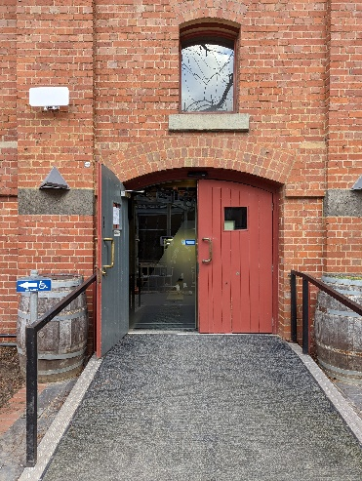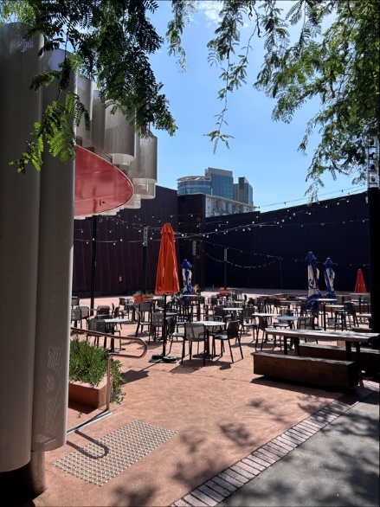

Entrance from Dodds Street side (wheelchair access)
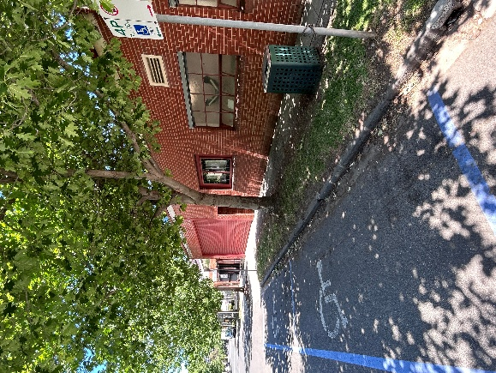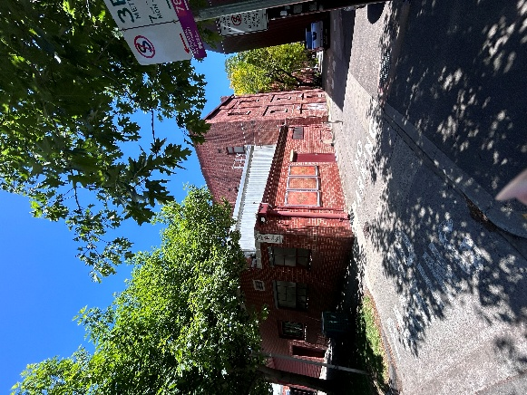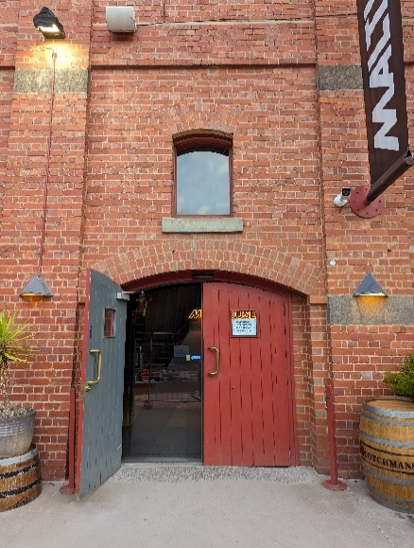

Bar and seating in the Foyer
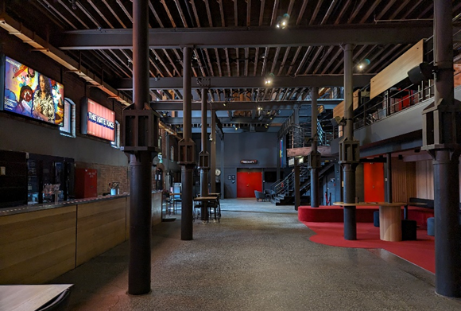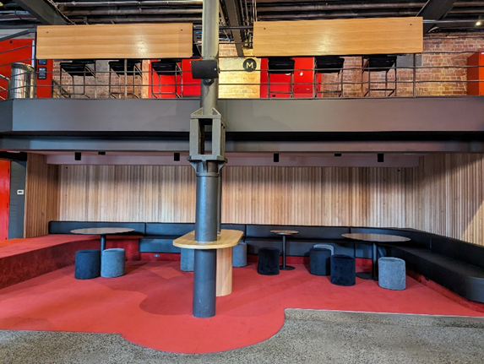

Box Office in the Foyer
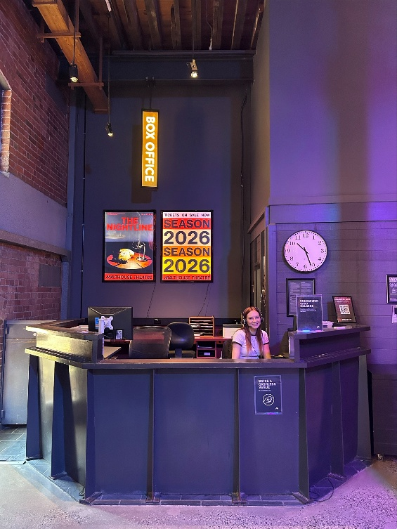

Bathrooms in Foyer (Ground Level)
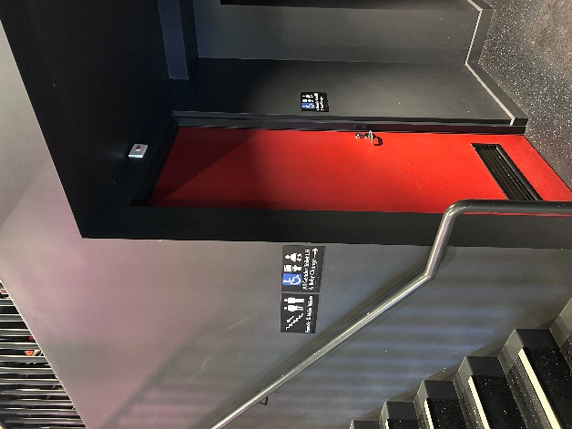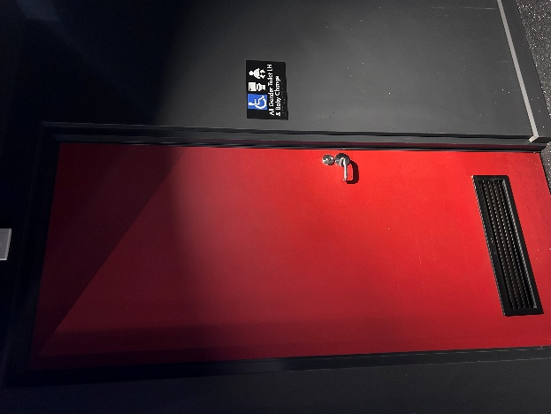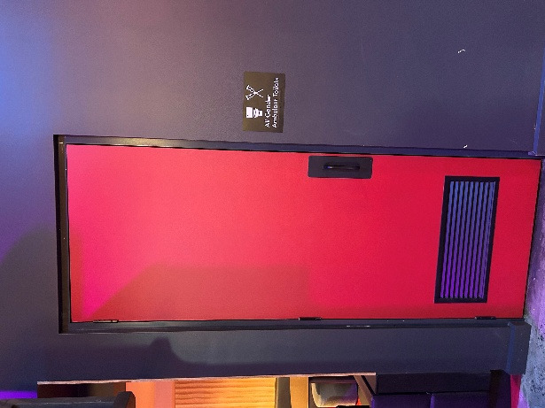

Bathrooms on Mezzanine (up a flight of stairs)
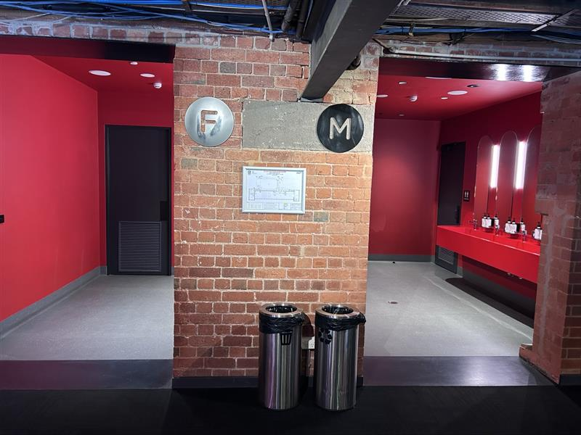

The bathrooms to the left have seated toilet stalls, an ambulant stall, and sanitary bins. The bathrooms to the right have seated stalls, urinals, an ambulant stall, and sanitary bins.
THEATRES
All theatres and spaces at the Malthouse are clearly marked. There are many staff members who will be able to assist you if you have any questions.

Merlyn Theatre
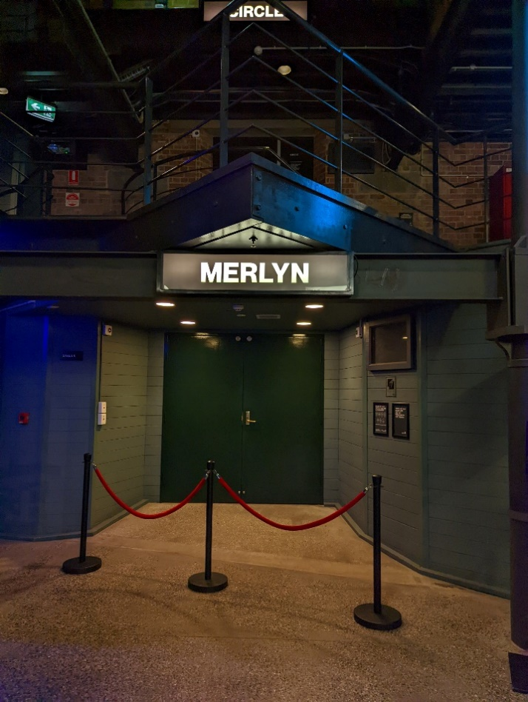
This entrance is wheelchair accessible.

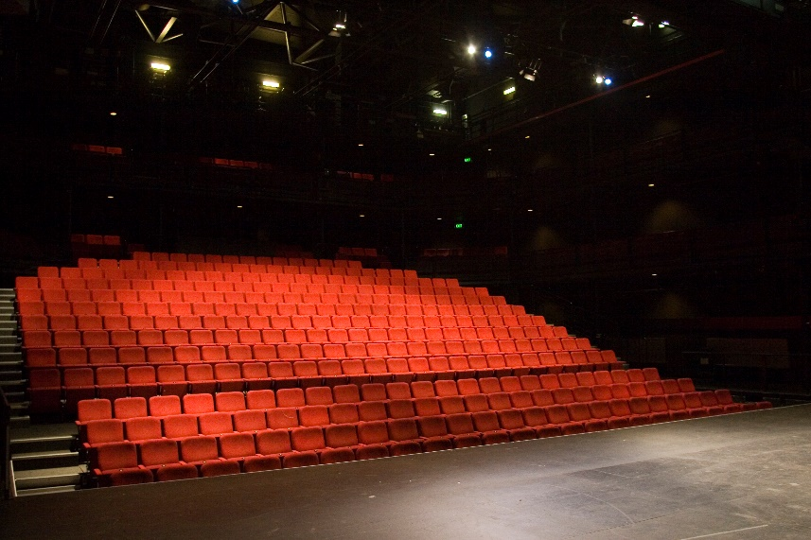

The theatre seats are organised in rows, labelled with letters from AA to M. Each seat also has a number on it. Your ticket will show which row and seat number you can sit in. The seating bank is not always in this configuration.

Beckett Theatre

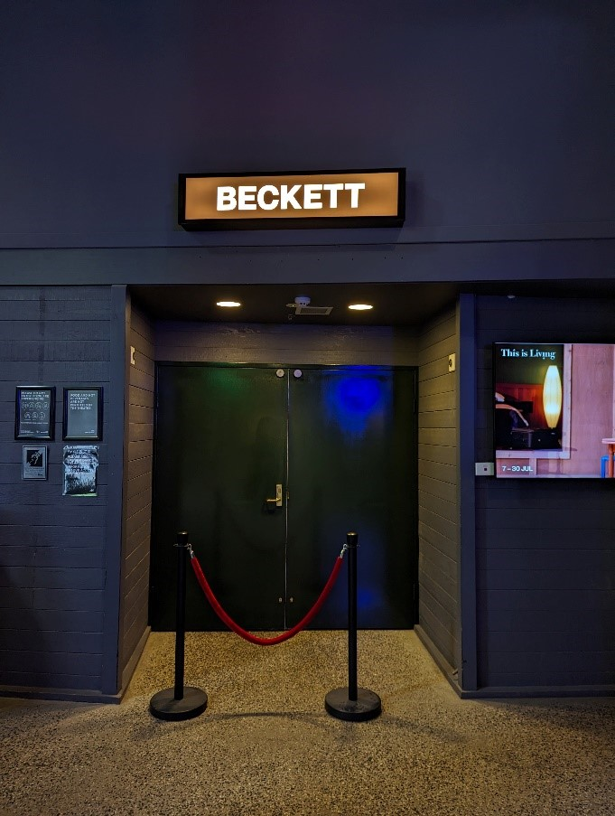

This entrance is wheelchair accessible.

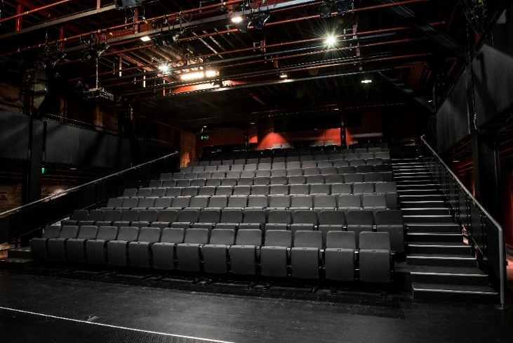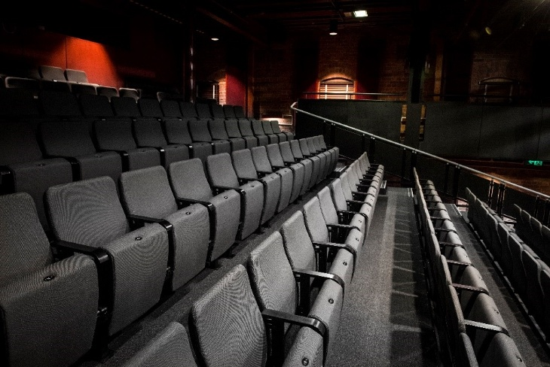

The theatre seats are organized in rows, labelled with letters from A to M. Each seat also has a number on it. Your ticket will show which row and seat number you can sit in.

WE’RE HERE TO ASSIST
If you need help finding your seat, or with anything else, you can ask a Malthouse Theatre Usher. Ushers wear a uniform of a black shirt with a lanyard.
