ACCESS PACK
Meow Meow’s The Red Shoes
19 November – 6 December 2025

VISUAL GUIDE: MALTHOUSE THEATRE
113 STURT STREET SOUTHBANK VIC 3006
GENERAL INFORMATION

From a chorus of hairy fauns to singing swans and showgirl stars, experience an unforgettable, frenetic song-and-dance into meaning.
Having wowed New York's Carnegie Hall, the world-renowned performer behind Meow Meow’s Little Match Girl and Meow Meow’s Little Mermaid now urgently remedies ‘The Red Shoes’. This fairytale by Hans Christian Andersen brutally punished its covetous protagonist with an ever-dancing curse that propelled her far from heaven’s gates. Meow Meow asks: what if she could never start dancing at all? Can we save her? Can we save the world?!
A musical celebration that will shock you out of stagnancy and into ecstatic oblivion from ‘the queen of chanson’ (Berliner Zeitung) with ‘devilish funny bones and heavenly vocal chords’ (Evening Standard UK), Meow Meow.
Leave in love with life again.
Remember why you wanted to dance in the first place.
DETAIL

Meow Meow’s The Red Shoes
Created by Meow Meow
Directed by Kate Champion

Dates: 19 November – 6 December 2025

Duration: Approximately 90 minutes, no interval
Relaxed Performance: No dedicated relaxed performance, please talk to our Front of House or Box Office Team if you require assistance.

Venue: Merlyn Theatre, The Malthouse, 113 Sturt Street, Southbank VIC 3006

Company Website: https://www.malthousetheatre.com.au/

Malthouse Theatre Access Webpage: https://www.malthousetheatre.com.au/visit-us/access

Event Page: https://www.malthousetheatre.com.au/whats-on/season-2025/meow-meows-the-red-shoes

CAST AND CREATIVES

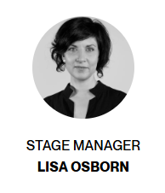
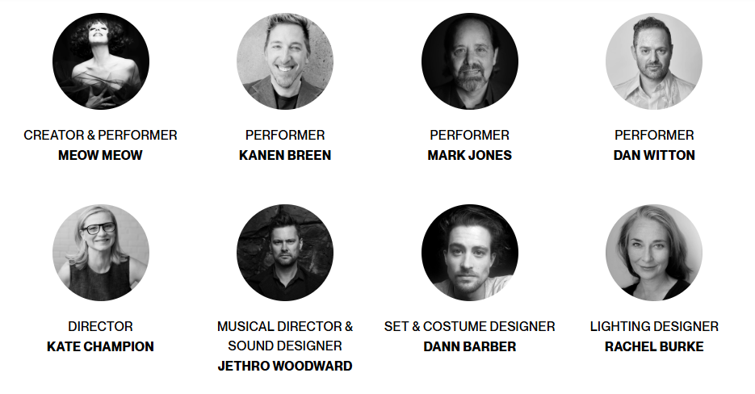
CAST

Meow Meow
Kanen Breen
Mark Jones
Dan Witton
Jethro Woodward

CREATIVES

Creator / Meow Meow
Director / Kate Champion
Musical Director & Sound Designer / Jethro Woodward
Set & Costume Designer / Dann Barber
Lighting Designer / Rachel Burke

Stage Manager / Lisa Osborn

Scenic Art / Patrick Jones
Costume Construction / Jo Foley
Costume Construction / Ra Stewart
Millinery / Philip Rhodes
Art Finishing / Nell Ferguson

Key Campaign Image / Karl Giant
Rehearsal Photography / Charlie Kinross

CONTENT & ACCESS RATINGS

This production contains mild coarse language, haze, smoke effects, and strobe lighting.

Aural Rating 50% – has both sound and visual components, but sight isn’t essential to be able to engage with the event.

Visual Rating 50% – includes dialogue and background music or sounds, so Deaf and hard of hearing audiences can have some engagement with the event.

HOW TO BOOK / CONTACT US

Information about The Malthouse venue and this production can be found on Malthouse Theatre’s website www.malthousetheatre.com.au

You can book tickets on the website or by calling the Box Office on (03) 9685 5111.

For more detailed access information, please feel free to contact our box office team on: boxoffice@malthousetheatre.com.au

We are committed to continual improvement and learning and welcome your feedback.

HOW TO GET TO THE MALTHOUSE
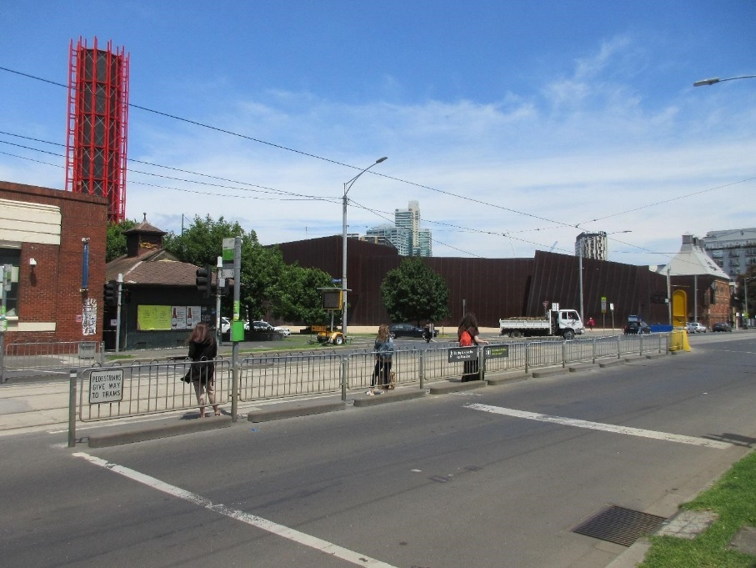
Pictured: The view of Stop 18 with Malthouse and ACCA in the distance
The Malthouse is located at 113 Sturt Street in Southbank. You can get here by tram, train, bike or car.

Tram: The closest tram stop is Stop 18 – Grant Street/Sturt Street (Route 1). You can also get to the venue from St Kilda Road. Get off at Stop 17 – Grant Street, Police Memorial/St Kilda Road. From this stop, it is a 6-minute walk to the venue via Grant Street.

Train: Flinders Street station is approximately 15-minute walk away.

Bike: There are bike racks and a Melbourne Bike Share station outside The Malthouse.

Car: There is limited on-street parking on Grant Street, Sturt Street and Dodds Street. There are 2 disabled spaces outside The Malthouse entrance on Sturt Street.

The closest secure carparks are:
- Arts Centre Melbourne Car Park (enter from Sturt Street)
- The Australian Ballet Centre Car Park (2 Kavanagh Street)

VENUE IMAGES
Entrance from Sturt Street side
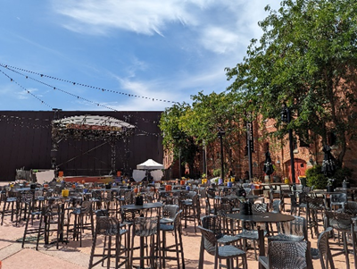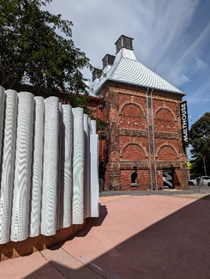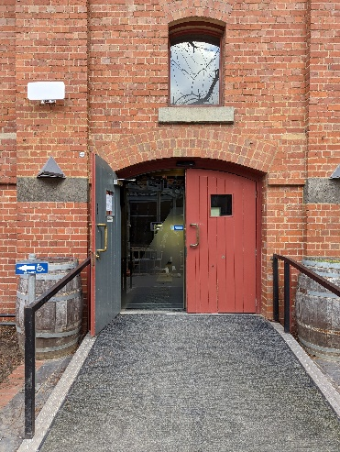

Entrance from Dodds Street side (wheelchair access)
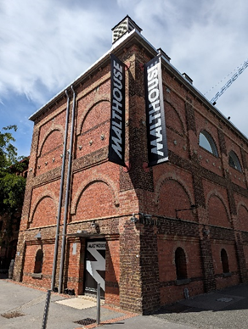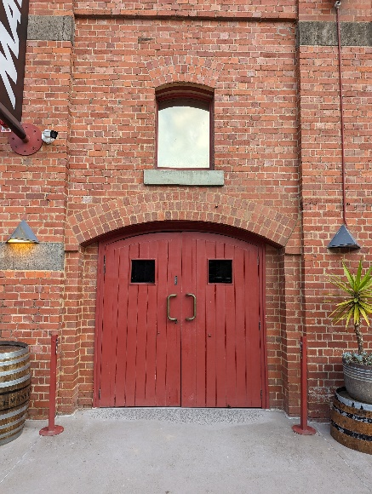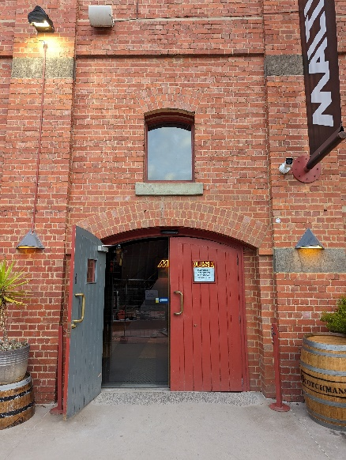

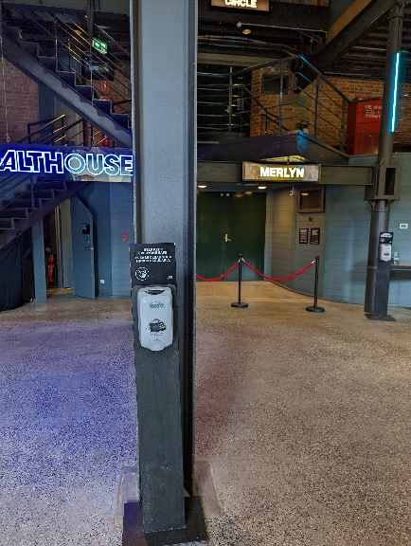
Sanitiser station in the Foyer
Bar and seating in the Foyer
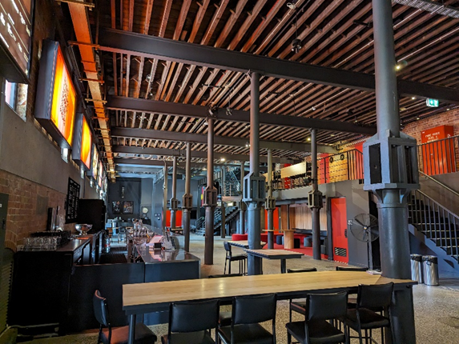
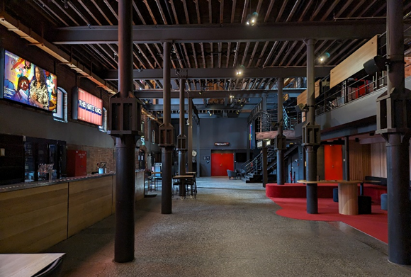

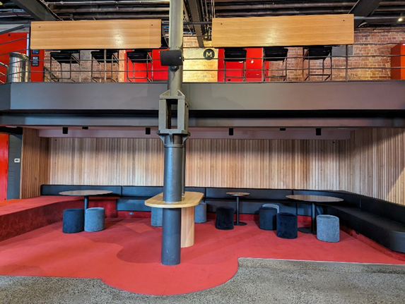

Box Office in the Foyer
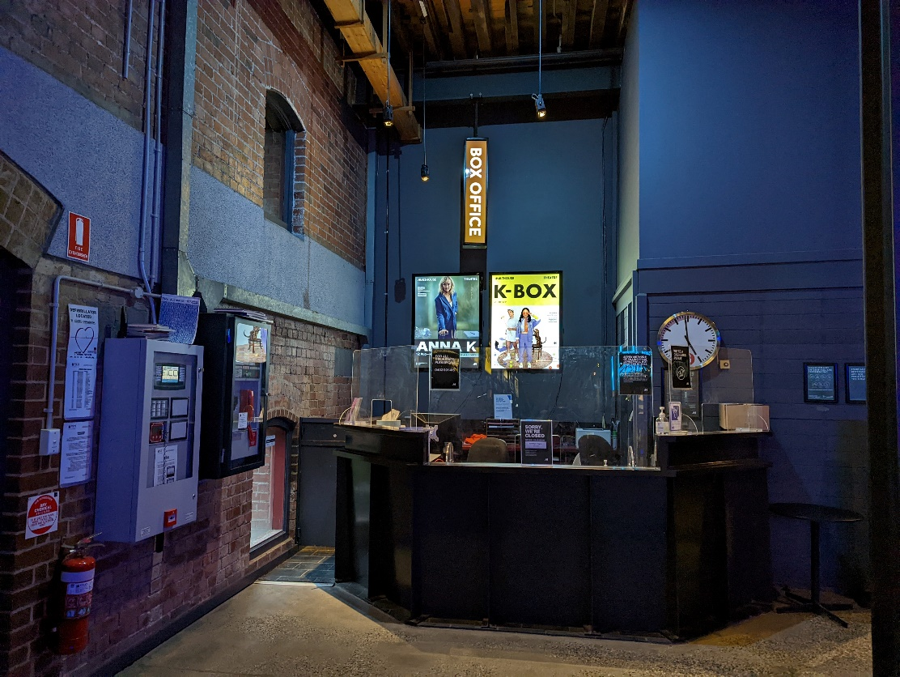

Bathroom in Foyer (Ground Level)

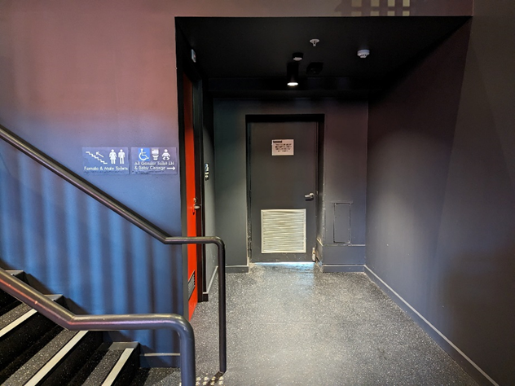
All gender toilet, Baby Change

Bathrooms on Mezzanine (up a flight of stairs)

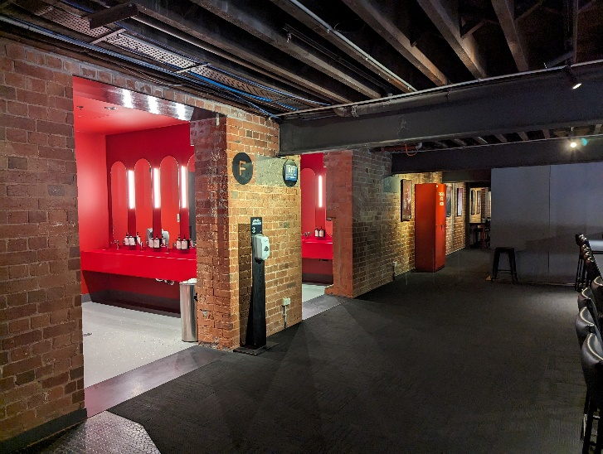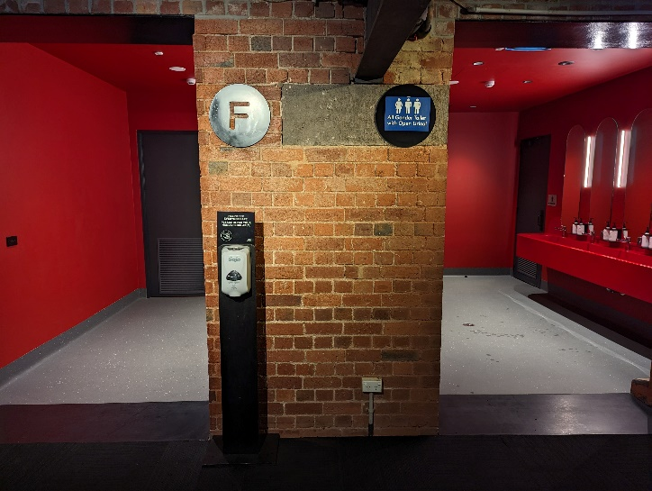

THEATRES
The Malthouse has three theatres, The Merlyn, The Beckett and the Tower Theatre.

All theatres and spaces at the Malthouse are clearly marked. There are many staff members who will be able to assist you if you have any questions.

Merlyn Theatre entrance

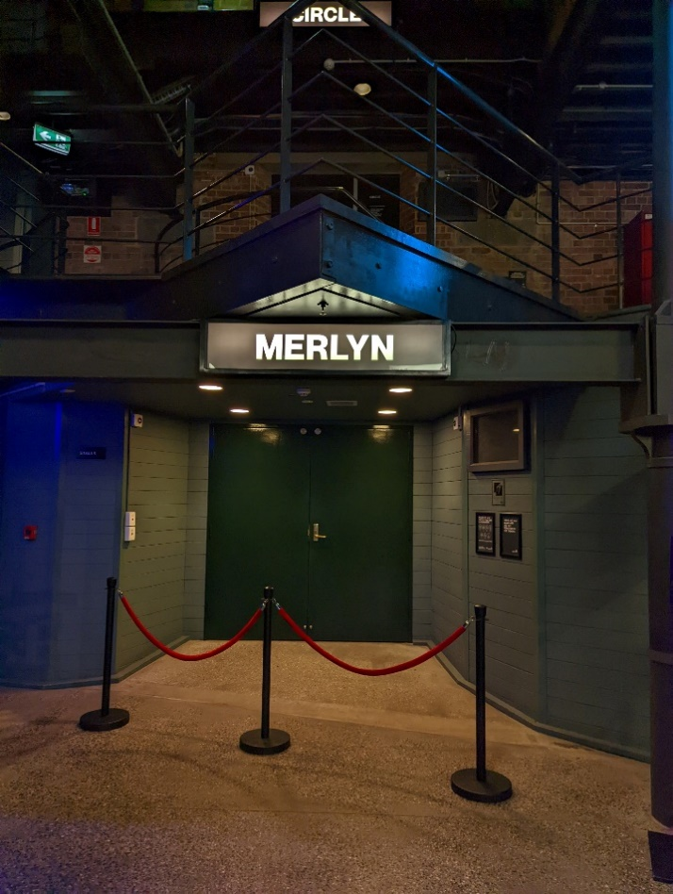
This entrance is wheelchair accessible.

Below is a picture of inside the Merlyn Theatre, the seats are not always in this configuration. 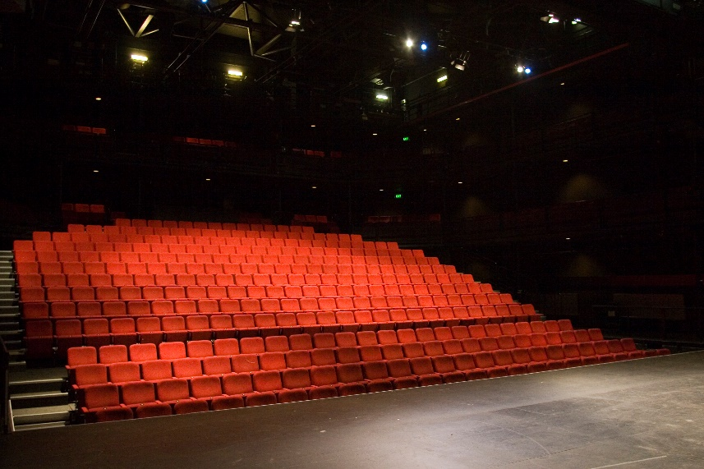

The theatre seats are organized in rows, labelled with letters from AAA to M. Each seat also has a number on it. Your ticket will show which row and seat number you can sit in.

Pictured: theatre seats with number labels

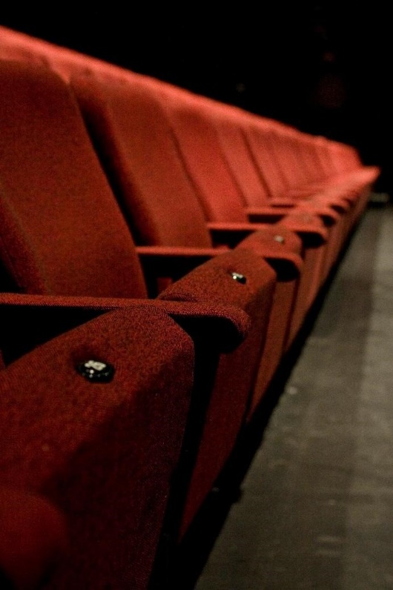

Beckett Theatre entrance
This entrance is wheelchair accessible.
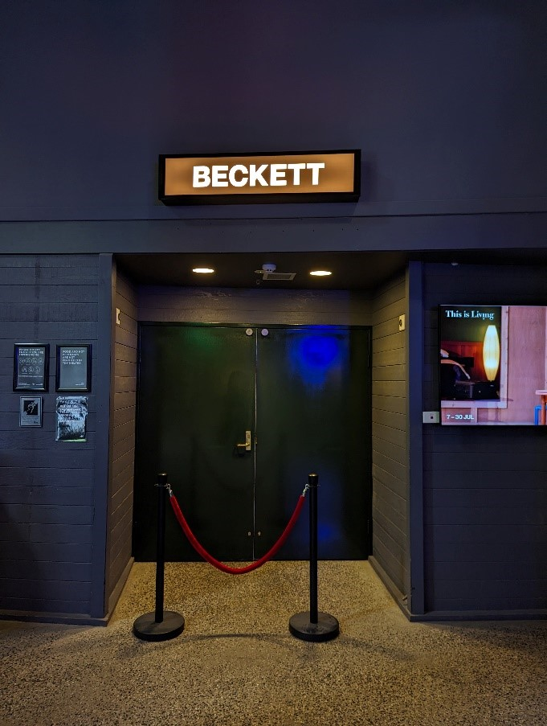

Below is a picture of inside the Beckett Theatre

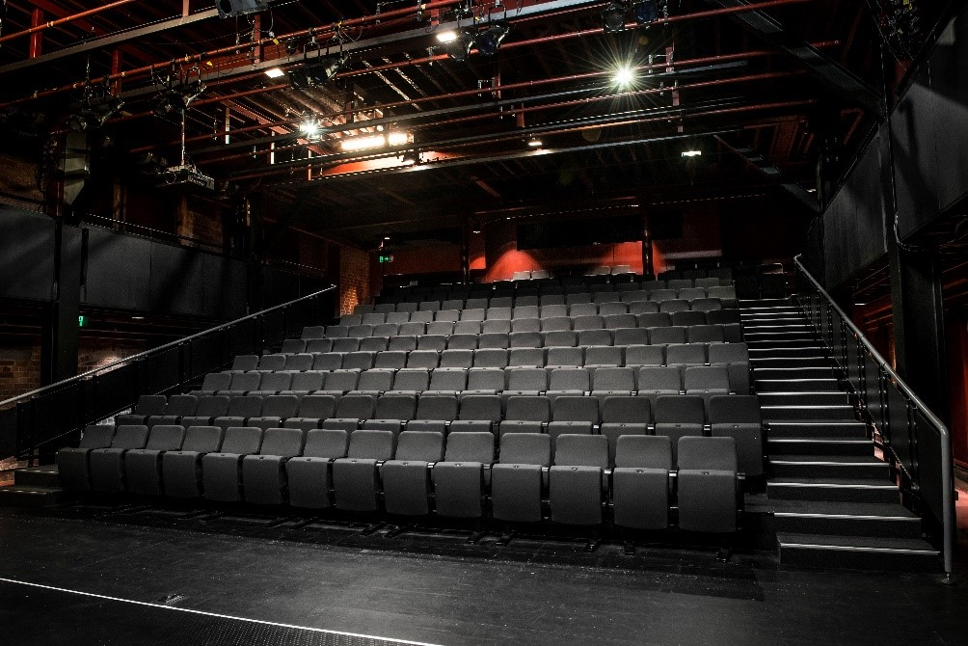

The theatre seats are organized in rows, labelled with letters from A to M. Each seat also has a number on it. Your ticket will show which row and seat number you can sit in.

Pictured: theatre seats with number labels

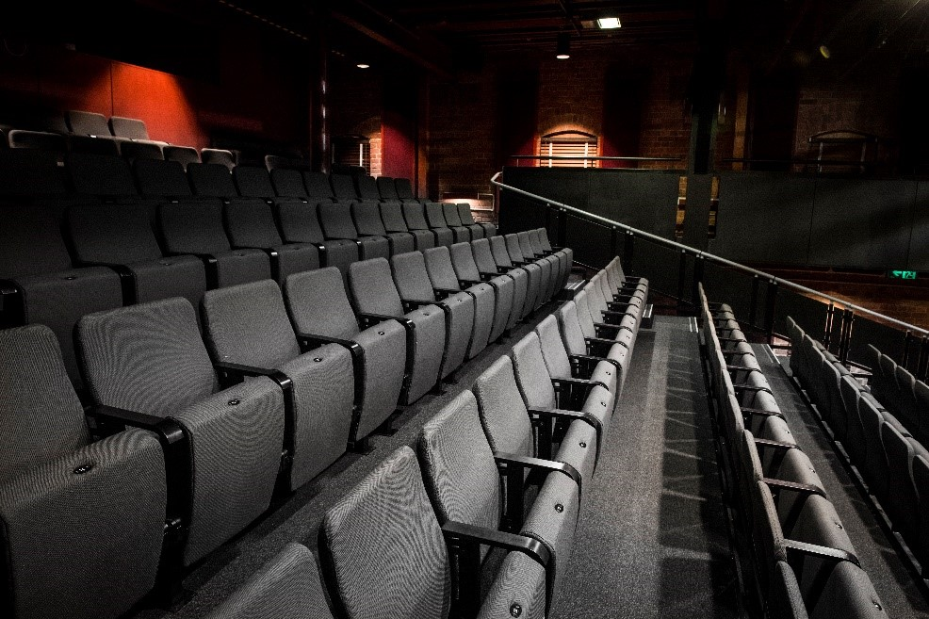

WE’RE HERE TO ASSIST
If you need help finding your seat, or with anything else, you can ask a Malthouse Theatre Usher. Ushers wear a uniform of a black shirt with a lanyard.
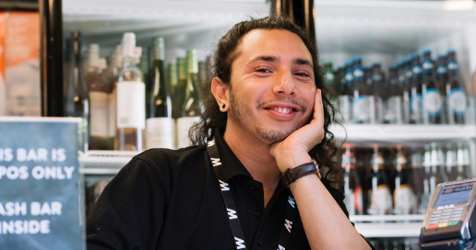
Pictured: Usher wearing their uniform.

