ACCESS PACK
Black Light
13 February – 7 March 2026

VISUAL GUIDE: MALTHOUSE THEATRE
113 STURT STREET SOUTHBANK VIC 3006
CONTENTS

- General information
- Season details
- Community Night
- Captioned Performance
- Content warnings
- Access ratings
- How to book / contact us
- Cast and Creatives
- How to get to Malthouse
- Venue images

GENERAL INFORMATION

In a family home on the outskirts of Darwin, four Larrakia mothers find themselves stuck together, on the precipice of a drastically changing world.
Black Light is a play about finding our way back to ourselves, to Country and to the people we love, when everything else tries to tear us apart.
Things are uneasy in town. No one’s sure what’s going on, or how long it’s going to last. Fuel is scarce, so is water, military jets fly overhead and all other flights are grounded. The only choice they have is to wait it out. Together. The eldest in the family is Nan – she has dementia and finds it difficult to make sense of the world. The youngest is Bub. Recently separated from their wife, Bub is struggling to find stability and parent alone. Aunty and Mum are sisters and yet polar opposites. They nitpick at each other, barely able to conceal their disdain. There's so much history between them all, so much water under the bridge, and none of it clean. What emerges while they wait, are the deeply ingrained fears they're all carrying. The pain and the wisdom. In the stillness, it all seems ever-present. But Country is speaking louder now and it cannot be ignored.
Black Light is written by renowned playwright Jada Alberts (writer and director of Aretha: A Love Letter, Brothers Wreck and director of Seven Stages of Grieving) and stars sisters Rachael and Lisa Maza, as well as Tahlee Fereday and Trisha Morton-Thomas. This work brings you on a deeply personal journey as it explores the complexities of intergenerational wisdom, trauma and survival in a colonial world.
SEASON DETAILS

Black Light
Written and Directed by Jada Alberts

Dates: 13 February – 7 March 2026
Community Night: Monday 16 February, 6:30pm
Captioned performance: Saturday 21 February, 2:00pm
Venue: Merlyn Theatre, Malthouse, 113 Sturt Street, Southbank VIC 3006
Company Website: https://www.malthousetheatre.com.au/
Malthouse Theatre Access Webpage: https://www.malthousetheatre.com.au/visit-us/access
Event Page: https://www.malthousetheatre.com.au/whats-on/season-2026/black-light

COMMUNITY NIGHT
Monday 16 February, 6.30pm
The Black Light Community Night invites First Nations audiences to come along to the performance on Monday 16 February and join us for a special celebration after the show.

Aboriginal and Torres Strait Islander community members can purchase $25 tickets to the performance on Community Night when you book via our website.

There is also an allocation of free tickets available to Mob across every performance of Black Light (including Community Night). Submit your request for free MobTix HERE.

CAPTIONED PERFORMANCE
Saturday, 21 February at 2pm (open and closed captioning)

Captioning offers an accurate text display of a performance, making it accessible for patrons who are d/Deaf, hard of hearing, or culturally and linguistically diverse.

In partnership with The Captioning Studio we provide open and closed captioning services for specific performances.

OPEN CAPTIONING

Open captioning is captioning displayed on large TV screens positioned either on or to the side of the stage. Generally, performances in our Merlyn Theatre will have two screens, and those in the Beckett Theatre will have one.
For open captioned performances, you do not need to bring any technology of your own.

CLOSED CAPTIONING

Closed captioning is provided for specific performances and can be accessed from any seat in the Theatre using the GoTheatrical App on a personal device (i.e. a compatible smartphone or tablet). You can download and check the app requirements on the GoTheatrical website.

CONTENT WARNINGS

This production contains:

- adult themes
- coarse language
- depiction of natural disasters
- references to domestic violence
- colonial violence and racism
- moments of dynamic sound
- flashing lights
- smoke effects

For detailed content information, please visit: https://www.malthousetheatre.com.au/visit-us/content-warnings

ACCESS RATINGS

Aural Rating 50% – has both sound and visual components, but sight isn’t essential to be able to engage with the event.

Visual Rating 50% – includes dialogue and background music or sounds, so Deaf and hard of hearing audiences can have some engagement with the event.

HOW TO BOOK / CONTACT US

Information about The Malthouse venue and this production can be found on Malthouse Theatre’s website www.malthousetheatre.com.au

You can book tickets on the website or by calling the Box Office on (03) 9685 5111.

For more detailed access information, please feel free to contact our box office team on: boxoffice@malthousetheatre.com.au

We are committed to continual improvement and learning and welcome your feedback.

CAST AND CREATIVES

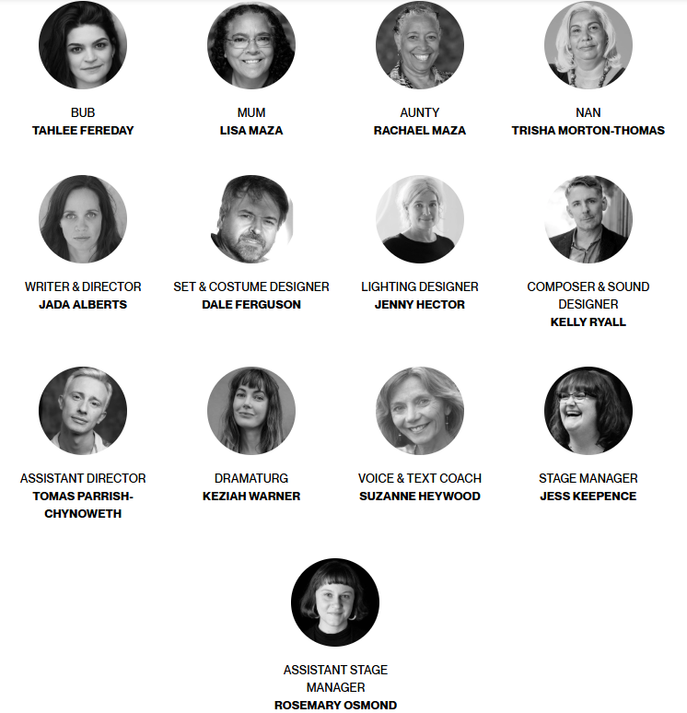

CAST

BUB / Tahlee Fereday
MUM / Lisa Maza
AUNTY / Rachael Maza
NAN / Trisha Morton-Thomas
STANDBY / Ella Ferris

CREATIVES

DIRECTOR / Jada Alberts
SET & COSTUME DESIGNER / Dale Ferguson
LIGHTING DESIGNER / Jenny Hector
COMPOSER & SOUND DESIGNER / Kelly Ryall
ASSISTANT DIRECTOR / tomas parrish-chynoweth
DRAMATURG / Keziah Warner
VOICE & TEXT COACH / Suzanne Heywood
STAGE MANAGER / Jess Keepence
ASSISTANT STAGE MANAGER / Rosemary Osmond
SCENIC ART / Patrick Jones
LX PROGRAMMER / Jamie Turner
SOUND OPERATOR / Eugene Mackinnon
HOW TO GET TO MALTHOUSE
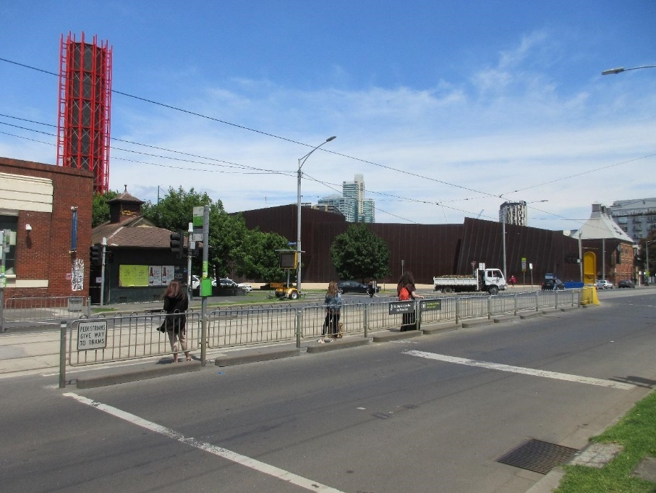
Pictured: The view of Stop 18 with Malthouse and ACCA in the distance
The Malthouse is located at 113 Sturt Street in Southbank. You can get here by tram, train, bike or car.

Tram: The closest tram stop is Stop 18 – Grant Street/Sturt Street (Route 1), however this is not wheelchair accessible. You can also get to the venue from St Kilda Road. Get off at Stop 17 – Grant Street, Police Memorial/St Kilda Road – a wheelchair accessible stop. From this stop, it is a 6-minute walk to the venue via Grant Street.

Train: Flinders Street station is approximately 15-minute walk away.

Bike: There are bike racks and a Melbourne Bike Share station outside The Malthouse.

Car: There is limited on-street parking on Grant Street, Sturt Street and Dodds Street. There are 2 disabled spaces outside The Malthouse entrance on Sturt Street.

The closest secure carparks are:
- Arts Centre Melbourne Car Park (enter from Sturt Street)
- The Australian Ballet Centre Car Park (2 Kavanagh Street)

VENUE IMAGES
Entrance from Sturt Street side
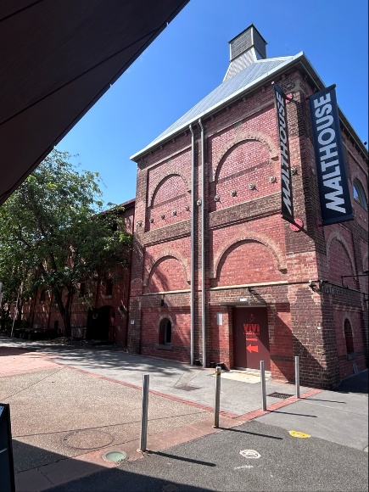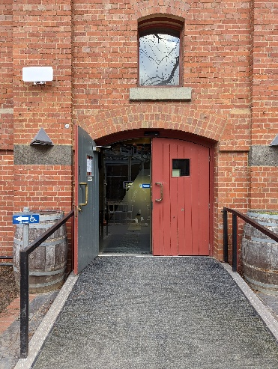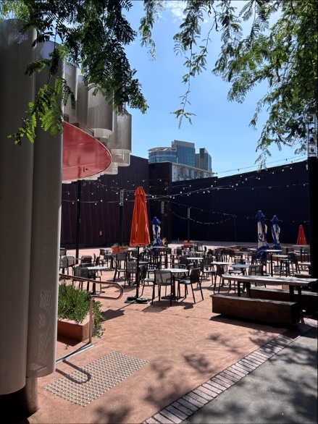

Entrance from Dodds Street side (wheelchair access)
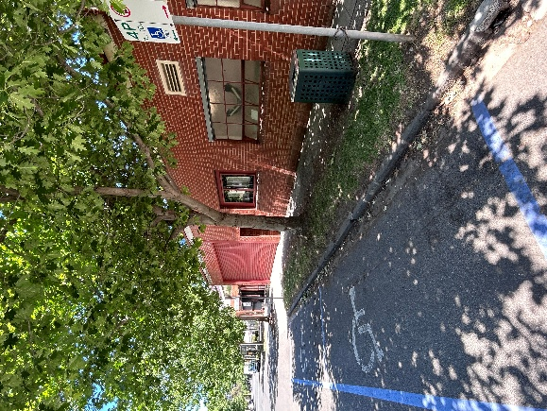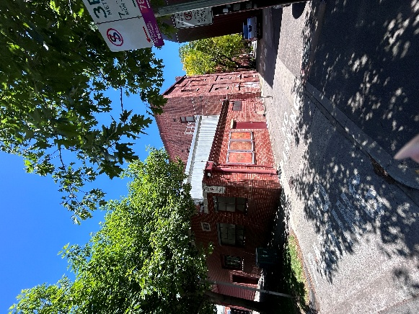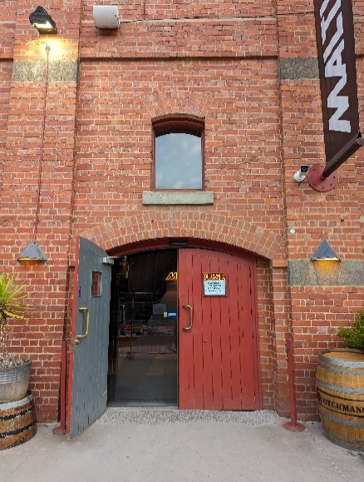

Bar and seating in the Foyer
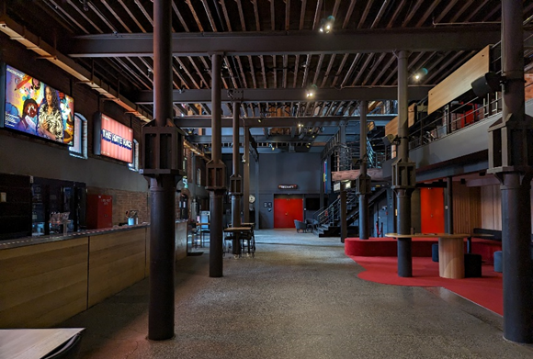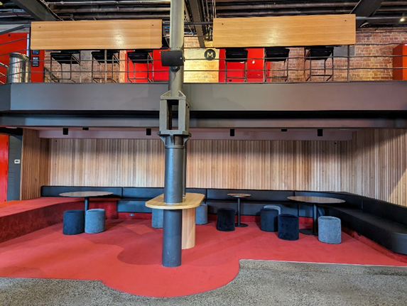

Box Office in the Foyer
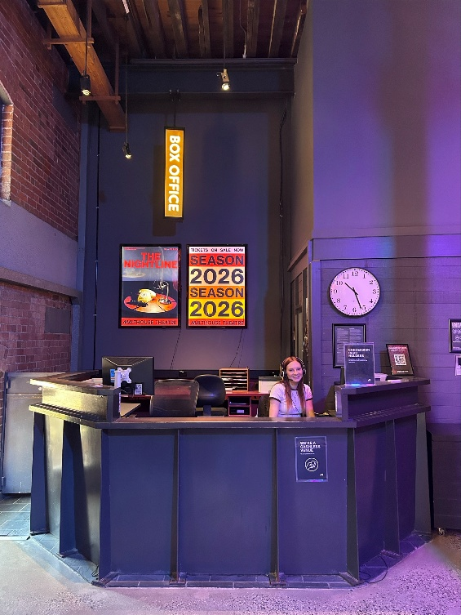

Bathrooms in Foyer (Ground Level)
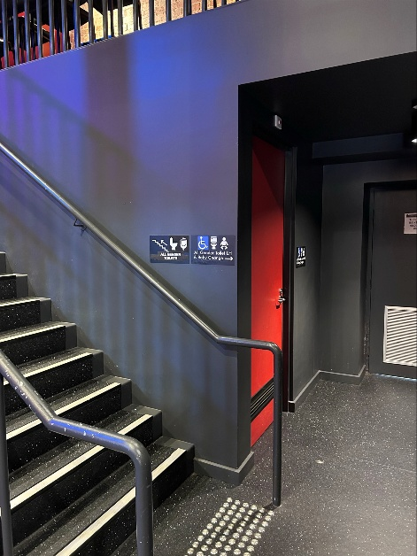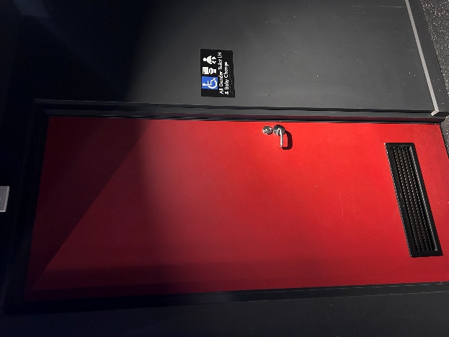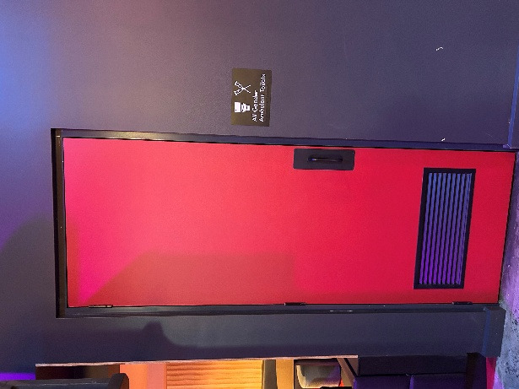

Bathrooms on Mezzanine (up a flight of stairs)
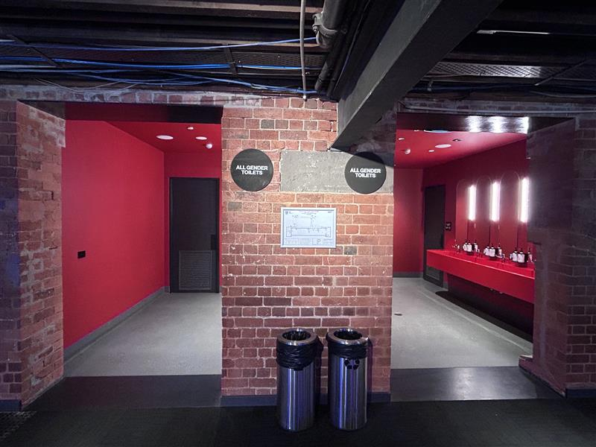
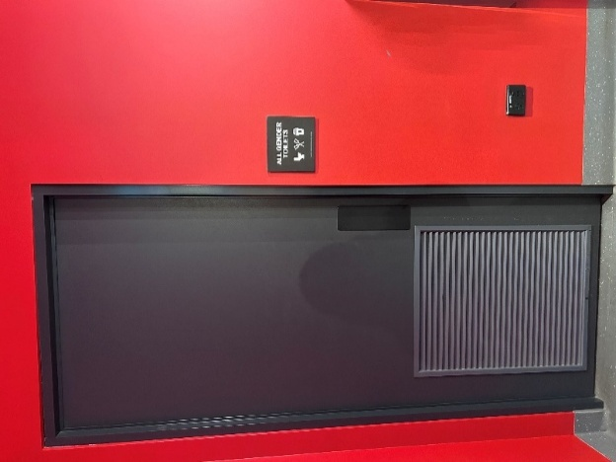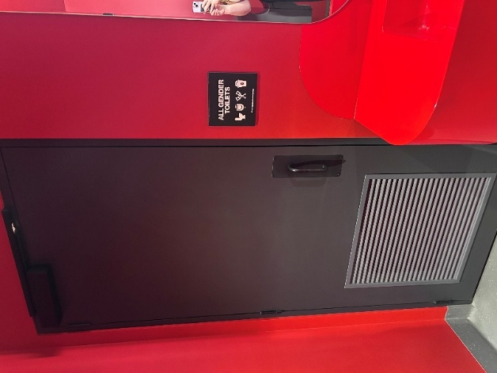

The bathrooms to the left have seated toilet stalls, an ambulant stall, and sanitary bins. The bathrooms to the right have seated stalls, urinals, an ambulant stall, and sanitary bins.
THEATRES
All theatres and spaces at the Malthouse are clearly marked. There are many staff members who will be able to assist you if you have any questions.

Merlyn Theatre
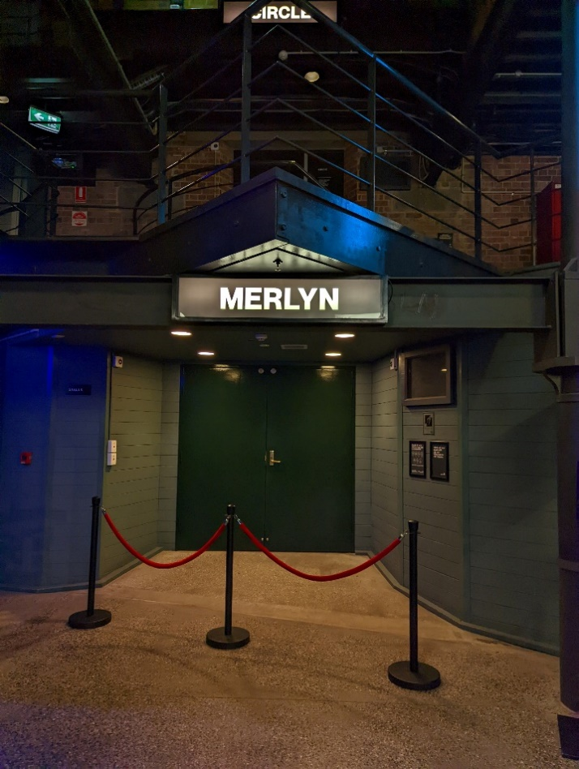
This entrance is wheelchair accessible.

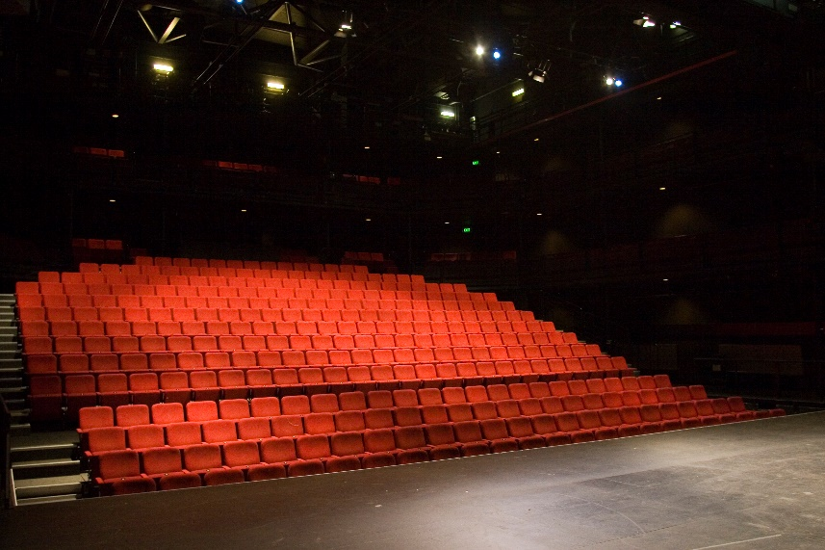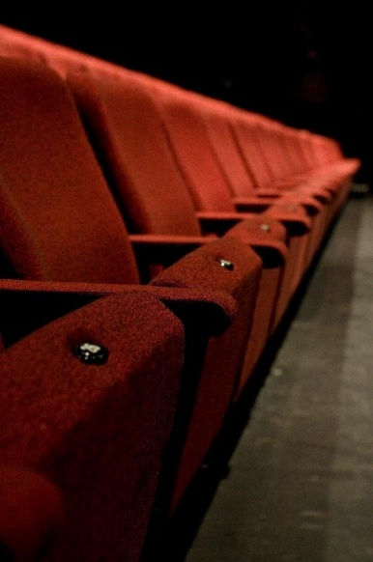

The theatre seats are organised in rows, labelled with letters from AA to M. Each seat also has a number on it. Your ticket will show which row and seat number you can sit in. The seating bank is not always in this configuration.

Beckett Theatre

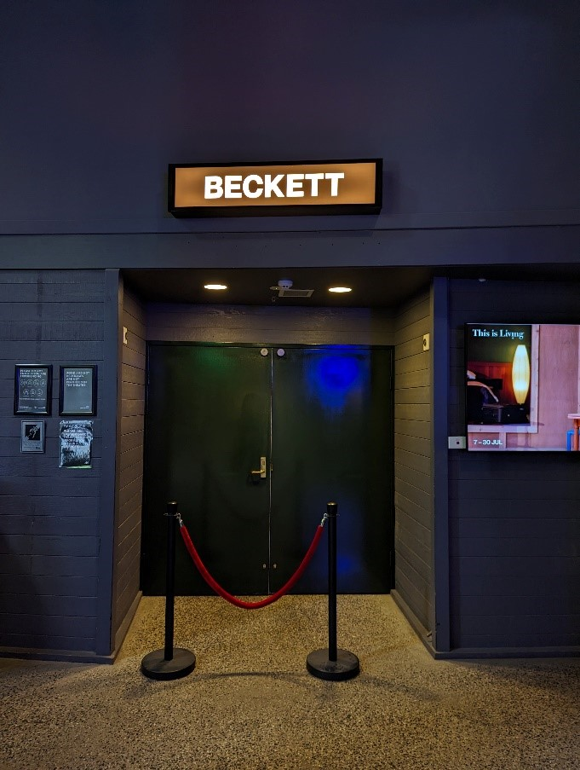

This entrance is wheelchair accessible.

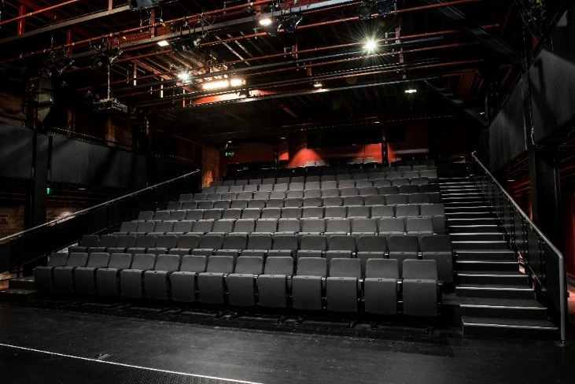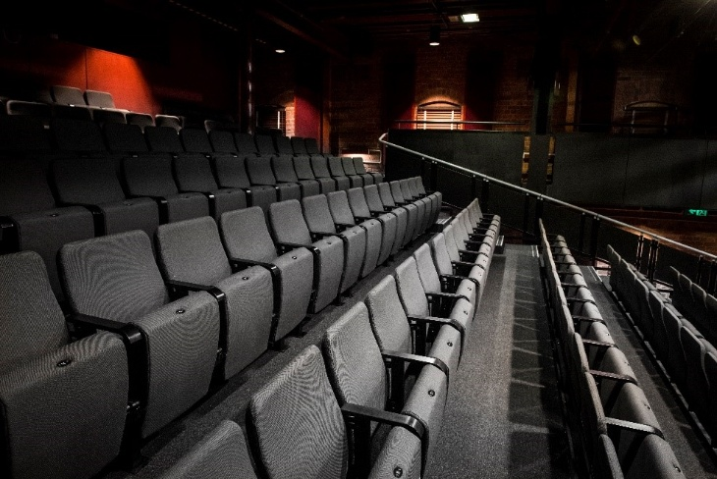

The theatre seats are organized in rows, labelled with letters from A to M. Each seat also has a number on it. Your ticket will show which row and seat number you can sit in.

WE’RE HERE TO ASSIST
If you need help finding your seat, or with anything else, you can ask a Malthouse Theatre Usher. Ushers wear a uniform of a black shirt with a lanyard.
