**ACCESS PACK**

***The Birds***

**16 May – 7 June 2025**

**VISUAL GUIDE: MALTHOUSE THEATRE**

**113 STURT STREET SOUTHBANK VIC 3006**

**GENERAL INFORMATION**

Overnight, the weather has turned in a small town. A war has been declared and there’s no one who can stop it.

One family sounds the warning, but what can you do when denial is as easy as keeping your head down?

Award-winning actor Paula Arundell (*Harry Potter and the Cursed Child*) sends your pulse sky-rocketing in this adrenaline-shot adaptation of Daphne du Maurier’s classic gothic horror that Hitchcock immortalised in film.

Lights off, headphones on, it is time to be immersed in a theatrical feat of audio engineering. Enter a nightmarish soundscape of flying feathers, murderous swoops and thrilling carnage directed by Matthew Lutton (responsible for making you scream during *Picnic at Hanging Rock*).

As you dodge and duck out of reach, just remember: the big-wigs in the city won’t save you.

**DETAIL**

The Birds is adapted from the story by Daphne du Maurier.

Commissioned and developed by Malthouse Theatre.

**Dates:** 16 May – 7 June 2025

**Duration:** 80 minutes

**Relaxed Performance:** No dedicated relaxed performance, please talk to our Front of House or Box Office Team if you require assistance.

**Venue:** Beckett Theatre, The Malthouse, 113 Sturt Street, Southbank VIC 3006

**Company Website:** <https://www.malthousetheatre.com.au/>

**Malthouse Theatre Access Webpage**: <https://www.malthousetheatre.com.au/visit-us/access>

**Event Page**: <https://www.malthousetheatre.com.au/whats-on/season-2025/the-birds>

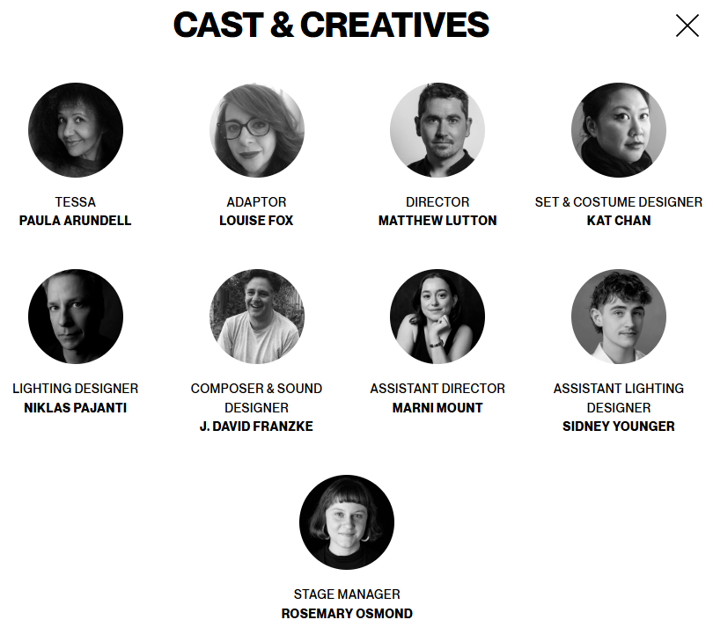

TESSA / Paula Arundell

DIRECTOR / Matthew Lutton

SET & COSTUME DESIGNER / Kat Chan

LIGHTING DESIGNER / Niklas Pajanti

COMPOSER & SOUND DESIGNER / J. David Franzke

SOUND ASSOCIATE / Gideon Cozens

ASSISTANT DIRECTOR / Marni Mount

ASSISTANT LIGHTING DESIGNER / Sidney Younger

STAGE MANAGER / Rosemary Osmond

SOUND OPERATOR / Gideon Cozens

SET & COSTUME INTERN / David Wotherspoon

**CONTENT & ACCESS RATINGS**

This production contains coarse language, graphic descriptions of violence, harm, and death, strong horror themes, loud and sudden noises, flashing lights, strobe and smoke effects.. The audience will be supplied headphones to wear throughout the performance.

The audience will be supplied headphones to wear throughout the performance.

For more detailed content warnings, please see <https://www.malthousetheatre.com.au/visit-us/content-warnings>

Aural Rating 75% – mainly sound-based, with visuals only incidental to the work, so blind or low vision audiences can have close to the full experience of the event.

Visual Rating below 50% – predominantly sound-based event.

The Birds is experienced through headphones and heavily incorporates a stunning sound design. Whilst many people with minor hearing impairments will find the headphone system adequate to hear the show, we also have oversized headphones for those wearing external heading aids, can provide personal induction loops, and have sockets for patrons with direct inputs. We can also provide independent volume controls. Please call or email Box Office (information below) if you would like assistance with headphones.

**HOW TO BOOK / CONTACT US**

Information about The Malthouse venue and *The Birds* can be found on Malthouse Theatre’s **website** [www.malthousetheatre.com.au](http://www.malthousetheatre.com.au)

You can book tickets on the website or by calling the **Box Office** on (03) 9685 5111.

For more detailed access information, please feel free to contact our box office team on: [boxoffice@malthousetheatre.com.au](mailto:boxoffice@malthousetheatre.com.au)

We are committed to continual improvement and learning and welcome your feedback.

**HOW TO GET TO THE MALTHOUSE**

*Pictured: The view of Stop 18 with Malthouse and ACCA in the distance* 

The Malthouse is located at 113 Sturt Street in Southbank. You can get here by tram, train, bike or car.

**Tram:** The closest tram stop is Stop 18 – Grant Street/Sturt Street (Route 1). You can also get to the venue from St Kilda Road. Get off at Stop 17 – Grant Street, Police Memorial/St Kilda Road. From this stop, it is a 6-minute walk to the venue via Grant Street.

**Train:** Flinders Street station is approximately 15-minute walk away.

**Bike:** There are bike racks and a Melbourne Bike Share station outside The Malthouse.

**Car:** There is limited on-street parking on Grant Street, Sturt Street and Dodds Street. There are 2 disabled spaces outside The Malthouse entrance on Sturt Street.

The closest secure carparks are:

* Arts Centre Melbourne Car Park (enter from Sturt Street)
* The Australian Ballet Centre Car Park (2 Kavanagh Street)

**VENUE IMAGES**  
  
Entrance from Sturt Street side

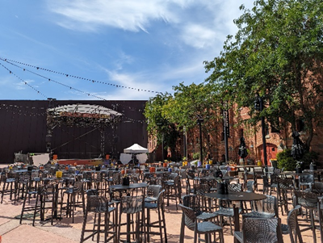 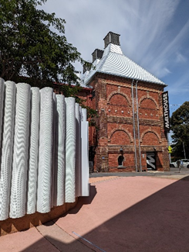

Entrance from Dodds Street side (wheelchair access)

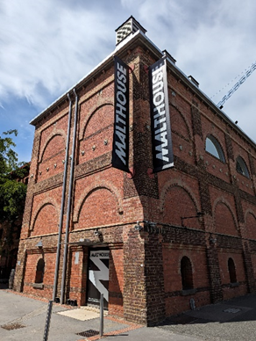

Bar and seating in the Foyer

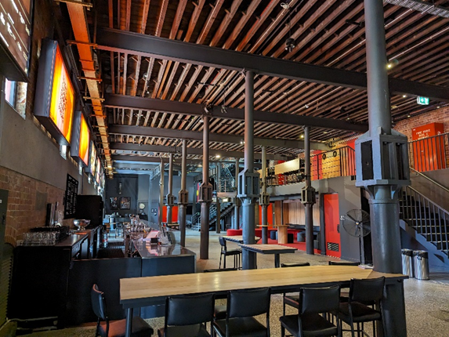

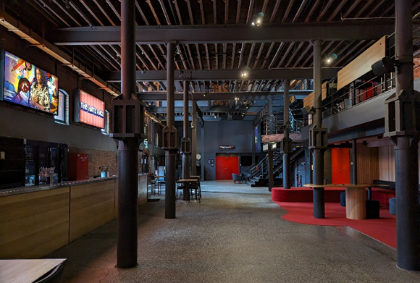

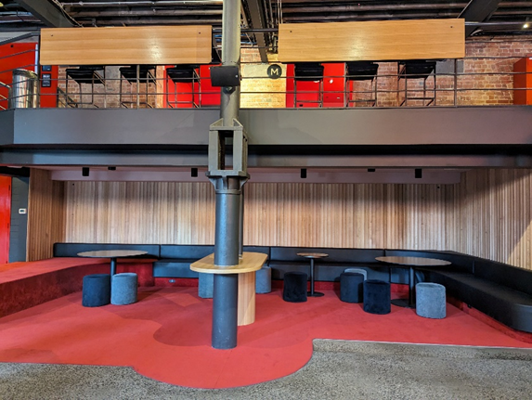

Box Office in the Foyer

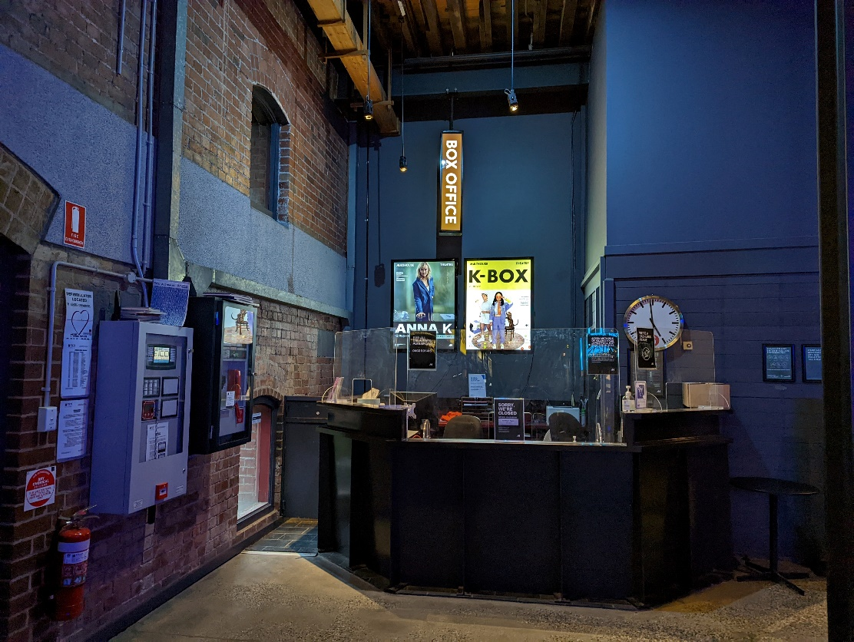

Bathroom in Foyer (Ground Level)

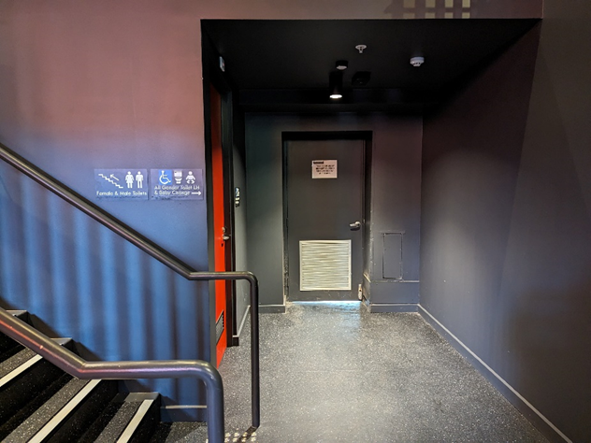

*All gender toilet, Baby Change*

Bathrooms on Mezzanine (up a flight of stairs)

**THEATRES**

The Malthouse has three theatres, The Merlyn, The Beckett and the Tower Theatre.

All theatres and spaces at the Malthouse are clearly marked. There are many staff members who will be able to assist you if you have any questions.

**Merlyn Theatre entrance**

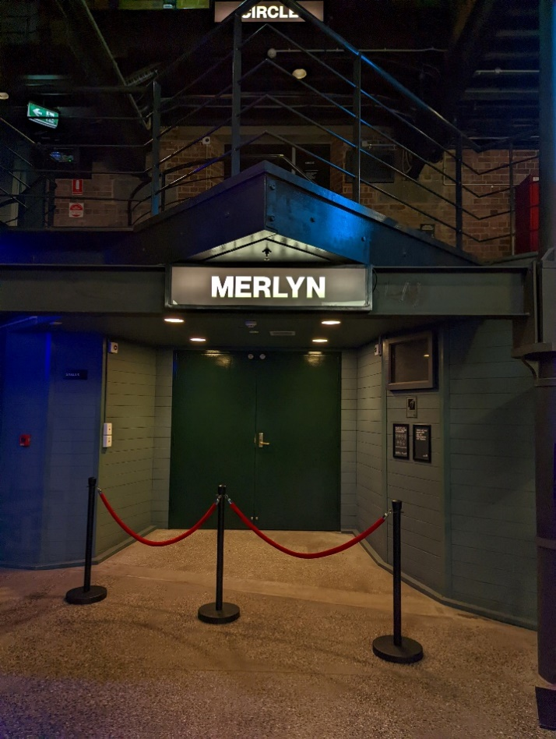

*This entrance is wheelchair accessible.*

*Below is a picture of inside the Merlyn Theatre*, the seats are not always in this configuration. 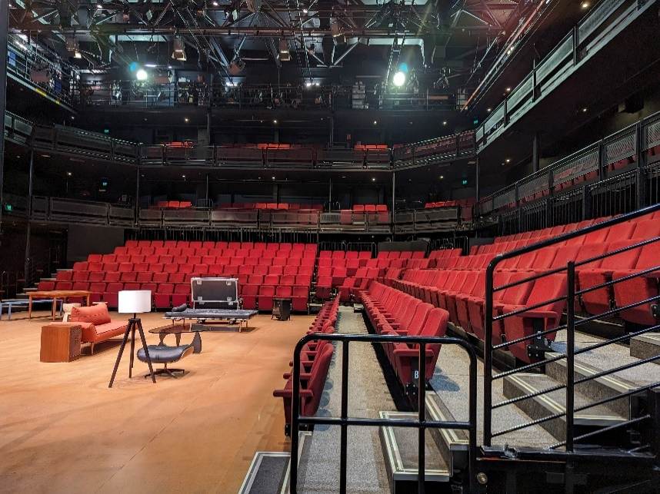

The theatre seats are organized in rows, labelled with letters from AAA to M. Each seat also has a number on it. Your ticket will show which row and seat number you can sit in.

Pictured: theatre seats with number labels

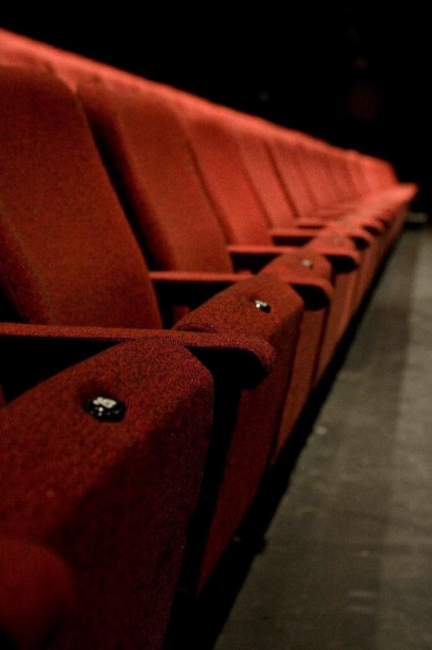

**Beckett Theatre entrance**

This entrance is wheelchair accessible.

*Below is a picture of inside the Beckett Theatre*

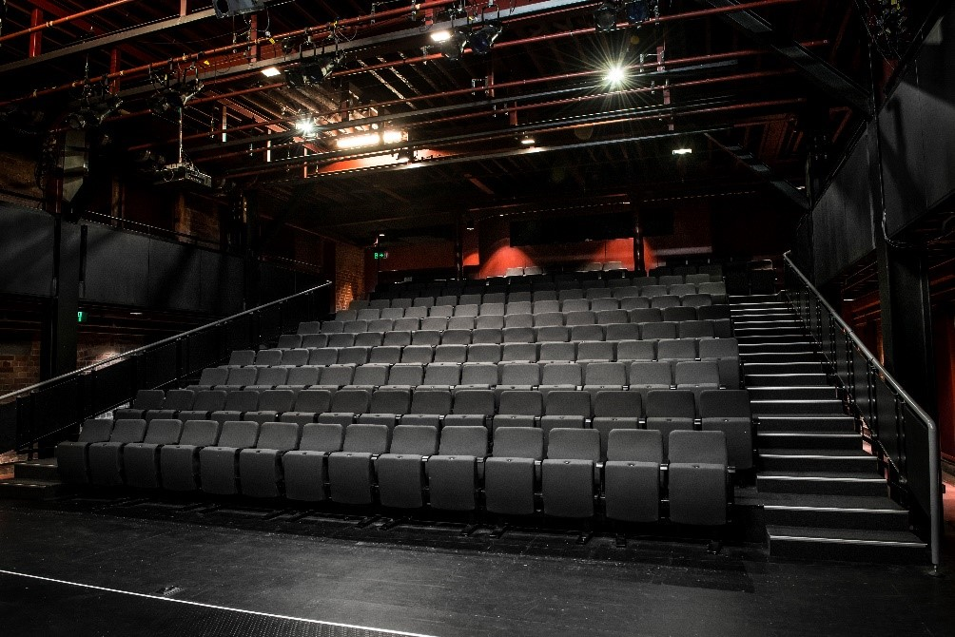

The theatre seats are organized in rows, labelled with letters from A to M. Each seat also has a number on it. Your ticket will show which row and seat number you can sit in.

Pictured: theatre seats with number labels

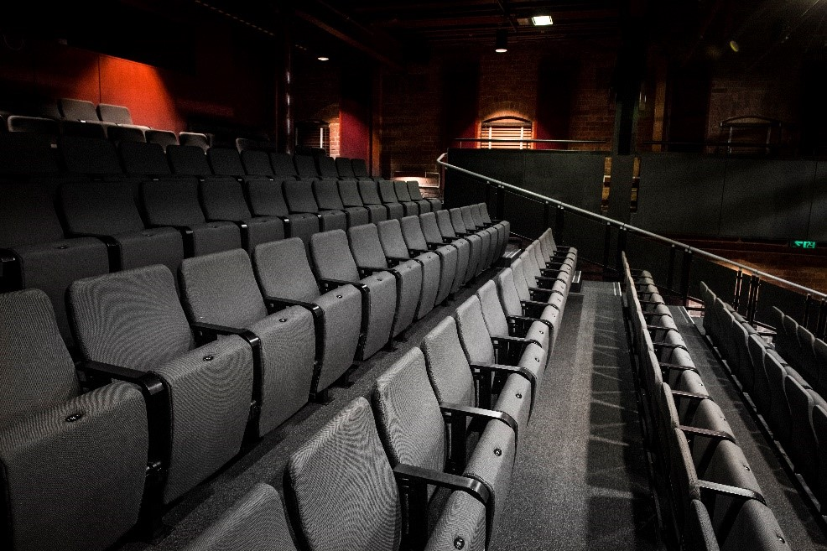

**WE’RE HERE TO ASSIST**

If you need help finding your seat, or with anything else, you can ask a Malthouse Theatre Usher. Ushers wear a uniform of a black shirt with a lanyard.

**Pictured:** Usher wearing their uniform.