ACCESS PACK
The Nightline
13 – 29 August 2026

VISUAL GUIDE: MALTHOUSE THEATRE
113 STURT STREET SOUTHBANK VIC 3006
CONTENTS

- General information
- Season details
- Content warnings
- Access ratings
- How to book / contact us
- Cast and Creatives
- How to get to Malthouse
- Venue images

GENERAL INFORMATION

Welcome to The Nightline – where you can listen in to real-life voice messages, left by anonymous Melburnians between midnight and 6am. Will you pick up?
Come share the small hours with sleepless parents, shift workers, the homesick, the restless, the grieving. Pick up your phone and use your personal switchboard to explore messages collected from local late-night callers. Listen to their serenades, secrets, confessions of love, strange memories, and perhaps a vent or two. We can’t promise what you’ll hear – only that you’ll have the power to choose your own adventure.
As you fall deeper into this velvet night, you may find that those ghostly voices have been freed from the machine. The distance between the sleepless speakers and avid listeners is closing. The night may still be dark, but for now, no one is alone.
An intimate and beautiful production from director Roslyn Oades, renowned for her groundbreaking documentary concepts, and internationally acclaimed, ARIA Award-winning sound artist Bob Scott, The Nightline is a propulsive listening experience unlike any other. Take a seat at a table for one, pick up your phone and let the night envelop you in a deeper kind of listening.
Please note seating for this show is general admission.
SEASON DETAILS

The Nightline
Created by Roslyn Oades & Bob Scott, with collaborators

Dates: 13 – 29 August 2026
Venue: Bagging Room, Malthouse, 113 Sturt Street, Southbank VIC 3006
Company Website: https://www.malthousetheatre.com.au/
Malthouse Theatre Access Webpage: https://www.malthousetheatre.com.au/visit-us/access
Event Page: https://www.malthousetheatre.com.au/whats-on/season-2026/the-nightline

CONTENT WARNINGS

The Nightline contains some bright flashes of light and periods of sustained darkness. It may be anxiety inducing for audiences with sensory sensitivities. The work contains some coarse language and references to death, sex and drugs. Recommended for 14+ years.

Detailed information regarding health and hygiene management, audience agency, lighting and sound sensitivity advice, as well as detailed show content information is available on the final two pages of this document. Please note this information contains spoilers.

ACCESS RATINGS

Aural Rating 75% – mainly sound-based, with visuals only incidental to the work, so blind or low vision audiences can have close to the full experience.

Visual Rating below 50% – predominantly sound-based event.

This work is immersive and occurs in low light conditions. Guests are led into and out of the experience by a Host. Latecomers cannot be admitted once doors close.

The Nightline is a detailed listening experience and may be of particular interest to audiences with low-vision.

Detailed information regarding health and hygiene management, audience agency, lighting and sound sensitivity advice, as well as detailed show content information is available on the final two pages of this document. Please note this information contains spoilers.

HOW TO BOOK / CONTACT US

Information about The Malthouse venue and this production can be found on Malthouse Theatre’s website www.malthousetheatre.com.au

You can book tickets on the website or by calling the Box Office on (03) 9685 5111.

For more detailed access information, please feel free to contact our box office team on: boxoffice@malthousetheatre.com.au

We are committed to continual improvement and learning and welcome your feedback.
CAST AND CREATIVES

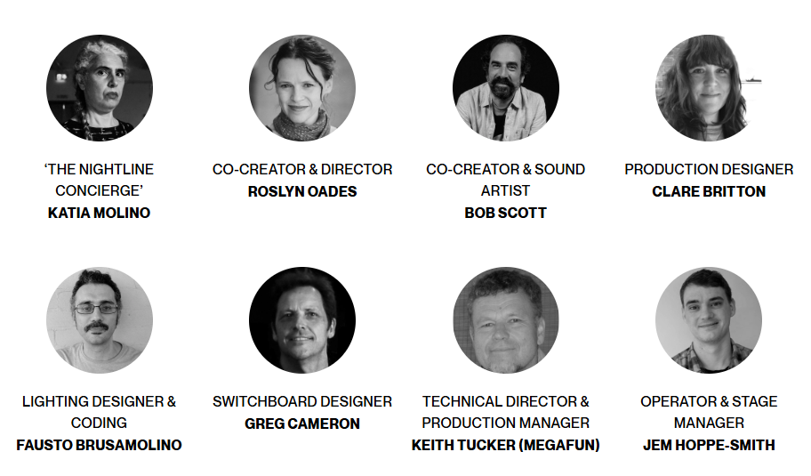

CAST

The Nightline Concierge / Katia Molino

CREATIVES

Co-Creator & Director / Roslyn Oades
Co-Creator & Sound Artist / Bob Scott
Production Designer / Clare Britton
Lighting Designer & Coding / Fausto Brusamolino
Switchboard Designer / Greg Cameron
Technical Director & Production Manager / Keith Tucker (Megafun)
Operator & Stage Manager / Jem Hoppe-Smith
HOW TO GET TO MALTHOUSE
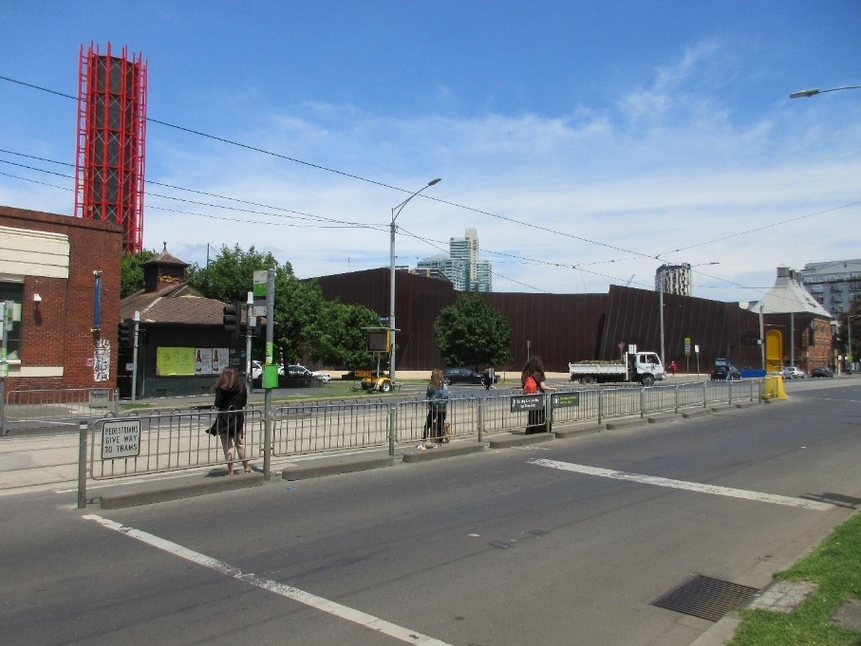
Pictured: The view of Stop 18 with Malthouse and ACCA in the distance
The Malthouse is located at 113 Sturt Street in Southbank. You can get here by tram, train, bike or car.

Tram: The closest tram stop is Stop 18 – Grant Street/Sturt Street (Route 1), however this is not wheelchair accessible. You can also get to the venue from St Kilda Road. Get off at Stop 17 – Grant Street, Police Memorial/St Kilda Road – a wheelchair accessible stop. From this stop, it is a 6-minute walk to the venue via Grant Street.

Train: Flinders Street station is approximately 15-minute walk away.

Bike: There are bike racks and a Melbourne Bike Share station outside The Malthouse.

Car: There is limited on-street parking on Grant Street, Sturt Street and Dodds Street. There are 2 disabled spaces outside The Malthouse entrance on Sturt Street.

The closest secure carparks are:
- Arts Centre Melbourne Car Park (enter from Sturt Street)
- The Australian Ballet Centre Car Park (2 Kavanagh Street)

VENUE IMAGES
Entrance from Sturt Street side
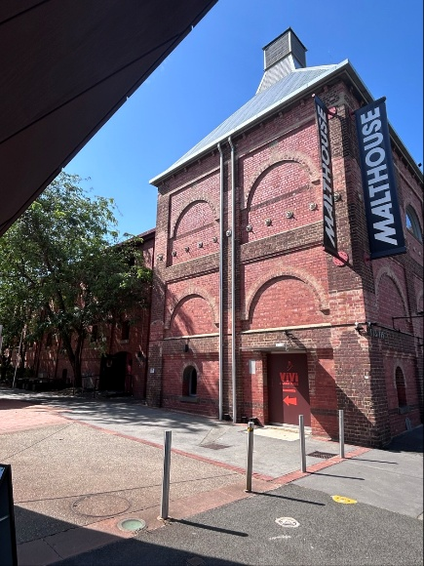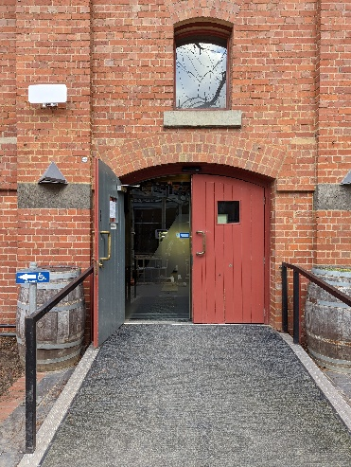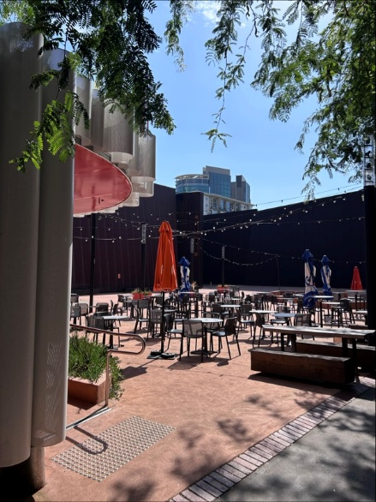

Entrance from Dodds Street side (wheelchair access)
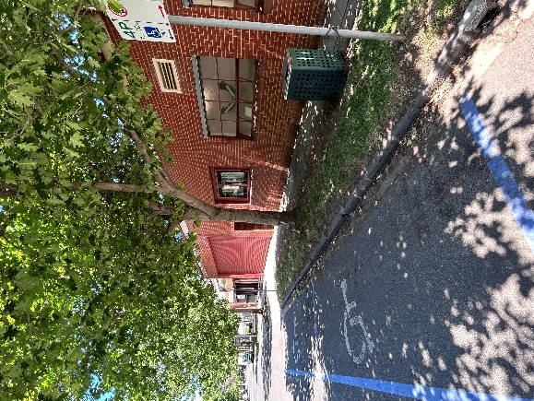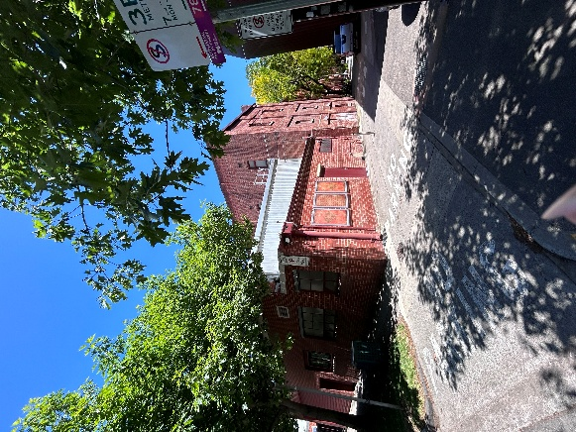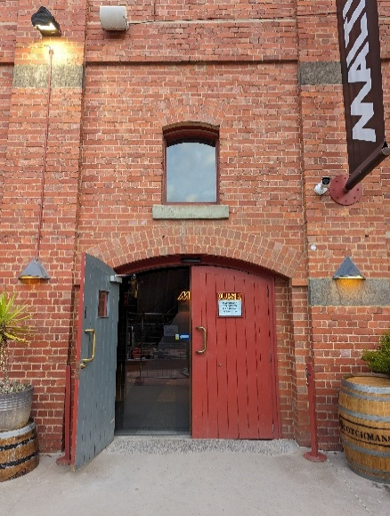

Bar and seating in the Foyer
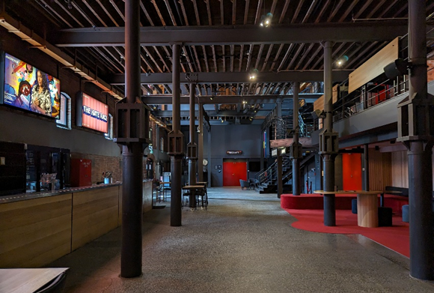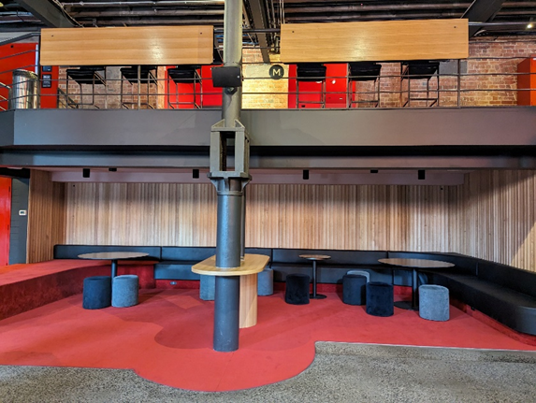

Box Office in the Foyer
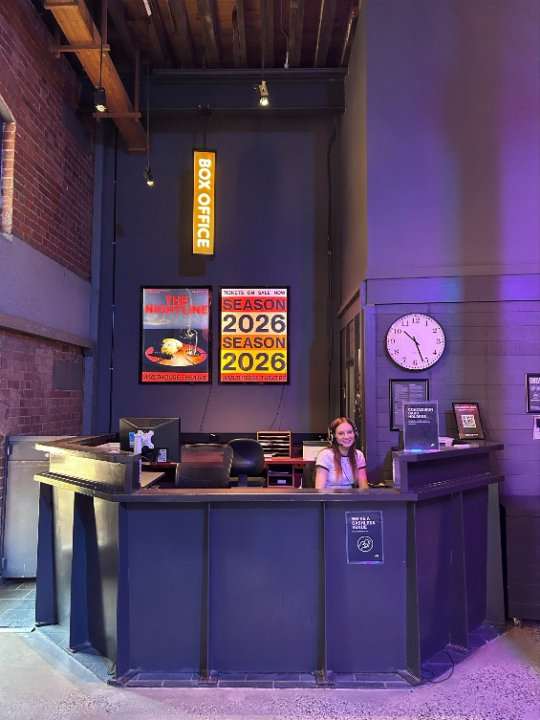

Bathrooms in Foyer (Ground Level)
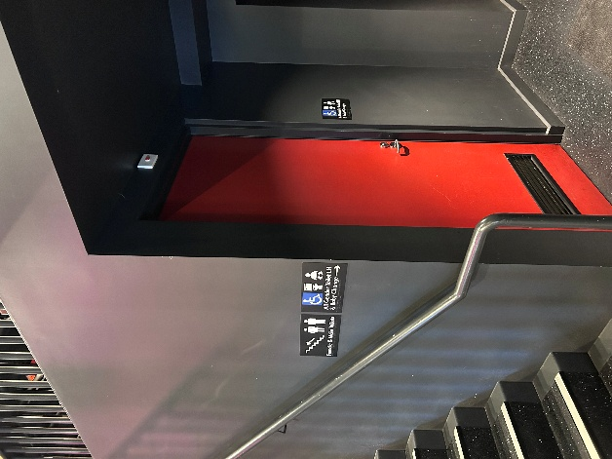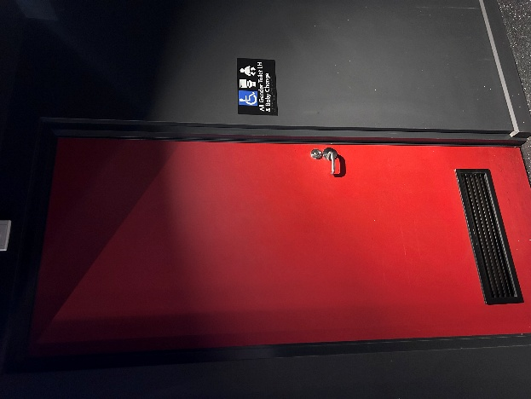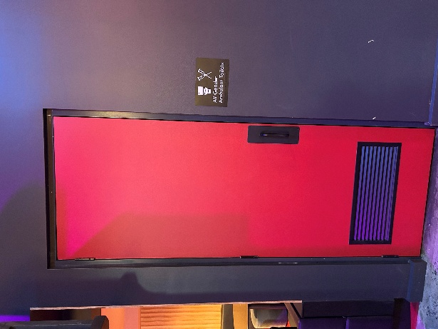

Bathrooms on Mezzanine (up a flight of stairs)
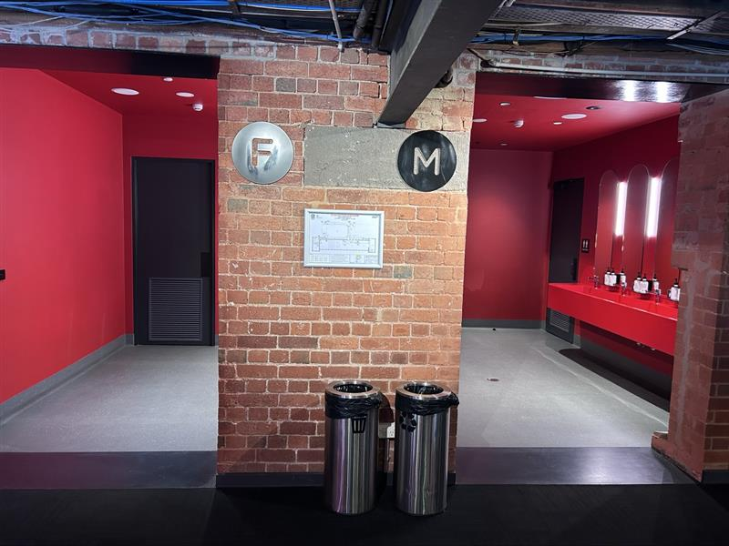

The bathrooms to the left have seated toilet stalls, an ambulant stall, and sanitary bins. The bathrooms to the right have seated stalls, urinals, an ambulant stall, and sanitary bins.
THEATRES
All theatres and spaces at the Malthouse are clearly marked. There are many staff members who will be able to assist you if you have any questions.

The Nightline is not in one of our main spaces – it is in The Bagging Room (usually used as a rehearsal space). There is a special meeting place in the foyer for this show, under a light up sign that says THE NIGHTLINE. See photo below. Our helpful Front of House staff will meet you in this waiting space, before taking you to the show. The show space is upstairs, so please let our Front of House team know as soon as possible if you want to use the lift.

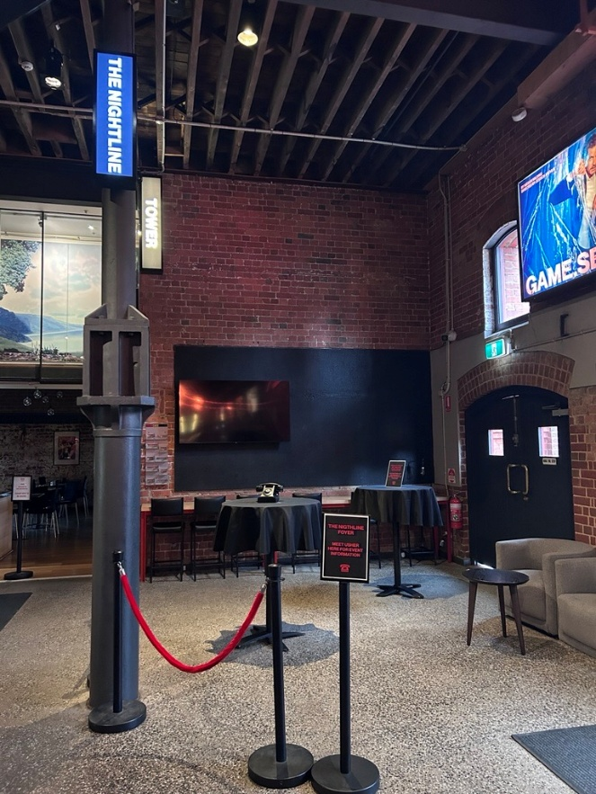

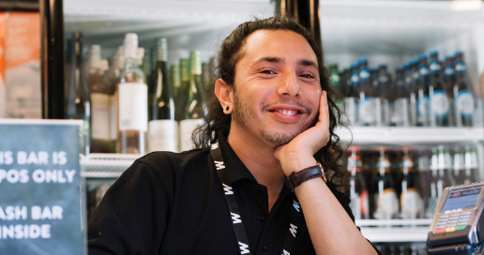
WE’RE HERE TO ASSIST
If you need help finding your seat, or with anything else, you can ask a Malthouse Theatre Usher. Ushers wear a uniform of a black shirt with a lanyard.
THE NIGHTLINE – DETAILED CONTENT INFORMATION

Please note, the following information contains spoilers.
The Nightline is a creative documentary concept, which in this instance means all the voices you hear in this show are actual voice message recordings from real people who have voluntarily contributed anonymous first-person stories and insights to The Nightline project, for our audiences to hear. Our ethical contract with these community participants is: what happens at The Nightline stays at The Nightline. As such, these often very intimate recordings can only be heard in The Nightline experience itself.
The content in this bespoke Melbourne edition of The Nightline, created for Malthouse Theatre, contains coarse language, mature themes, sexual references, and references to death and dying.
Periods of sustained darkness, as well as a short period of loud sound and ‘storm-like’ flashes of light are also used in the production.
Health and hygiene management:
Each audience member in this experience is seated at their own interactive telephone table-for-one. Central to the audience experience is picking up the handset of the old rotary-dial telephone on their table and placing it to their ear. Please be assured that all telephone handsets and audience touch points are hygienically cleaned with disinfectant wipes between shows.
Audience agency:
- It may be useful to know that you will be shown how to switch between eight available channels of documentary voice material (choose-your-own-adventure style), via an interactive switchboard built into your table-for-one. The only exception to this rule is when ‘crossed-line’ moments occurs in the show structure. At these moments, all telephone ear-pieces will receive the same voice content, regardless of which audio-channel you are plugged into. Crossed-line moments occur at three points during the show.
- The show’s voice content can only be heard via the phone ear-pieces. If you’d like to take a break from listening to the voice content, you can chose to replace your telephone hand-set and only hear the work’s soundscape in the room’s surround-sound speaker system.

If you need to leave mid-show:
- If for any reason, you’d like to leave the experience, simply raise your hand and a staff will assist you to safely exit the room in a timely manner. Due to low-lighting states and the immersive nature of this experience, it’s very important you do not attempt to exit the room unassisted. Once you have exited, it is not possible to re-enter the work.
Strong coarse language:
- The use of coarse language is minimal, however the words: ‘shit’, ‘fuck’, ‘penis’ and ‘titties’ are occasionally used by documentary voices in the work.
Mature themes:
- Personal real-life references to alcohol misuse, cigarette smoking, marijuana smoking and gambling.
- Personal real-life references to experiences of death, grief, loneliness and loss (including in one instance, the impact of a suicide on a community of friends).
- Personal real-life references to economic insecurity and homelessness.
- Personal real-life references to physical assault, criminal behaviour, police violence, bullying and a road accident.
- Personal real-life references to medical procedures, pregnancy and childbirth. Voices in the work reference first-person experiences of: Restless Leg Syndrome, Insomnia, amputation, Autism, Parkinson’s Disease, Arthritis, Dementia, Depression and Anxiety – as well as medical treatments associated with these lived experiences.
Sexual references:
- Some of the voices in the work share personal stories about their sex life, including expressions of sexual desire and of infidelity. These stories are not explicit.
Lighting and sound sensitivity advice:
- If you have sound and/or lighting sensitivities, it may be useful to know that at approximately 18 minutes into the show, some flashes of bright light and loud sound effects will occur – which are designed to approximate the feeling of being momentarily in the middle of a ‘thunder storm’. Please be advised these effects will last approximately two minutes only. You are welcome to close your eyes and or block your ears for this period.
- Please be aware, the work includes extended periods of darkness and low lighting.
Statement of values:
Please be aware that any opinions expressed in The Nightline’s documentary materials are those of the individual speaker and do not necessarily reflect the views and values of the creative team or of Malthouse Theatre.

